4. Cooperation with Business Partners

# Relevance for Business

Under certain circumstances, Siemens may be held liable (B.1.) for the actions of certain third parties which we refer to as “[Business Partners](https://webbooks.siemens.com/public/LC/chen/index.htm?n=General-Introduction,2.-Definitions-and-Abbreviations)”.

Before starting a concrete relationship with certain third parties, Siemens must take steps to create transparency and ensure that the relationship is responsibly evaluated and managed. A **Compliance Due Diligence (CDD)** (A.4.) has to be initiated in the [CDD-Tool](https://compliance-tools.siemens.com/due-diligence/) and certain **contract provisions** (A.6.) need to be included in a contract with them.

After the approval of a CDD, an ongoing Business Partner relationship must be monitored by the respective Company Unit. The relevant CDD has to be kept up to date (A.4.2.).

Please find as follows an overview of our internal Business Partner landscape:

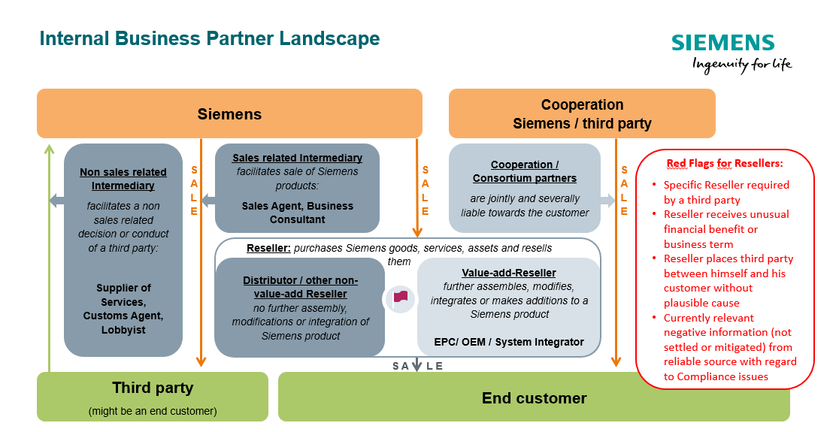

## A.1. Business Partner Types

Certain business relationships require a Compliance Due Diligence (CDD) to be performed in the [CDD-Tool](https://compliance-tools.siemens.com/due-diligence/).

Generally, all Business Partners can be categorized as follows:

|  |
| --- |
| Intermediaries   * **Sales-related Intermediaries**, e.g. Sales Agents, Business Consultants (A.1.1.); * **Non-sales related Intermediaries**, incl. Lobbyists and Customs Agents (A.1.2.).   Resellers with Red Flags   * **Value-add Reseller**, e.g. EPC, OEM / System Integrator (A.1.3.2.); * **Distributor / other Reseller** (A.1.3.).   For these Resellers, a CDD and the use of certain contract provisions is only mandatory in case of one of the following **Red Flags**:   * The use of the specific Reseller is required by a third party, e.g. an end  customer (A.1.3.1.1.); * The Reseller receives an unusual financial benefit or business term from  Siemens (A.1.3.1.2.); * The Reseller places another third party between himself and his customer  without plausible cause (A.1.3.1.3.); * There is currently relevant negative compliance related information (not settled or mitigated) about the Reseller from reliable source (A.1.3.1.4.).   Cooperation/Consortium Partners (A.1.4.) |

**Majority shareholdings** of Siemens (= affiliated companies) and **Siemens employees** are not in scope.

The identification of such Business Partners requiring a CDD is supported by the [Business Partner Checklist](https://compliance-tools.siemens.com/due-diligence/#/ui/checklist) in the [CDD-Tool](https://compliance-tools.siemens.com/due-diligence/).

### A.1.1. Sales related Intermediary

|  |
| --- |
| A “Sales related Intermediary” is a third party which   * facilitates[1] the sale of Siemens goods, services[2] and/or assets[3] * to another third party without purchasing[4] them and * receives a fee or other financial benefits[5] (including price reductions)  from Siemens for such service[6] (e.g. Sales related Business Consultants or Sales Agent) |

#### A.1.1.1. Examples for sales related intermediaries

* **Sales related business consultant without sales rights**

Third party commissioned to assist Siemens to **obtain sales or orders for defined specific business opportunities**, often larger projects. A sales related Business Consultant assists Siemens in generating revenue potential through direct contact with the customer (e.g. by promoting projects or supporting the pre-acquisition phase). He usually receives a fee that is not success related and works in an advisory capacity without being accountable for the outcome of a consulting exercise (e.g. hired to facilitate introduction to customers or assist the sales function in other ways). A Consultant could also negotiate economical terms of a contract on behalf of Siemens. Purchasing contracts for the goods and services resulting from the consulting exercise are typically concluded between Siemens and the end customer directly.

* **Sales agent**

A Sales Agent is a person or company that **arranges sales transactions** as an **independent contractor** for an **undefined number of business opportunities**, on behalf of a Siemens entity as principal. Often in a defined territory or for a defined customer group, regarding contractually defined Siemens products or services (often also referred to as "commercial agent" or "commercial broker"). Sales Agents usually receive a commission from the principal for the business deal arranged and for projects based on separate agreed commission agreements. Sales Agents do not purchase and resell Siemens products and services (as opposed to Resellers) but represent the company in a certain region or towards certain customers. The purchasing contracts for the goods and services are typically concluded between Siemens and the end customer directly (also see [SC 140 Regional sales activities - Representation rights and sales rights](https://regulations-admin.siemens.com/content/SC/140/en)).

Please keep in mind that Strategy (ST TO) is responsible for the preparation and conclusion of contracts between sales agents / distributors and Siemens AG allocating representation rights / sales rights to third parties to ensure that sales rights granted to the Business Partner do not overlap with those granted to other sales agents.

#### A.1.1.2. Exceptions

Introducer are Business Partner of Siemens Financial Services (SFS) to which [SFS Implementing Rule](https://circulars.siemens.com/content/circulars/ca/CircularAttachmentsCorporate/SR_226_SFS.pdf) (only accessible for SFS employees) applies. Please refer to A.8.

### A.1.2. Non-sales related Intermediary

|  |
| --- |
| A regular “Non-sales related Intermediary” is a third party which   * facilitates[7] a **non-sales related** decision or conduct (e.g. the issuance or award of an approval, permit, license or visa, a technical certification, or the payment of a debt)[8] * of another **third party** to the **benefit of Siemens**[9] and * receives a **fee or other financial benefits**[10] (including price reductions) from Siemens for such service[11]. |

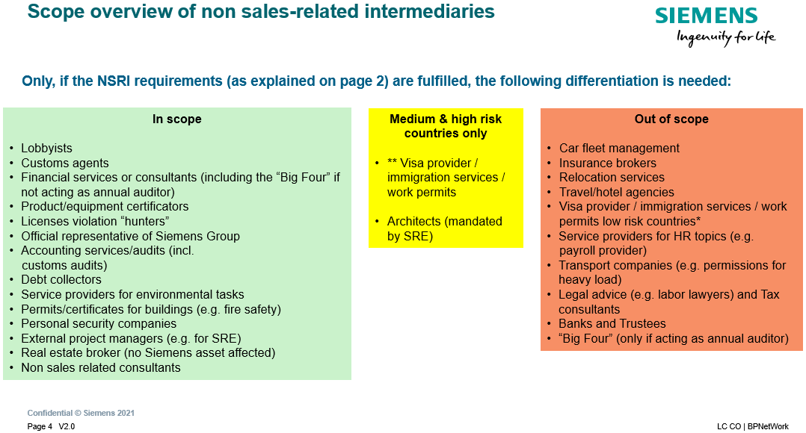

The respective definitions with examples, specific approval requirements etc. can be found [here](https://findit.compliance.siemens.com/content/10000101/Compliance/LC_CO/LC_CO_DF/findIT_LC_CO_DF_9246.pdf).

**Customs Agents**

**Customs Agents conduct** customs clearing in the name and on behalf of Siemens as his sole service or part of other services.

For additional requirements regarding **Customs Agents** please refer to the [Broker Processing and Clearance process of CF T](https://intranet.for.siemens.com/wll/0087/en/cu-org/ext/brpc/Pages/tab.aspx). This process needs to be followed **prior** to conducting a CDD.

**Lobbyists**

“**Lobbyist**” who represents Siemens’ interests in the political domain (e.g. in relation to governments) regarding non-sales related decisions or measures including regulation or legislation.

Details can be found [here](https://findit.compliance.siemens.com/content/10000101/Compliance/LC_CO/LC_CO_DF/findIT_LC_CO_DF_9246.pdf).

If a **mandatory** **lobbyist register** exists in the country, a lobbyist can only be contracted if he is listed in the register. If he is not listed, the reasons for that need to be clarified.

Besides the regular CDD-Process, a Lobbyist must be approved by the local GA department and by GM GA.

This applies to all new agreements with lobbyists and to all amendments to and renewals or extensions of existing agreements.

Further information and contacts of GA can be found [here](https://intranet.for.siemens.com/cms/056/en/about/org/Pages/gm-ga-org.aspx).

### A.1.3. Reseller / Distributors

A **Reseller** is a third-party who is planned to be contracted to purchase goods, services and/or other assets from Siemens and to resell or lease them to other third-parties on its own account.

A **Distributor** is a Reseller who resells Siemens products, services and/or other assets via his/her sales channels, or directly to multiple end customers without further assembly, technical modifications or additions.

Resellers and distributors are only in scope under certain conditions:

#### A.1.3.1. Reseller / Distributors with Red Flag

Reseller and Distributors are only in scope if they have at least one “**Red Flag”**. Value-add-resellers are only in scope if they have at least one red flag and involvement of recognizable Siemens product (Details can be found in section A.1.3.2.)

“**Red Flags**” are any circumstances that may indicate a risk regarding the Business Partner’s integrity. Any commercial, financial, legal or ethical irregularity can be a “Red Flag.” The existence of a “Red Flag” does not preclude business but makes it necessary to review the Business Partner via a CDD.

If Resellers **additionally** fulfill criteria of a Sales related Intermediary or Cooperation/Consortium Partner (e.g. in case of combined agency / distributorship agreements), they are automatically in scope notwithstanding any red flags.

In unclear cases, please contact your [Compliance Officer](https://intranet.siemens.com/en/compliance/contacts.htm). The results of such consultation and decision shall be documented accordingly.

Please also keep in mind to check the need for an AML Due Diligence and that certain competition law requirements must be met in [dual distribution](https://lkb.siemens.com/content/00000008/LegalKnowledgeBase/y5t2v021dbqp/LKB006654.pdf)[12] situations (more details can be found in the [LC intranet](https://intranet.for.siemens.com/org/lc/en/legal/orga/cmp/Pages/cmp.aspx?tabcardname=single%20topic%20guidance)).

|  |
| --- |
| Examples for “Red Flags”   * The use of the specific Reseller[13] is required[14] by a third party[15], e.g. an end customer (A. 1.3.1.1.); * The Reseller receives an unusual[16] financial benefit[17] or business term[18] from Siemens (A.1.3.1.2.); * The Reseller places[19] another third party between himself and his customer without plausible cause[20] (A.1.3.1.3.); * There is currently relevant negative compliance related information (not settled or mitigated) about the Reseller from reliable source[21] (A.1.3.1.4.). |

##### A.1.3.1.1. Required by a third party

A third party (e.g. end customer) might require a Reseller in bad faith for fostering problematic purposes on behalf or to the benefit of the third party or persons within the third party and/or the Reseller. This Reseller might create a pool of money (e.g. by overcharging) colluding with the third party or its employees which could be misused for problematic purposes, e.g. for bribery or kickbacks. In most cases the third party is a representative of the end customer or another decision-making authority involved in the business case.

The required specific Reseller could be critical if:

* The reasons for requiring a Reseller are not plausible and/or transparent because of missing commercial, technical or legal justification;
* Indications are available that key persons or key employees within the required Reseller have close personal ties to the decision maker or end customer or are even the same persons represented in both companies;
* The required Reseller has no obvious references, track record or experience in the respective field or country of activities;
* A Reseller who has not been mentioned in ongoing contract negotiations between Siemens and the end customer is suddenly introduced by the third party (e.g. the end customer) as the required new contractual partner.

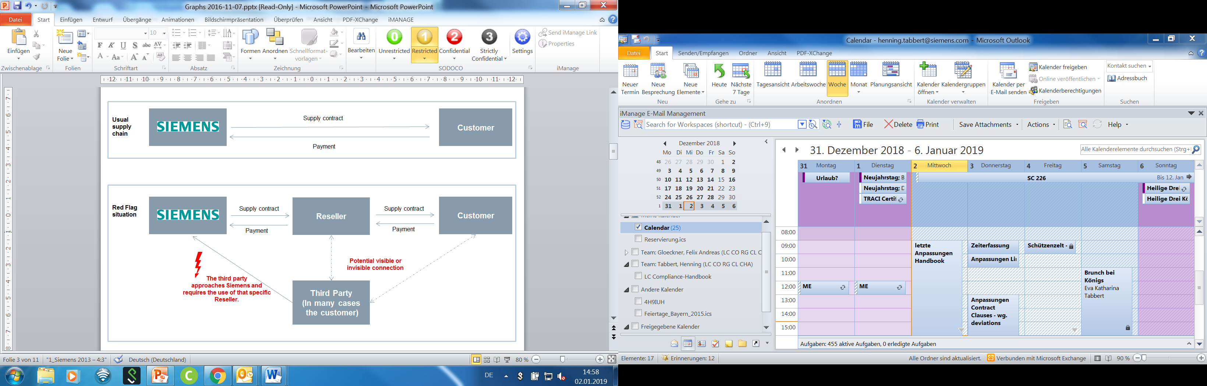

##### A.1.3.1.2. Unusual financial benefit or business term

It is not uncommon that Siemens supports Resellers to promote Siemens' products and services by targeted sales and marketing activities. In addition, sometimes Siemens might reimburse warehousing expenses to its Resellers to ensure adequate stock level for the indirect channel or might give a start-up financing reimbursing costs for promotion and merchandizing. In many cases, these reimbursements are part of an established “partner program”. Instead of an actual reimbursement, special investments by the Reseller (in e.g. marketing activities, sales competency, stock excellency) might also be measured based on predefined targets and then financially rewarded in form of an incentive scheme, all of which is documented in a “partner agreement”.

On the other hand, it can be a danger sign for corruption if “unusual” financial benefits or unusual business terms are agreed with a Reseller. The Reseller might create a pool of money e.g. claiming inflated contractual penalties or passing on financial benefits which could be misused for problematic purposes, e.g. for bribery.

To identify an “unusual” nature it is important to assess first what “usual” means. This could be done by using examples from similar constellations in the relevant market or country. Also, the Siemens price lists and standard business terms should be considered. Then a comparison with the actual business case is needed to identify gaps (and possible tolerable reasons for these). The pure facts, that a payment was made or a business term was used for several times, does not automatically imply an “usual” character of that payment or business term.

Unfortunately, no fixed rules can be provided regarding the result of the comparison between a “usual” and the constellation of the concrete business case to find out if it is still “usual” or already “unusual”. Therefore, a case by case evaluation is necessary.

**Examples** regarding the “usual” or “unusual” character of a “financial benefit”:

* A financial benefit may be “usual” if it is a part of a partner program or one-time marketing activity and if it is transparently calculated, accessible to many partners, openly communicated and part of a written agreement;
* A financial benefit may be “unusual” if it is requested from Siemens by the Reseller to receive such benefits exclusively and without a transparent target setting. And of course, the amount is of essence.

“Unusual business terms” differ often clearly from Siemens` general terms and conditions:

* Extended or uncommon contractual penalties;
* Extended warranties;
* Very high discounts without product strategic rationale;
* Actual scope and adequacy of prices of services (e.g. assembly, maintenance) cannot be determined;
* Low or no down payments in project business;
* Very long or unwarranted payment terms.

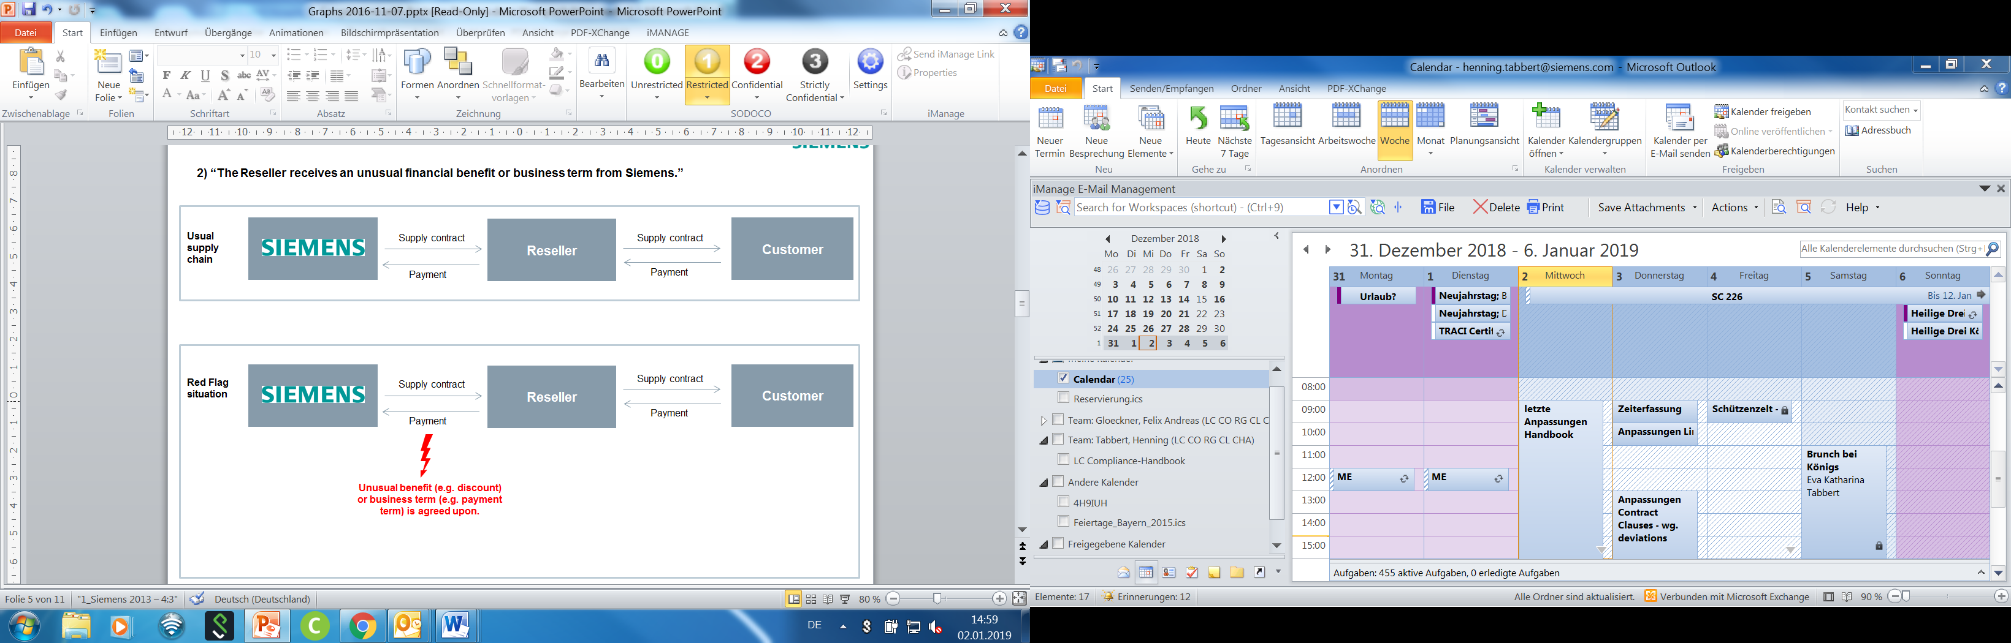

##### A.1.3.1.3. Another third party between the Reseller and his customer

The involvement of an additional third party (e.g. an additional reseller or an intermediary) between our contractual Reseller and the end customer without a comprehensible reason is a danger sign. This constellation decreases transparency and might be misused for problematic purposes. The additional third party might create a pool of money e.g. by a collusive overcharging which could be misused for problematic purposes, e.g. for bribery or kickbacks.

The following examples indicate a missing plausible cause:

* Circumvention of tax or foreign exchange regulations: Our Reseller might involve a further third party to circumvent potentially the tax or foreign exchange regulations. Often jurisdictions with the character of a tax haven are involved.
* Disguised identity of the additional third party: Our Reseller might use an additional third party with the intention to camouflage the identity of the person or company potentially critically profiting of the business activity (e.g. via the additional third party acting as a straw man or a dummy). It might also be the case that the unknown person or company uses the money he gains for critical purposes, e.g. bribery or kick back.
* Price inflation: The final price charged to the end-customer gets unnaturally inflated using additional third party, which increases the risk that money is channeled out of the value chain for critical purposes.
* Money laundering: The payment contractually owed to Siemens by our Reseller is announced to be transferred from the additional third party.

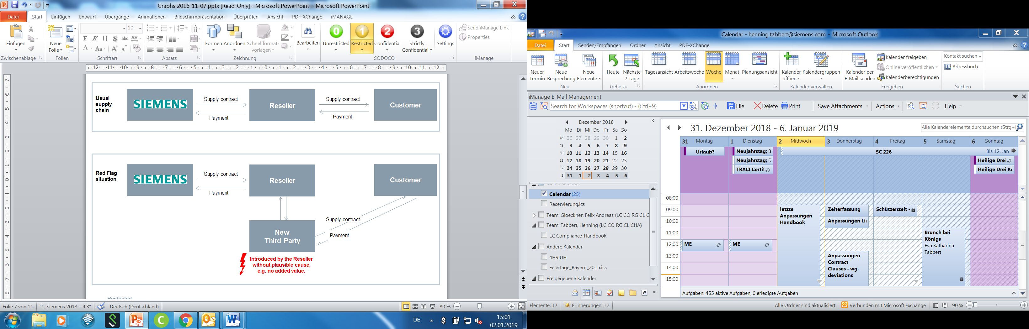

##### A.1.3.1.4. Currently relevant negative compliance related information

There might be currently negative Compliance related information about the Reseller itself or its key employees, for example:

* Current accusations or criminal proceedings (not settled or mitigated);
* Unsolved or ongoing compliance cases;
* Close ties to a decision maker at the (end)customer;
* Payments from a third country;
* “Management Judgment”, i.e. a request from Business Management or responsible Compliance Officer to perform a Due Diligence on this Reseller, e.g. based on suspicions on potential problematic activities or lack of integrity of the Reseller;
* Other currently relevant negative Compliance related information (not settled or mitigated) about the Business Partner from reliable source .

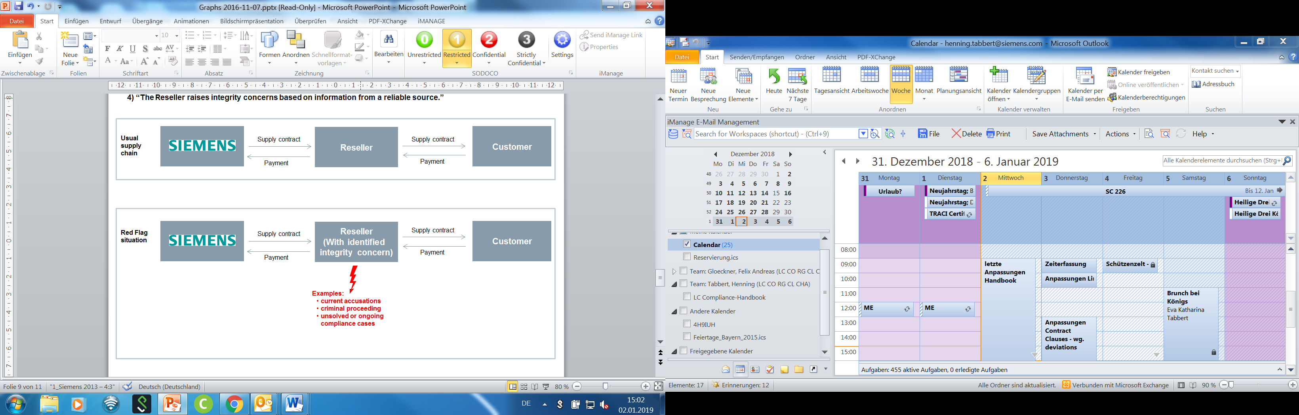

#### A.1.3.2. Value-Add Reseller

A **Value-Add Reseller** (e.g. EPC / OEM / System Integrator) is a Reseller who further assembles, technically modifies or makes additions to a Siemens product. A Value-Add Reseller is only in scope if the Siemens product remains “recognizable” as such, that means that it forms a **major part** of the newly created product of the Reseller (e.g. a large Siemens turbine in a power plant).

This will usually be the case when:

1. The value of the Siemens product in relation to the total volume is greater than 20%.
2. The decision of the end customer to purchase the product is essentially based on the fact that a Siemens product is included.

A Value-Add Reseller is not in scope if the Siemens product only forms a **minor part** (e.g. a Siemens fire detection system in a building).

**Please note:**

In case an Value-Add Reseller shows **massive negative information**, it is **strongly recommended**, also regardless of the above mentioned requirements, to create a CDD to be able to monitor the Value-Add Reseller during the business relationship. The responsible Compliance officer should consult with the colleagues from LC CO RFC LF / PT in each individual case.

#### A.1.3.3. Exceptions

* Leasing company

An End Customer request to use a leasing company is no Red Flag since it is normal business conduct that end customer decides to lease instead of purchasing a product.

* Group of companies / purchasing companies

A Reseller belonging to the same group of companies as the end customer is not considered as Business Partner. This also applies to state-controlled companies which are reselling to an end customer also controlled by that state. However, other purchasing companies remain in scope.

### A.1.4. Cooperation/Consortium Partners

|  |
| --- |
| A “Cooperation/Consortium Partner” is a third party with whom Siemens   * plans to collaborate to achieve a sales related[22] common goal and * is jointly and severally liable towards the customer for the scope of the contract   (e.g. a partner in a Consortium, Arbeitsgemeinschaft or “ARGE”, Unión Temporal de Empresas or “UTE”, Groupement Momentané d’Entreprises or “GME”) |

A Cooperation/Consortium is usually based on an arrangement in which several firms (from the same or different industry sectors or countries) to pool their technical, financial and human resources.

#### A.1.4.1. Examples

* In an **open consortium** all members of the consortium, i.e. Siemens and its consortium partner(s) enter into a contract with the customer and all consortium members are jointly and severally liable towards the customer for the performance of the contract. In case Siemens enters into an open consortium a CDD must be conducted for all consortium partner(s). The same applies for all other agreements with joint and several liabilities irrespective of the title of the agreement (e.g. “Teaming Agreements”, “Three Party Agreements” etc.).
* In a **silent consortium** the contract with the customer is only concluded between the customer and one of the companies and only that company is liable towards the customer for the performance of the contract. For silent consortium partners, generally no CDD is required. This is only necessary if they also fall into another category (e.g. as resellers, non-sales related intermediaries, suppliers etc.). In such cases, the respective processes must be followed.

However, please note that not only the contractual agreement is decisive, but all actual circumstances must be considered.

#### A.1.4.2. Exceptions

The following constellations of cooperation/consortia are **excluded** from the scope:

* Consortium partners (including the consortium leader) which participate in a **bank lending consortium** together with a Siemens finance company as well as any bank or other third party which perform typical functions in a financing provided by a lenders’ consortium (e.g. Facility Agent, Security Trustee, Paying Agent, Technical Agent) are out of scope.
* **Silent Consortium Partners** do not require a CDD if they do not perform additionally a task which is in scope of Circular No. 226, e.g. as a sales agent (see above A.1.1.1.).
* **Joint Venture Partners** aresubject to [Circular No. 222: “Application for and approval of capital investments and divestments”](C://Users/z002bpmd/Downloads/SC_222.pdf). If, however, they perform additionally a task, e.g. as a sales agent, they are in scope.

## A.2. Business Partner Strategy

For the company units Digital Industries (DI), Smart Infrastructure (SI) and Siemens Mobility (SMO), a Business Partner Strategy must be defined by the respective management based on a mandatory Business Partner portfolio and strategy statement. The selection of Business Partners must be in line with this strategy. On an annual basis the Business Partner portfolio and strategy review is reviewed by the responsible CEO of the Siemens unit, supported by Compliance. Details can be found in the document “[Business Partner Strategy”.](https://findit.compliance.siemens.com/content/10000101/Compliance/CL_CO/L_CO_OM/findIT_L_CO_OM_4992.pdf) Further details on Business Partner portfolio and strategy review can be found in Chapter B.2.

## A.3. Subcontractors of Business Partners

The use of subcontractors or further resellers is subject to the condition that the Business Partner obliges the subcontractor/further reseller to comply with compliance provisions equivalent to those in the contract between Siemens and the Business Partner.

It is not required that the Business Partner includes exactly or even similar clauses to the Binding Contract Provisions since Siemens’ influence on the concrete terms of a contractual agreement between third parties is limited.

However, as a minimum, the Business Partner must oblige its subcontractors or further resellers to comply with all applicable laws and regulations, in particular to any laws and regulations relating to anti-corruption, anti-money laundering and antitrust.

**For specific Business Partner types, please note the following**:

**Intermediaries:** Where an Intermediary intends to use a subcontractor for the services agreed with Siemens, an approval by Siemens is required, provided that such subcontractor would be in scope of [Circular No. 226](https://circulars.siemens.com/content/circulars/ca/_layouts/querplex/circularapplication/documents/CircularDownload.aspx?id=sc_226.pdf) if he would be retained by Siemens directly.

**Reseller**: A Reseller must notify Siemens if he intends to resell the goods to a party other than the end customer.

If the Company Unit is notified by the Business Partner after the conclusion of the contract that it intends to use a new or other subcontractor or further reseller, for medium and high risk CDDs the CDD Responsible has to update the CDD.

Where a red flag is identified in relation to any subcontractor/further reseller of a Business Partner, the same action must be taken as if the red flag had occurred regarding the Business Partner himself.

## A.4. Compliance Due Diligence (CDD)

A valid and approved CDD is a prerequisite for cooperating with Business Partners. Only the [CDD-Tool](https://compliance-tools.siemens.com/due-diligence/) may be used for this. Details are explained in **Chapter C** “Relevance only for Tool User (Tool description)”.

### A.4.1. CDD Process (Overview)

The Compliance Due Diligence process (**CDD Process**) supports conducting a risk- based integrity check of Business Partners. The aim is to ensure that all Business Partner engagements are based upon a transparent overview of the planned relationship and that this relationship is continuously and effectively monitored.

The Siemens Company Unit who would like to engage a Business Partner is responsible for starting a CDD in the [CDD-Tool](https://compliance-tools.siemens.com/due-diligence/).

The steps of a CDD are as follows:

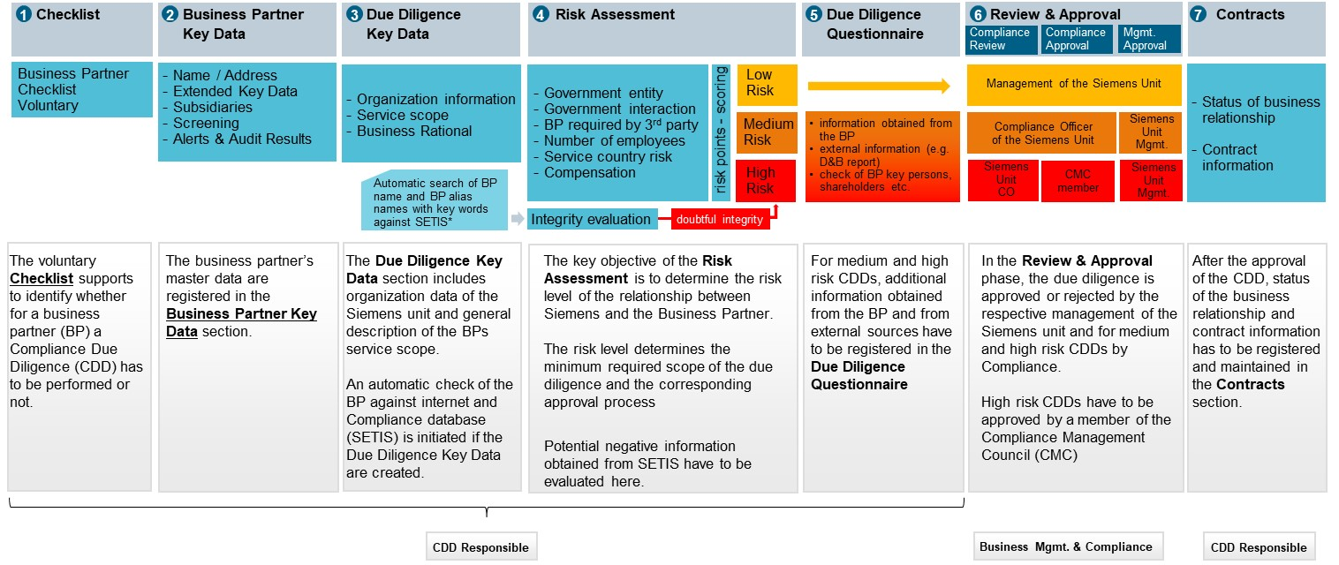

**Specific Approval**

Contracts with business partners assigned to the risk category “**high risk**”, have to be approved by the CEO / Head of a Business Company[23], Regional Company or Corporate Function prior to the contract signature.[24] Responsible for informing are both the CDD Responsible and the approving manager.

**Please note**:

If a CDD serves for more than one “Division” or Business Unit, the "**biggest user principle**" applies. The Division (or Business Unit) must be selected that is having or is planned to have the biggest business volume with the Business Partner. This principle avoids that CDDs are assigned to “- performed on ARE level -“ or “- performed on division level -“ which causes intransparency. If you are unsure about the correct assignment, please contact your Compliance Officer.

**For further details of the CDD process, please see chapter** **C.1.**

### A.4.2. Monitoring / Update

Approval of the CDD does not mean that all corruption risks can be excluded. Accordingly, once the CDD has been approved the Siemens unit dealing with the Business Partner must stay in close contact with the Business Partner and be alert and vigilant to any danger signs pointing to a risk of corruption which may appear in the course of the business relationship.

The Update Process in combination with the existing Business Partner portfolio reviews of CDDs in Compliance Review Boards and management meetings supports the ongoing monitoring of Business Partner relationships.

#### A.4.2.1 Principles

**Business awareness**

The business unit is aware of its responsibility for its Business Partners. This awareness can for example be expressed by clear tone from the top message by the CEO to the respective entities, or simply by the fact that relationships to Business Partners are regularly discussed in business meetings, Compliance Review Boards or corresponding meetings.

**Regular assessments**

The need for the relationship and the performance in consideration of the compensation is reassessed on a regular basis. Especially if the engaging Siemens entity is not located in the country but another Siemens entity is, there must be clear and transparent evidence why the relevant services cannot be provided by the Siemens organization.

If a Business Partner acts as a “door opener”, for example due to his unique technical experience or market knowledge, the engagement should only be temporary until the targets of the engagement are fulfilled or “until the door is open” and the knowledge about a market or a technology has been built up in Siemens.

Especially for Distributors and Sales related Intermediaries, it is recommended to visit them before the engagement is started. An assessment on a regular basis whether the Business Partner provides the services and that the compensation, rebates or any other benefits (in line with local law) are in proportion to these services is part of any common business behavior.

**Warning signs are taken seriously**

Potential warning signs in the relationship need to be taken seriously and properly addressed.

“Red flags" can, for example, be:

* A suspicion of a breach of the compliance provisions in the contract with the Business Partner e.g.: chapter compensation and expense reimbursement (e.g. the partner insists on being paid in cash in departure from the contractual agreements or issues false invoices or other false documentation, or makes suspicious statements in conversations which may be indicative of corrupt activities, e.g. that he needs financial or other support for accommodating the demands of a “friend” employed at the end customer).
* Credible information about the Business Partner which indicates non-compliance with laws, contract regulations or other rules and procedures regarding the integrity of the Business Partner.
* A merger or acquisition which has influence on the Business Partner directly or indirectly, if there is a justified suspicion about Compliance issues at the acquired company.
* A change in management which creates doubts about the integrity of the Business Partner, e.g. if a close government connection or a reputation for corruption of the new management are known.

**Measures to be taken**

The Siemens unit must take appropriate steps – in cooperation with the General Counsel and the Compliance Officer – to eliminate corruption risks, for example:

* to update the CDD;
* to seek clarification from the Business Partner;
* to decide to conduct an audit in consultation with Legal, Controlling and Finance Audit (CF A) and the Compliance Officer;
* to adjust the contract conditions (if this would constitute a viable remedy to a risk identified);
* to terminate the business relationship (i.e. if there is no other way of remedying the corruption risk identified);
* to disapprove the CDD. It is possible to centrally disapprove a CDD or the Business Partner by the Compliance Officer (see chapter C.5.1.3);
* to restrict the CDD approval, e.g. to a particular payment.

**Regular discussion of high-risk relationships**

Relationships with the highest risk are discussed regularly e.g. in the Compliance Review Board meetings. The risk level determined in the [CDD-Tool](https://compliance-tools.siemens.com/due-diligence/) should not be decisive, but one indication.

Further criteria, either solely or combined, should be considered to focus on business relationships with highest risk, like

* sales related higher risk due diligences for natural persons;
* due diligences for Business Partners located or performing services in countries with a high corruption index;
* Business Partners located or providing services in a country outside of the country of the respective Siemens entity or in a country where Siemens is not represented;
* due diligences with adverse but not proven information (e.g. negative press reports);
* business relationships where different third parties are involved in the value chain, e.g. sub-distributors, subcontractors especially where the customer is located in a country with a high corruption risk;
* Business Partners that receive a considerable compensation for their services, especially if the compensation is a success fee;
* sales related business relationships where the Business Partner is engaged in the tender phase with a governmental customer especially in countries with a high corruption risk.

The [Business Partner Dashboard](https://dashboard.compliance.siemens.com/dashboard/client/risk.html) can be used by Compliance Officers to identify such CDDs.

#### A.4.2.2 Update of CDDs

A Regular (mandatory) update of a CDD will be due every three years. A limited number of questions have to be re-answered and are marked in the [CDD-Tool](https://compliance-tools.siemens.com/due-diligence/):

* Low risk: updated integrity search;
* Medium risk: as low risk plus a new version of the independent background report (Dun & Bradstreet) to be obtained and reviewed;
* High risk: as for low/medium plus update of organizational setup (Extended Key Data and group structure) and integrity checks (SETIS/internet and Involvement of Key Persons in litigations)

The CDD Responsible will be automatically informed by an email notification to start an Update of a CDD and the approval process is based on the significance of changes.

No significant changes: only sign-off by the CDD Responsible, with the Management Approver and CO Reviewer informed of the changes via email. They may raise questions and request further information if deemed necessary.

Significant changes: a new Management Approval and CO Review is required with the CO Reviewer responsible to involve further stakeholders like CO or CMC if deemed necessary. Only an increase of the risk level requires a Compliance approval.

The [CDD-Tool](https://compliance-tools.siemens.com/due-diligence/) will automatically determine the relevant approval process.

For further details, please refer to chapter C.3.

### A.4.3. Global Business Partners

Specific Business Partners with global focus and a number of subsidiaries are “Global Business Partners”.

* The following Logistic service providers (including listed subsidiaries) performing customs clearance

| **CDD ID** | **BP Name (Headquarter)** | **Contact** |  | **List of subsidiaries** |
| --- | --- | --- | --- | --- |
| 0081227 | Agility GIL Services AG | LC CO Corp. |  | [Download PDF](https://findit.compliance.siemens.com/content/10000101/Compliance/Sectors_CU_XSBS/Sector_CU/findIT_Sector_CU_6773.pdf) |
| 0082242 | Deutsche Post AG / DHL | LC CO Corp. |  | [Download PDF](https://findit.compliance.siemens.com/content/10000101/Compliance/Sectors_CU_XSBS/Sector_CU/findIT_Sector_CU_3798.pdf) |
| 0083789 | Karl Heinz Dietrich GmbH & Co. KG | LC CO Corp. |  | [Download PDF](https://findit.compliance.siemens.com/content/10000101/Compliance/Sectors_CU_XSBS/Sector_CU/findIT_Sector_CU_4088.pdf) |
| 0066215 | Kuehne + Nagel | LC CO Corp. |  | [Download PDF](https://findit.compliance.siemens.com/content/10000101/Compliance/Sectors_CU_XSBS/Sector_CU/findIT_Sector_CU_9812.pdf) |
| 0075756 | Schenker AG | LC CO Corp. |  | [Download PDF](https://findit.compliance.siemens.com/content/10000101/Compliance/Sectors_CU_XSBS/Sector_CU/findIT_Sector_CU_3766.pdf) |
| 0082411 | Bollore | LC CO Corp. |  | [Download PDF](https://findit.compliance.siemens.com/content/10000101/Compliance/Sectors_CU_XSBS/Sector_CU/findIT_Sector_CU_3884.pdf) |
| 0066200 | Fracht AG | LC CO Corp. |  | [Download PDF](https://findit.compliance.siemens.com/content/10000101/Compliance/Sectors_CU_XSBS/Sector_CU/findIT_Sector_CU_6541.pdf) |
| 0084828 | United Parcel Service Inc. | LC CO Corp. |  | [Download PDF](https://findit.compliance.siemens.com/content/10000101/Compliance/Sectors_CU_XSBS/Sector_CU/findIT_Sector_CU_6976.PDF) |
| 0084827 | FEDEX CORP (incl. TNT) | LC CO Corp. |  | [Download PDF](https://findit.compliance.siemens.com/content/10000101/Compliance/Sectors_CU_XSBS/Sector_CU/findIT_Sector_CU_7302.pdf) |
| 0300383 | Geodis | LC CO Corp. |  | [Download PDF](https://findit.compliance.siemens.com/content/10000101/Compliance/Sectors_CU_XSBS/Sector_CU/findIT_Sector_CU_7720.pdf) |
| 0302284 | Senator | LC CO Corp. |  | [Download PDF](https://findit.compliance.siemens.com/content/10000101/Compliance/LC_CO/LC_CO_STR_RM/findIT_LC_CO_STR_RM_8682.pdf) |

* The following Engineering, Procurement and Construction companies (EPCs) and their subsidiaries

| **CDD ID** | **Name (Parent Company)** | **Responsible country** | **List of subsidiaries** |
| --- | --- | --- | --- |
| 0073534 | DURO FELGUERA, S.A. | Spain | [Link](https://findit.compliance.siemens.com/content/10000101/Compliance/Sectors_CU_XSBS/Sector_CU/findIT_Sector_CU_6158.xlsx) |
| 0070706 | SNC Lavalin Inc. | Canada | [Link](https://findit.compliance.siemens.com/content/10000101/Compliance/Sectors_CU_XSBS/Sector_CU/findIT_Sector_CU_7315.pdf) |
| 0078166 | TECNICAS REUNIDAS, S.A. | Spain | [Link](https://findit.compliance.siemens.com/content/10000101/Compliance/Sectors_CU_XSBS/Sector_CU/findIT_Sector_CU_5974.xlsx) |
| 0080241 | Hyundai Engineering & Construction Co Ltd | South Korea | [Link](https://findit.compliance.siemens.com/content/10000101/Compliance/LC_CO/LC_CO_STR_RM/findIT_LC_CO_STR_RM_8163.xlsx) |

* Siemens Shareholders in UAE/Saudi Arabia as below

| **CDD ID** | **BP Name (Headquarter)** | **Contact** |
| --- | --- | --- |
| 0057814 | Scientechnic (Br of Easa Saleh Al Gurg Group LLC) | LC CO UAE |
| 0055655 | Electro Mechanical Company LLC | LC CO UAE |
| 0070619 | E.A. Juffali & Brothers | LC CO UAE |

* Other Global Business Partners as below (including listed subsidiaries)

| **CDD ID** | **Name (Parent Company)** | **Contact** | **List of subsidiaries** |
| --- | --- | --- | --- |
| 0304709 | Siemens Energy AG | LC CO RFC LF | [Download PDF](https://findit.compliance.siemens.com/content/10000101/Compliance/LC_CO/LC_CO_STR_RM/findIT_LC_CO_STR_RM_9716.pdf) |

CDDs for Global Business Partners (flagged with a globe in the [CDD Too](https://compliance-tools.siemens.com/due-diligence/)l) can be used by all Company Units**. No local CDD is needed for the same scope of work**. Local contracts with the Global Business Partners and its listed subsidiaries will not require the inclusion of binding contract provisions if a reference to the central frame contract made.

Details of the process can be found in section B.3.

## A.5. Training of Business Partners

An efficient Compliance Program also includes training of Business Partners.

Siemens Compliance training is **mandatory** for all Business Partners with **high risk CDDs** and has to be documented in the [CDD Too](https://compliance-tools.siemens.com/due-diligence/)l. Training of Business Partners with medium and low risk CDDs is **optional**.

In the mandatory training, at least all **key persons** must participate. The Business Partner has the possibility to invite further employees.

Even if the Business Partner has a comprehensive Compliance program in place, the training must be conducted because it informs the Business Partner about Siemens’ requirements and procedures.

There are several possibilities how to conduct the training:

* The **standard external web-based training** for Business Partner can be initiated [here](https://bpcdd.compliance.siemens.com/bpext/nui/train)
* **Use of the available documents** ([Business Partners Flyer](https://findit.compliance.siemens.com/content/10000101/Compliance/CL_CO/CL_CO_AT/findIT_CL_CO_AT_1764.pdf), [Business Partner Presentation](https://findit.compliance.siemens.com/content/10000101/Compliance/CL_CO/CL_CO_AT/findIT_CL_CO_AT_2829.pptx) and [Speaker Notes](https://findit.compliance.siemens.com/content/10000101/Compliance/CL_CO/CL_CO_AT/findIT_CL_CO_AT_2242.pdf). It can be sufficient to hand over the flyer to the Business Partner and clarify questions over the phone.
* **In-person trainings**. Ideally in the frame of existing business events and not on a separate basis.

## A.6. Contract provisions

The Company Unit is responsible for its contracts.

Contracts with business partners must contain the binding contractual provisions depending on the CDD risk level (low/medium/high). In addition, the Code of Conduct for Siemens Suppliers and Third-Party Intermediary Partners must be attached to all contracts. For specific business partner types (e.g. Consortium Partner, EPC etc.), specific contract provisions exist. Details can be found in Section B.5.

For deviations of contract provisions please follow the respective approval process (B.5.5.).

## A.7. Payments

Payments to a Business Partner require an approved CDD. They must be made directly to the partner and supported by evidence of services and/or goods received.

The Siemens unit is responsible for reviewing Business Partners’ invoices to determine if the contractual requirements for payment have been met.

Payments must be done as ERP system-based payments to the bank account identified in the CDD. "ERP-System-Based Payment" means any payment based on an instruction generated by an ERP-System and contained in a batch payment file, where the batch payment file is sent either to finavigate® or a Bank of the Entity.

## A.8. Specifics for certain Siemens units

SFS

The following exceptions for **Intermediaries** apply exclusively to the SFS Commercial Finance (SFS COF) Business Unit of the Service Company Siemens Financial Services (SFS):

“**Introducers**” within the leasing and receivables purchase business and “**Remarketing Partners”** are only in scope of the Business Partner Regulations, if the preliminary review during business initiation or during the annual reviewshow **compliance relevant** **"**[**Red Flags**](https://webbooks.siemens.com/public/LC/chen/index.htm?n=Part-1-Activity-Fields,A.-Anti-Corruption,4.-Cooperation-with-Business-Partners,A.-Relevance-for-Business,A.1.-Business-Partner-Types,A.1.3.-Reseller-/-Distributors,A.1.3.1.-Reseller-/-Distributors-with-Red-Flag)**"** e.g. corruption, money laundry etc. and the Introducer/ Remarketing Partner is contractually entitled to compensation which exceeds 1.000 EUR annually.

Introducers (Product category Brokerage of financing)

According to SFS COF’s I[ntroducer Assessments and Review Guideline](https://workspace-secure.sfs.siemens.com/content/10001100/rm/Guidelines/O.Introducer%20Assessment/COF%20Introducer%20Guideline.docx) an “**Introducer**” is a third party business partner of the SFS Business Unit COF who is introducing a finance transaction as “**Vendor**“ or “**Broker**”.

* **“Vendors”** are typically the equipment suppliers whose products are financed by SFS COF. There are two subtypes: “**Manufacturers”** and “**Resellers incl. Distributors**”.

The additional requirement of a Red Flag / Threshold is based on the comparably lower compliance risk of the financing of the sale of products which is merely an annex to the main business activity of the Vendor. The vendor's goal is to sell its own product to an end customer, whereby SFS COF only provides the financing to facilitate the Vendor`s customers use of the asset.

* **Brokers** typically facilitate business opportunities of SFS COF by introducing SFS financing to third party equipment suppliers or their customers. There are three subtypes: “**Traditional Brokers”, “Assignors”** and “**Other Brokers”**.

The additional requirement of a Red Flag / Threshold is based on the comparably lower compliance risk of the broker market versus the product market. In the broker market the business success of a broker is based exclusively on the good financing conditions he can offer his customer. As the financing rate / interest is the key factor in the customer`s considerations, the risk of bribes to the customer to accepts SFS financing over another financing with better condition is low.

Remarketing Partners (Product category remarketing of used Siemens owned assets)

**“Remarketing Partners** act as brokers on behalf of SFS in sale of used leasing assets owned by SFS or other used assets that SFS can claim title to in event of customer default during a finance contract. Remarketing Partner will seek and introducer buyers to SFS with the aim of achieving the best possible outcome for SFS and will receive compensation for their service

The additional requirement of Red Flag / Threshold is based on the comparably lower compliance risk of the resale of used goods of usually smaller value or a relatively low amount of commission.

## A.9. Contacts

For questions please contact your [**Compliance Officer**](https://intranet.for.siemens.com/cms/059/en/about/org/Pages/compliance_organization.aspx)**.**

Technical questions concerning [CDD-Tool](https://compliance-tools.siemens.com/due-diligence/) can be answered by IT Hotline, generally available from 9 a.m. to 5 p.m. CET (Monday – Friday) except public holidays in Germany / Bavaria). Supported languages: German and English. E-mail: [bpc-tool.cit@siemens.com](mailto:bpc-tool.cit@siemens.com), Phone: +49 (89) 636-31436, Fax: +49 (89) 636-35893.

# Relevance only for Legal and Compliance

## B.1. Siemens` liability for Business Partners

Siemens may be held accountable for the actions of a Business Partner from a legal and a reputational point of view. Working with a potentially corrupt Business Partner, therefore, creates a significant risk for Siemens. The OECD-Report on “[the liability of legal Persons for foreign bribery](https://www.oecd.org/daf/anti-bribery/Liability-Legal-Persons-Foreign-Bribery-Stocktaking.pdf)” identifies multiple jurisdictions in which a company can be held liable for the actions of its Business Partners (see [chapter 2.6.2 p. 91 et seq.](https://www.oecd.org/daf/anti-bribery/Liability-Legal-Persons-Foreign-Bribery-Stocktaking.pdf)) and outlines possible consequences for companies, such as debarment from public tenders (see [chapter 2.10 p. 129 et seq.](https://www.oecd.org/daf/anti-bribery/Liability-Legal-Persons-Foreign-Bribery-Stocktaking.pdf)). On the other hand, the OECD Report also shows that the existence of an effective compliance system not only has a preventive function, but it also serves to mitigate sanctions in some jurisdictions (see [chapter 2.11 p. 148 et seq.](https://www.oecd.org/daf/anti-bribery/Liability-Legal-Persons-Foreign-Bribery-Stocktaking.pdf)). In general, the legal risk depends on the legal landscape of the respective jurisdiction. However, there are jurisdictions where very limited or no connection to the country is needed to have local consequences for the acts of a corrupt Business Partner (see [chapter 2.8 p. 110 et seq.](https://www.oecd.org/daf/anti-bribery/Liability-Legal-Persons-Foreign-Bribery-Stocktaking.pdf)).

### B.1.1. German Criminal Code (StGB)

German law distinguishes between offences affecting public officials (e.g. Sec. 331-334 StGB - [German Criminal Code](https://www.gesetze-im-internet.de/englisch_stgb/)) and those which affect fair competition (e.g. Sec. 298, 299 StGB). Sec. 11 StGB determines who is a “public official” (if necessary, in conjunction with Sec. 335a StGB).

In the sense of Sec. 331 et seq. StGB corruption can be committed:

* In active form (demand, offer and promise of a benefit, granting of an (undue) advantage, bribery, kickback payments)
* In passive form (accepting of an (undue) advantage, bribability)

In the case of accepting an advantage (Sec. 331 StGB) the public official accepts an advantage for which he has no legal claim as an equivalent for his or her duties. The official act does not have to be illegal. The granting of such an advantage is punishable by Sec. 333 StGB.

Bribability and bribery within the meaning of Sec. 332 and 334 StGB are always accompanied by a breach of duty, therefore an official act contrary to his or her duty.

Pursuant to Sec. 299 StGB it is a criminal offence for an employee or representative of a business company to demand, promise or accept an (undue) advantage in business transactions, so that in return he or she will get an unfair advantage in the competition of purchasing goods or commercial services.

A criminal responsibility in relation to the actions of third parties may arise due to the legal concepts of direct and indirect perpetrator (Täter / mittelbarer Täter) or co-perpetrator (Mittäter) (Sec. 25 StGB) as well as accessory (Teilnehmer) consisting of instigation (Anstiftung, Sec. 26 StGB) and assistance (Beihilfe, Sec. 27 StGB).

### B.1.2. UK Bribery Act 2010

According to [Section 7](http://www.legislation.gov.uk/ukpga/2010/23/section/7) and [Section 8](http://www.legislation.gov.uk/ukpga/2010/23/section/8) of the UK Bribery Act of 2010 (UKBA), a company may be responsible for offences of so called “associated persons” if they bribe with the intent to obtain or retain business or a business advantage. An “associated person” of a company is defined as someone who performs services for or on behalf of a company. For example, an agent of a company qualifies as an associated person. Whether a third party “performs services for or on behalf of” a company is determined by a review of all relevant circumstances, and not merely the nature of the relationship between the third party and the company. The official [Guidance to the Bribery Act](https://www.justice.gov.uk/downloads/legislation/bribery-act-2010-guidance.pdf) further explains (p. 16) that a person who “performs services for or on behalf of” a company includes anyone connected to the company who might be capable of committing bribery on its behalf. This broad scope means that contractors and resellers could be “associated” persons. It is also noteworthy that [Section 7](http://www.legislation.gov.uk/ukpga/2010/23/section/7) of the UKBA provides a defense for companies that have in place adequate procedures designed to prevent “associated persons” from undertaking illegal conduct.

### B.1.3. US Foreign Corrupt Practices Act

According to Sections 78dd-1, 78dd-2, 78dd-3, 78m, 78ff of the US [Foreign Corrupt Practices Act of 1977](https://www.justice.gov/criminal-fraud/statutes-regulations) (FCPA), a company is liable for its agents and stockholders acting on its behalf if they behave corruptly towards any foreign official or provide financial benefits to any person while knowing that all or a portion of such will be used to corruptly influence or induce a foreign official to obtain or retain business or secure an improper advantage for the company. According to the official [Guidance](https://www.justice.gov/criminal-fraud/fcpa-guidance), the FCPA expressly prohibits corrupt payments made through third parties or intermediaries. Specifically, this covers payments made to “any person, while knowing that all or a portion of such money or thing of value will be offered, given, or promised, directly or indirectly” to a foreign official. Because the US Congress anticipated the use of third-party agents in bribery schemes and to avoid the related “head-in-the-sand” problem, it defined the “knowing” element as being aware of a high probability of a bribery payment. In so doing, the FCPA holds companies liable for a “con­scious disregard,” “willful blindness” or “deliberate ignorance” of a bribery scheme committed by third-party agents ([FCPA Guidance p. 21](https://www.justice.gov/criminal-fraud/fcpa-guidance)). The FCPA Guidance also specifically identifies the pool of third parties to include agents, consultants, and distributors. At the same time, the FCPA also makes clear that risk-based due diligence is particularly important for the use of third-parties and such due diligence will be considered by the DOJ and the SEC in assessing the effectiveness of a company’s com­pliance program ([FCPA Guidance p. 60](https://www.justice.gov/criminal-fraud/fcpa-guidance)).

### B.1.4. DOJ Settlement 2008

The 2008 Settlement Agreement with the Department of Justice (DoJ) requires that all Siemens subsidiaries and affiliates indefinitely maintain an anti-corruption internal control system and corporate compliance program with specifically defined elements. This includes e.g. due diligence requirements (e.g. for Business Partners), a corporate official with overall responsibility for the implementation and oversight of the Siemens Compliance System globally, an effective reporting system and disciplinary procedures. The DOJ requirements have since become the framework of the Siemens Compliance System. Today, Siemens AG must ensure that all independently operating entities fully implement the core elements of the Siemens Compliance System. Failure to do so by any independently operating Siemens-owned entity would constitute a breach of the Settlement Agreement by Siemens AG, potentially resulting in the rescission of the Settlement Agreement.

## B.2. Business Partner Portfolio and Strategy review

Business Partner portfolio and strategy review is mandatory for Digital Industries (DI), Smart Infrastructure (SI) and Siemens Mobility (SMO) on an annual basis. For other units, it must be decided by the respective management and the Compliance Officer.

Business and Compliance jointly identify and analyze the business strategies involving the cooperation with Business Partners to develop a strategic business statement of the responsible CEO. The key objectives of the Business Partner Portfolio and Strategy Review are to help ensure:

* a strategic focus to Business Partner engagements;
* an alignment with general business strategy;
* improved management awareness.

The review should challenge the use of Business Partners reflecting the current set-up and taking the business strategies (e.g. go-to-market approach, sales channels, partner management, etc.) into consideration. The individual strategy is binding for the respective business.

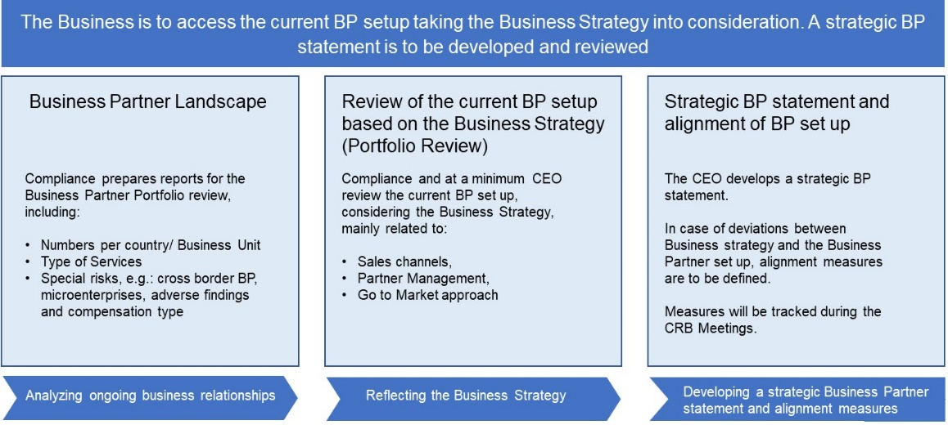

### B.2.1. Current Business Partner landscape

To facilitate the discussions, comprehensive information on all Business Partners should be obtained and include:

* number of Business Partners, risk profile, type of services, service country, special risks e.g. cross border business, microenterprise, compensation type, adverse findings.
* For specific high-risk partners: generated business versus commissions paid.

### B.2.2. Future Business Strategy

The future business strategy must be obtained by the Compliance Officer from the responsible CEO / Strategy Team / Business Development and would typically include details on:

* actual and potential new markets / portfolio;
* impact of changes in country specific political/economic outlook;
* particular customers, product line, geographical area, niche market, etc.;
* business areas most likely to require Business Partner support based on sales channel / go to market strategy.

|  |
| --- |
| **Example questions that Compliance may ask the Business:**  Does the current Sales Agent set-up reflect the sales channel strategy overall and/or in the respective countries?  Does the Business Partner portfolio support the go to market approach related to Markets, Regions, Business Segments?  Do you see future changes in the business model that might impact the Business Partner portfolio, for example:   * + new markets to be tapped using support from a Business Partner,   + termination of non-performing businesses in certain countries,   + decisions to change from an internal to an external sales force;   + M&A activities? |

### B.2.3. Strategic statement

The key deliverable of the Portfolio Review is the Strategic Business Partner statement of the CEO.

The actual strategic statements of the Siemens entities can be found here: [Business Partner Portfolio & Strategy Review](https://findit.compliance.siemens.com/content/10000101/Compliance/CL_CO/L_CO_OM/findIT_L_CO_OM_4992.pdf). The result of the respective workshop / statement is to be shared with the assigned countries and respective BUs.

## B.3. Global Business Partners

For certain Business Partners including their subsidiaries a **centralized CDD** is valid for all Siemens entities (“Global Business Partners”). For the work scope covered in a due diligence for a Global Business Partner and its subsidiaries, **no** **local CDDs needs to be performed**.

**Local** **contracts** with the Global Business Partner and its listed subsidiaries will not require binding contract provisions if a central frame contract including binding contract provisions exists and reference to this frame contract is made.

**CDDs** for Global Business Partners are flagged with a special symbol (a globe) in the [CDD-Tool](https://compliance-tools.siemens.com/due-diligence/) and can be used by all Siemens entities.

A new Global Business Partner can be nominated to LC CO RFC by the respective department and must be confirmed by Head of LC CO RFC.

In detail:

**Compliance Due Diligence**

For the Global Business Partner **Parent Company**, the respective Siemens entity must perform a high risk CDD. No separate questionnaires exist in the [CDD Too](https://compliance-tools.siemens.com/due-diligence/)l. However specific guidance (C.2.2.4.) has to be followed.

A Compliance expert session with the Business Partner has to be conducted by the Compliance Officer to exchange and obtain more information in relation to its corporate direction and past activities to ensure there is no historic, legal or compliance issues and a sound basis for the integrity of its business activities in its headquarters and subsidiaries.

The Global Business Partner incl. all listed subsidiaries must be checked against SETIS. The approval follows the standard approval process except the Compliance Approval, which always must be done by the Head of LC CO RFC CU.

**Contracts**

Mandatory binding contracts provisions must be accepted and form part of a contract with the contracting party, either

* as part of a **global framework agreement** and a reference to it in the local engagement letter or
* as part of each **individual contract** if no global framework exists.

For any deviations the standard escalation process has to be followed (B.5.5.). The global framework agreement needs to be registered in the [CDD Too](https://compliance-tools.siemens.com/due-diligence/)l. All individual contracts must be registered by the respective business responsible under the CDD for the Global Business Partner. Compliance Officers shall monitor the conclusions of individual contracts e.g. via the [LoA process](https://webbooks.siemens.com/public/LC/chen/index.htm?n=Part-2-Business-Perspective,H.-Compliance-in-Business-Processes-and-Projects,1.-Compliance-in-Project-Business) to assure correct registration in time.

**New or modified subsidiaries**

To add further subsidiaries, the Compliance Officer responsible for the CDD, must be contacted. The Questionnaire for new or modified subsidiaries (according to the type, see following chapters) must be filled and necessary documents, information and confirmations relating to the new / changed subsidiary must be gathered.

The list of Global Business Partners including subsidiaries has to be adjusted and forwarded to LC CO PT CO or publication on the [CDD Homepage](https://intranet.siemens.com/en/compliance/topics-tools/business-partner.htm).

**Update**

The Update of a CDD must cover the worldwide Siemens business of all subsidiaries of the Global Business Partner.

**Information Letter / Consent Form of subsidiaries**

The Information Letter / Consent Form requirements (C.5.2.2.) need to be considered according to the rules of the country of a subsidiary, if personal data (e.g. information about material litigation) is obtained from Key Persons or Key Employees.

Further information is available in the following supporting documents:

* [“Discussion Guide” for Compliance Expert Session](https://findit.compliance.siemens.com/content/10000101/Compliance/LC_CO/LC_CO_STR_RM/findIT_LC_CO_STR_RM_5173.doc)
* [“Company List”](https://findit.compliance.siemens.com/content/10000101/Compliance/LC_CO/LC_CO_STR_RM/findIT_LC_CO_STR_RM_5174.xlsx)
* [“Guideline on Interpretation” of the Due Diligence Questionnaire for Global Business Partners](https://findit.compliance.siemens.com/content/10000101/Compliance/LC_CO/LC_CO_STR_RM/findIT_LC_CO_STR_RM_5175.xlsx)
* [“CDD-Questionnaire” for new/additional subsidiaries](https://findit.compliance.siemens.com/content/10000101/Compliance/LC_CO/LC_CO_STR_RM/findIT_LC_CO_STR_RM_5176.xlsx)
* Release documents [for Global Logistics Service Providers](https://findit.compliance.siemens.com/content/10000101/Compliance/LC_CO/LC_CO_STR_RM/findIT_LC_CO_STR_RM_5172.doc)

**Please note**: The so-called “whitelisting process” for EPCs without Red Flags (formerly described in section 3.3.3.4.) was discontinued as of 1 October 2020, as the whitelisted EPCs were Business Partners mainly of Siemens Energy business. It was not necessary to maintain the process for Siemens AG.

## B.4. Compliance onsite check

A compliance onsite check is an **onsite review** at the premises of the Business Partner to identify potential compliance risks. It includes a face to face discussion with the Business Partner, ideally at their offices/premises. supporting an assessment and judgment of the appropriateness and suitability of the Business Partner to work with Siemens.

There are **two types** of Compliance checks:

* **Initial check of a proposed Business Partner**

The initial compliance onsite check is a mandatory preventive measure in the Business Partner Due Diligence process. It must be performed prior to the approval of the CDD and formalization of the relationship with the Business Partner.

Based on the following criteria the [CDD-Tool](https://compliance-tools.siemens.com/due-diligence/) will after the risk assessment automatically determine, the requirement for a mandatory initial onsite check for Sales related Intermediaries (A.1.1.) with a high risk CDD:

* + The Business Partner is located in a **medium or high-risk country** outside the country of the contracting Siemens entity and/or
  + The Business Partner country is **not the country where the services are provided** (but only if at least one of the countries is a high-risk country

This onsite check is a onetime event (regardless of the number of active CDDs for the Business Partner).

* **Ad hoc check of an existing Business Partner**

The ad hoc compliance onsite check is a voluntary detective measure (e.g. as result of monitoring observations) on an existing Business Partner to identify and mitigate potential compliance risks arising from the existing relationship.

### B.4.1. Roles and Responsibilities

The Compliance Officer of the Siemens entity who wants to engage the Business Partner is responsible that the check is undertaken. The compliance onsite check is performed by the Compliance organization that is responsible for the country where the Business Partner is located.

For exceptional cases (e.g. the Business Partner is located in a country with no Siemens presence) the compliance check and/or due diligence can be outsourced to external service providers.

The Siemens business representative is responsible to provide all the relevant available information for the preparation of the compliance check and for the communication with the Business Partner.

The Siemens business representative will be invited to join the onsite check. His or her participation on the onsite review is recommended, not mandatory.

### B.4.2. Process

The Compliance onsite check consists of three steps: preparation, execution and reporting.

#### B.4.2.1. Preparation

The person from the Compliance organization who performs the check (**Compliance Check Performer)** gathers all relevant information concerning the Business Partner from the [CDD-Tool](https://compliance-tools.siemens.com/due-diligence/), including the CDD (or CDDs if more than one active) and use the [Excel-Template Preparation Tool](https://findit.compliance.siemens.com/content/10000101/Compliance/CL_CO/CL_CO_P/findIT_CL_CO_P_4166.xlsx).

The Compliance Check Performer organizes an initial discussion for preparation of the Compliance Check with the Siemens Business representative.

Important topics for discussion with the Business representative:

* business rationale to hire the Business Partner;
* size of the Business Partner organization (including number of employees and other resources)
* scope of service;
* contractual conditions (including remuneration) and performance;
* potential representatives from the Business Partner side who should attend the onsite visit[25];
* Possible compliance risks (e.g. resulting from media information or connected to the future business).

For checks on existing Business Partners, there might be several CDDs involving different Siemens AREs. An internal alignment with all relevant AREs (respective Business representatives) must be performed by the Compliance Check Performer to identify the most appropriate person from business that should coordinate the communication and potentially join the onsite review.

Align with the Business representative the preparation and execution, including participants, timing, communication protocol with the Business Partner and the agenda for the meeting with the Business Partner.

A sample Announcement Letter [template](https://findit.compliance.siemens.com/content/10000101/Compliance/CL_CO/CL_CO_P/findIT_CL_CO_P_4164.docx) is available to assist in the communication of the request for a compliance check to the Business Partner - its use is not mandatory. Not all the topic considered in the Preparation Tool would be applicable or appropriate considering the Business Partner size and nature. It shall be used as guidance only for a customized discussion. Additional topics can be considered.

#### B.4.2.2. Execution

There is no requirement concerning the duration or format but shall be decided based on what would be appropriate under the circumstances[26]. The Onsite Check should be used for the Business Partner training.

#### B.4.2.3. Reporting

A report in English (or a reliable translation) has to be prepared by the Compliance Check performer.

The report must be prepared using the Executive Summary template as well as the Appendix 1 – Detailed Report template provided in the Compliance Check Performance Tool Excel file. The Appendix 1 template is available in both [Excel](https://findit.compliance.siemens.com/content/10000101/Compliance/CL_CO/CL_CO_P/findIT_CL_CO_P_4166.xlsx) and [Word](https://findit.compliance.siemens.com/content/10000101/Compliance/CL_CO/CL_CO_P/findIT_CL_CO_P_4167.docx).

The content of the report and the result of the compliance check need to be aligned with the involved Compliance stakeholders. There should be no disparity of opinion about the result of the Compliance Check between the relevant Compliance stakeholders.

The final version of the report should be distributed to the Compliance stakeholders and uploaded in the [CDD-Tool](https://compliance-tools.siemens.com/due-diligence/) as audit result (Alerts & Audit Results in the Business Partner key data section).

The report should not be shared with the Business Partner.

#### B.4.2.4. Results

The result of the Compliance Check can be:

* **Positive** → No concerns identified.
* **Positive with Reservations** → ‘Reservations’ are concerns that are not substantial to our decision to continue working with the Business Partner. Those reservations are not material or are easily remediated (i.e., potential shortcomings on their books and records or minor concerns about Business Partner internal processes). Such ‘Reservations’ do not affect the positive nature of our assessment and we consider the Business Partner suitable to continue working with Siemens.

In case reservations are noted, required follow-up actions may be defined by the responsible Compliance Officer and documented in the Executive Summary and in Appendix 1 – Detailed report.

* **Negative** → Material, compliance related concerns were detected that may require withdrawal from the proposed relationship or termination of contractual relationship.

For cases with a negative result the Compliance communicate the results of the check to the Siemens business counterparts. Disagreements should be escalated to the Chief Compliance Officer for decision.

#### B.4.2.5. Supporting documents

[Word-Template Exemplar Announcement Letter](https://findit.compliance.siemens.com/content/10000101/Compliance/CL_CO/CL_CO_P/findIT_CL_CO_P_4164.docx)

[Excel-Template Preparation Tool](https://findit.compliance.siemens.com/content/10000101/Compliance/CL_CO/CL_CO_P/findIT_CL_CO_P_4166.xlsx)

[Word-Template Reporting](https://findit.compliance.siemens.com/content/10000101/Compliance/CL_CO/CL_CO_P/findIT_CL_CO_P_4167.docx)[27]

## B.5. Contract Provisions

The aim of the Binding Contract Provisions is to:

* obligate the Business Partner to adhere to the applicable laws and regulations in the area of anti-corruption, antitrust and other regulations related to “white-collar crime”,
* allow Siemens the right to terminate the agreement – and, if possible, other agreements with the same Business Partner – in the event of a violation of these provisions,
* prevent cash payments and other potentially insecure methods of payment which may serve to transfer funds for illicit purposes, and
* allow Siemens (in high and medium risk cases) to perform audits in the event that Siemens has reason to believe that a breach of the Compliance provisions by the Business Partner has occurred, or in case internal assessments indicate a potential corruption risk that Siemens would need to address.

The provisions must be included into the agreement in accordance with the relevant risk level of the CDD.

|  |
| --- |
| There are different versions of the Binding Contract Provisions for different types of Business Partner as well as different risk levels (low/medium/high):   * **Standard Contract Provisions for Intermediaries and Resellers with Red Flags** (click here for [English (May 2018)](https://findit.compliance.siemens.com/content/10000101/Compliance/LC_CO/LC_CO_RG_PL/findIT_LC_CO_RG_PL_3729.docx), other languages see B.5.1.) * Contract Provisions for **Value-add Resellers / EPC with Red Flags** (B.5.2.); * Contract Provisions for **Cooperation/Consortium Partners** (B.5.3.); * Compliance Declaration for **Custom Agents** without a written contractual agreement (B.5.4.). |

The Company Unit concerned is responsible for its contracts with Business Partners and must involve the legal department. Contracts must include the Binding Contract Provisions. Any deviations of contract provisions must be approved by Legal (B.5.5).

**Please note**:

In the case of renegotiation of a contract, the most updated compliance provisions must be used. If the provisions used in the contract are stricter than the latest version of Compliance provisions, there is no need to renegotiate. The protection of Siemens is ensured.

In case of doubts, please contact your Compliance Officer or Legal Counsel.

### B.5.1. Standard Contract Provisions

The **Standard Contract Provisions** for all **Intermediaries** and those **Resellers who have Red Flags** (Version May 2018) can be found here:

|  |  |  |
| --- | --- | --- |
| **[English (May 2018)](https://findit.compliance.siemens.com/content/10000101/Compliance/LC_CO/LC_CO_RG_PL/findIT_LC_CO_RG_PL_3729.docx)** | [**German (May 2018)**](https://findit.compliance.siemens.com/content/10000101/Compliance/LC_CO/LC_CO_RG_PL/findIT_LC_CO_RG_PL_3738.docx) |  |
| [**Arabic (May 2018)**](https://findit.compliance.siemens.com/content/10000101/Compliance/LC_CO/LC_CO_RG_PL/findIT_LC_CO_RG_PL_3730.odt) | [**Bosnian (May 2018)**](https://findit.compliance.siemens.com/content/10000101/Compliance/LC_CO/LC_CO_RG_PL/findIT_LC_CO_RG_PL_3733.docx) | [**Brazil**](https://findit.compliance.siemens.com/content/10000101/Compliance/LC_CO/LC_CO_RG_PL/findIT_LC_CO_RG_PL_3732.docx)**ian (May 2018)** |
| [**Bulgaria**](https://findit.compliance.siemens.com/content/10000101/Compliance/LC_CO/LC_CO_RG_PL/findIT_LC_CO_RG_PL_3734.docx)**n (May 2018)** | [**Chinese**](https://findit.compliance.siemens.com/content/10000101/Compliance/LC_CO/LC_CO_RG_PL/findIT_LC_CO_RG_PL_4185.zip) **(May 2018)** | [**Croatia**](https://findit.compliance.siemens.com/content/10000101/Compliance/LC_CO/LC_CO_RG_PL/findIT_LC_CO_RG_PL_3735.docx)**n (May 2018)** |
| [**Czech (May 2018)**](https://findit.compliance.siemens.com/content/10000101/Compliance/LC_CO/LC_CO_RG_PL/findIT_LC_CO_RG_PL_7656.docx) | [**Dutch (May 2018)**](https://findit.compliance.siemens.com/content/10000101/Compliance/LC_CO/LC_CO_RG_PL/findIT_LC_CO_RG_PL_8393.docx) | [**French (May 2018)**](https://findit.compliance.siemens.com/content/10000101/Compliance/LC_CO/LC_CO_RG_PL/findIT_LC_CO_RG_PL_3753.docx) |
| [**Gree**](https://findit.compliance.siemens.com/content/10000101/Compliance/LC_CO/LC_CO_RG_PL/findIT_LC_CO_RG_PL_3739.docx)**k (May 2018)** | [**Hungarian**](https://findit.compliance.siemens.com/content/10000101/Compliance/LC_CO/LC_CO_RG_PL/findIT_LC_CO_RG_PL_3740.docx) **(2018)** | [**Italian (May 2018)**](https://findit.compliance.siemens.com/content/10000101/Compliance/LC_CO/LC_CO_RG_PL/findIT_LC_CO_RG_PL_7448.docx) |
| [**Polish (2018)**](https://findit.compliance.siemens.com/content/10000101/Compliance/LC_CO/LC_CO_RG_PL/findIT_LC_CO_RG_PL_8392.docx) | [**Romanian (May 2018)**](https://findit.compliance.siemens.com/content/10000101/Compliance/LC_CO/LC_CO_RG_PL/findIT_LC_CO_RG_PL_3746.docx) | [**Russian (May 2018)**](https://findit.compliance.siemens.com/content/10000101/Compliance/LC_CO/LC_CO_RG_PL/findIT_LC_CO_RG_PL_8755.doc) |
| [**Serbian (May 2018)**](https://findit.compliance.siemens.com/content/10000101/Compliance/LC_CO/LC_CO_RG_PL/findIT_LC_CO_RG_PL_3747.docx) | [**Spanish (May**](https://findit.compliance.siemens.com/content/10000101/Compliance/LC_CO/LC_CO_RG_PL/findIT_LC_CO_RG_PL_3750.docx) **2018)** | [**Slovakia**](https://findit.compliance.siemens.com/content/10000101/Compliance/LC_CO/LC_CO_RG_PL/findIT_LC_CO_RG_PL_3748.docx)**n (May 2018)** |
| [**Slovenian (May 2018)**](https://findit.compliance.siemens.com/content/10000101/Compliance/LC_CO/LC_CO_RG_PL/findIT_LC_CO_RG_PL_3749.docx) | [**Swiss**](https://findit.compliance.siemens.com/content/10000101/Compliance/LC_CO/LC_CO_RG_PL/findIT_LC_CO_RG_PL_3759.zip) **(May 2018)** | [**Turkish (May 2018)**](https://findit.compliance.siemens.com/content/10000101/Compliance/LC_CO/LC_CO_RG_PL/findIT_LC_CO_RG_PL_7836.pdf) |
| [**Ukrainian (May 2018)**](https://findit.compliance.siemens.com/content/10000101/Compliance/LC_CO/LC_CO_RG_PL/findIT_LC_CO_RG_PL_3751.doc) |  |  |

The above listed adoptions are only translations of the English version into local language, for detailed information please consult with the respective General Counsel.

### B.5.2. Value-add Resellers with Red Flags

Contracts with Value-add Resellers (e.g. EPC, OEM, System Integrators”) should at least include sections **1.1, 1.2** and **6.1** of the Global Binding Contract Provisions of the applicable language version as mutual obligation.

Based on the concrete business relationship, additional contractual safeguards (e.g. additional clauses of the Standard Contract Provisions, (B.5.1.) shall be considered and aligned between the responsible Legal Counsel and Compliance Officer.

If there is disagreement or the contracting party refuses to include certain compliance clauses, Compliance should involve the responsible Legal colleague for further alignment.

If it is not possible to amend the contract or to propose a Compliance provision at the time of the offer (for example in case of a public tender), a **wording of the general content** as described below shall be included with the offer.

*“Integrity is part of the values of both of our companies. For this very reason we shall have comprehensive clauses covering compliance aspects in our contract. For us this is a condition precedent for the validity of our offer and we are looking forward agreeing with you on this.”*

During contract negotiations, the responsible Siemens entity shall then strive to include a Compliance provision as proposed above.

### B.5.3. Cooperation / Consortium Partner

[Compliance Provisions for Consortium Agreements](https://findit.compliance.siemens.com/content/10000101/Compliance/CL_CO/L_CO_OM/findIT_L_CO_OM_4840.docx) (English/German)

[Compliance Provisions for Consortium Agreements (Czech)](https://findit.compliance.siemens.com/content/10000101/Compliance/LC_CO/LC_CO_RG_PL/findIT_LC_CO_RG_PL_7331.docx)

The provisions are already integrated in the relevant model agreements provided on the Legal homepage:

[Consortium Agreements](https://intranet.for.siemens.com/org/lc/en/legal/templates/cooperation/Pages/cooperation_consortium.aspx)

### B.5.4. Customs Agents

If no contractual agreement with a customs agent exists, the respective “Compliance Declaration by Customs Agent” must be signed by the Business Partner.

[Customs Agents declaration with respect to Siemens Business Partner](https://findit.compliance.siemens.com/content/10000101/Compliance/LC_CO/LC_CO_RG_PL/findIT_LC_CO_RG_PL_4072.docx) (English) ([German](https://findit.compliance.siemens.com/content/10000101/Compliance/LC_CO/LC_CO_RG_PL/findIT_LC_CO_RG_PL_4069.docx)) [(Italian)](https://findit.compliance.siemens.com/content/10000101/Compliance/LC_CO/LC_CO_RG_PL/findIT_LC_CO_RG_PL_8360.docx) [(Czech)](https://findit.compliance.siemens.com/content/10000101/Compliance/LC_CO/LC_CO_RG_PL/findIT_LC_CO_RG_PL_7333.docx)

Please refer also to the [Broker Processing and Clearance process of CF T](https://intranet.for.siemens.com/wll/0087/en/cu-org/ext/brpc/Pages/tab.aspx).

### B.5.5. Deviation process

Deviations of the Binding Contract Provisions require the approvals as described below. In general, two situations are treated differently, deviations

* in model contracts which are designed for multiple use by Siemens and such
* in individual contracts where the Binding Contract Provisions as provided here or the compliance provisions of a Siemens model contract are planned to be adjusted for a specific contractual relationship.

#### B.5.5.1. Deviations in model contracts

Binding Contract Provisions need to be included into every model contract intended for the use in Business Partner relationships. In general, no deviations of the model clauses shall be made. However, if legal requirements of a certain jurisdiction require adaptations e.g. in local model contracts (for individual contracts see B.5.5.2.) adaptions are possible. If changes to the contract provisions are considered material changes by the Legal Counsel, the following approval process applies:

**Low and medium risk clauses**

For “low risk” and “medium risk” model contracts, changes to the [Binding Contract Provisions](https://findit.compliance.siemens.com/content/10000101/Compliance/LC_CO/LC_CO_RG_PL/findIT_LC_CO_RG_PL_3729.docx) need to be approved by LC CO RFC LF. Therefore, the General Counsel as well as the Compliance Officer need to prepare a track changes document comparing the English version of the global “[Binding Contract Provisions](https://intranet.siemens.com/en/compliance/topics-tools/supporting-documentation.htm)” with an English version of the Binding Contract Provision of the respective country indicating the proposed changes and explaining the adaptation including a reference to the exact paragraph of the law requiring the adaptation (if any).

**High risk clauses**

For all changes in “high risk” model contracts, proposed changes of the “[Binding Contract Provisions](https://findit.compliance.siemens.com/content/10000101/Compliance/LC_CO/LC_CO_RG_PL/findIT_LC_CO_RG_PL_3729.docx)” need to be additionally approved by the superior to the General Counsel as well as the Compliance Officer (e.g. on Corporate / Lead Country level) prior to submitting the request to LC CO RFC LF.

For changes of audit rights in local “high risk” model contracts, LC CO RFC LF needs further approval by the Chief Compliance Officer.

#### B.5.5.2. Deviations in individual contracts

For any deviation to the Binding Contract Provisions or approved deviating model clauses (according to the deviation process in B.5.5.1.) that the negotiating Legal Counsel intends, the following approval processes apply:

**Low and medium risk clauses**

For “low risk” and “medium risk” contracts, the negotiating Legal Counsel himself is responsible for approving changes.

**High risk clauses**

For all deviations in “high risk” contracts, except for only editorial changes, the negotiating Legal Counsel has to obtain an approval of the responsible Business/Lead Country General Counsel, or the Head of the Corporate Legal Department after alignment with the Compliance Officer.

The Compliance Officer and the Legal Counsel must prepare a template to document and explain the changes. The Compliance Officer will be able to download this template from the [CDD Too](https://compliance-tools.siemens.com/due-diligence/)l.

For changes of audit rights in “high risk” contracts, a further approval of the Chief Compliance Officer is to be obtained by the approving General Counsel by forwarding the aforementioned template (with additional remarks if necessary) to the following e-mail-address for approval: [businesspartner_consultation.legal-compliance@siemens.com](mailto:businesspartner_consultation.legal-compliance@siemens.com).

The approval needs to be uploaded in the [CDD Too](https://compliance-tools.siemens.com/due-diligence/)l by the Compliance Officer.

### B.5.6. Code of Conduct

For every risk level, the [Code of Conduct for Siemens Suppliers and Third Party Intermediaries](https://findit.compliance.siemens.com/content/10000101/Compliance/LC_CO/LC_CO_STR_RM/findIT_LC_CO_STR_RM_8757.pdf) has to be attached to the contract.

For more information please see [Procurement Standards - Download center](https://intranet.for.siemens.com/cms/050/en/processes/jobrole/Pages/downloadcenter.aspx) or [SCM Homepage](https://new.siemens.com/global/en/company/about/corporate-functions/supply-chain-management.html).

## B.6. Additional mitigation measures

### B.6.1. Under Observation

Every Compliance Officer is entitled to flag a Business Partner with the “under observation” alert in the Business Partner Key Section.

Flagging as “under observation” means that a Business Partner could have valid CDDs, but additional measures are necessary to control and/or monitor a risk. It is of particular importance to describe the reasons for the flag very clearly and fully detailed.

The Compliance Officer, who enters the alert is responsible to keep the entry updated. The responsibility also includes the organization that all CDDs for this Business Partner consider the alert and align on a harmonized handling.

Further details are explained in this [guidance](https://findit.compliance.siemens.com/content/10000101/Compliance/LC_CO/LC_CO_DF/findIT_LC_CO_DF_10076.pdf).

How to set the "under observation” alert in the tool is explained under C.2.2.6.

### B.6.2. Disapproval / Alert & Audit

In the worst case, a Business Partner could also be “**Centrally disapproved**” (see chapter C.2.2.6. and C.5.1.3.). For specific Business Partners mandatory or voluntary audits may have been performed. Results of audits should be taken into consideration for the evaluation.

### B.6.3. Information sharing

When taking his or her position, the head of a Siemens unit shall discuss high risk Business Partners in the Compliance Review Boards or any corresponding meeting. The outcome shall be documented in the minutes. The Compliance Officer shall actively assist the head of the Siemens unit in such review.

### B.6.4. Breaches of Siemens Group Code of Conduct for Suppliers and Third Party Intermediaries

Further information can be found on the respective [SCM homepage.](https://intranet.for.siemens.com/cms/059/en/processes/publications/Pages/compliance_procurement.aspx?tabcardno=1-1)

## B.7. Specifics for certain Siemens units

Due to its specific risk structure, certain Siemens units require a tailored approach. Such **specific regulations** must be **approved** by the management and the Compliance Management Council (CMC).

It is the **responsibility** of the respective Management to align specific requirements with other units to cross-check whether or not similar requirements exist and to conduct an impact analysis (e.g. how many additional Business Partners will be in scope due to the specific regulation) before the approval.

An overview of the current specifics can be found in section A.8.

## B.8. Business Partner Dashboard

The [Business Partner Dashboard](https://dashboard.compliance.siemens.com/) is available only for Compliance employees. It combines data analytics together with data visualization to identify potential risks and quality issues and to support reporting.

## B.9. Supporting material

**Compliance Country Ratings**

Transparency International publishes the [Corruption Perception Index](https://www.transparency.org/research/cpi/overview) (TI/CPI) regularly. Based on these ratings and a risk evaluation by LC CO, the Compliance Country Ratings (low/medium/high) are determined and shown in this [country list with risk ratings](https://findit.compliance.siemens.com/content/10000101/Compliance/LC_CO/LC_CO_STR_RM/findIT_LC_CO_STR_RM_8266.pdf).

The threshold values are:

* High-risk countries are countries with a rating ≤ 42
* Medium-risk countries are countries with a rating ≥ 43 and ≤ 66
* Low-risk countries are countries with a rating ≥ 67

**Company registers**

To properly identify Business Partners and get certain basic information about them, a lot of countries offer online company registers.

European [Business Register](http://www.ebr.org/index.php/information-distributors/)

Germany - [Unternehmensregister](https://www.unternehmensregister.de/ureg/)

UK [Companies House](https://www.gov.uk/government/organisations/companies-house)

Please feel free to suggest other useful official registers or public sources to be displayed here.

**U.S. Securities and Exchange Commission**

The [SEC internet page](https://www.sec.gov/litigation.shtml) provides information on SEC enforcement actions, opinions issued by the Commission, briefs filed by SEC staff, trading suspensions, and notices concerning the creation of investors claims funds in specific cases.

**Micro-enterprises**

A short supporting document who to handle micro-enterprises could be found [here](https://findit.compliance.siemens.com/content/10000101/Compliance/LC_CO/LC_CO_DF/findIT_LC_CO_DF_10074.pdf).

## B.10. Business Partner Network

The Business Partner Network is a global team of individuals with varying degrees of Compliance Business Partner expertise who have a real interest and passion for the topic and can work collaboratively for the benefit of the entire organization. The general goal is to support the Compliance Community in all aspects related to Business Partner’s topics.

The BP Network consists of several workstreams:

| **Workstream** | **Organized by** |  |
| --- | --- | --- |
| Procedures enhancement | [Christina Wolfgramm](https://scd.siemens.com/luz/IdentitySearch?tcgid=Z002BPMD)and [Helge Seefeld](https://scd.siemens.com/luz/IdentitySearch?tcgid=ZZZZZOPZ) | [more](https://intranet.for.siemens.com/cms/059/en/processes/publications/Pages/compliance_bp_network.aspx?tabcardno=1&openPortlet=2) |
| Communication | [Sascha Bader](https://scd.siemens.com/luz/IdentitySearch?tcgid=Z000NEUS) | [more](https://intranet.for.siemens.com/cms/059/en/processes/publications/Pages/compliance_bp_network.aspx?tabcardno=1&openPortlet=3) |
| Knowledge development | [John Garred](https://scd.siemens.com/luz/IdentitySearch?tcgid=Z000SJTH) | [more](https://intranet.for.siemens.com/cms/059/en/processes/publications/Pages/compliance_bp_network.aspx?tabcardno=1&openPortlet=4) |
| Operational activities | [Peter Lohse](https://scd.siemens.com/luz/IdentitySearch?tcgid=Z00079UT) | [more](https://intranet.for.siemens.com/cms/059/en/processes/publications/Pages/compliance_bp_network.aspx?tabcardno=1&openPortlet=5) |
| Reporting | [Sascha Bader](https://scd.siemens.com/luz/IdentitySearch?tcgid=Z000NEUS) | [more](https://intranet.for.siemens.com/cms/059/en/processes/publications/Pages/compliance_bp_network.aspx?tabcardno=1&openPortlet=6) |
| Quality | [John Garred](https://scd.siemens.com/luz/IdentitySearch?tcgid=Z000SJTH) | [more](https://intranet.for.siemens.com/cms/059/en/processes/publications/Pages/compliance_bp_network.aspx?tabcardno=1&openPortlet=7) |
| Consultation | [Peter Lohse](https://scd.siemens.com/luz/IdentitySearch?tcgid=Z00079UT) | [more](https://intranet.for.siemens.com/cms/059/en/processes/publications/Pages/compliance_bp_network.aspx?tabcardno=1&openPortlet=8) |

Sponsors are Sandra Scherm (LC CO DI) and Carla Dalrymple (LC CO PT).

Details can be found [here.](https://intranet.for.siemens.com/cms/059/de/processes/publications/PublishingImages/Compliance/click_auf_die_Rakete.pdf)

## B.11. Contacts

Questions regarding the CDD process and legal aspects as well as process improvements can also be discussed directly with the responsible persons in the HQ:

* Helge Seefeld, LC CO PT CO; E-Mail: [helge.seefeld@siemens.com](mailto:helge.seefeld@siemens.com)
* Christina Wolfgramm, LC CO RFC LF; E-Mail: [christina.wolfgramm](mailto:helge.seefeld@siemens.com)[@siemens.com](mailto:schmidandrea@siemens.com)

Technical questions concerning [CDD-Tool](https://compliance-tools.siemens.com/due-diligence/) can be answered by IT Hotline, generally available from 9 a.m. to 5 p.m. CET (Monday – Friday) except public holidays in Germany / Bavaria). Supported languages: German and English. E-mail: [bpc-tool.cit@siemens.com](mailto:bpc-tool.cit@siemens.com), Phone: +49 (89) 636-31436, Fax: +49 (89) 636-35893.

## B.12. History of changes

|  |  |  |
| --- | --- | --- |
| **Version / Date** | **Author** | **Major changes** |
| Business Partner Web-Book Version 2.0  May 28, 2018 | Laszlo Nagy  Henning Tabbert | **1.2** Business Partner categories updated and redefined, new categories of Intermediaries and Resellers, scope of Value-add Resellers consolidated;  **1.3** Due Diligence chapter and roles and responsibilities adjusted according to new Due Diligence Tool process;  **1.3.4** Information Letter / Consent form requirements updated;  **1.4.1** Standard Contract Provisions updated;  **1.5** Monitoring chapter and roles and responsibilities adjusted according to new Due Diligence Tool process;  **1.5.5** Additional language versions of Audit and Books & Records Flyer;  For details, please also see [Redline Version](https://findit.compliance.siemens.com/content/10000101/Compliance/LC_CO/LC_CO_RG_PL/findIT_LC_CO_RG_PL_7266.pdf) of the former Business Partner Webbook (2017-12) compared to Version 2.0 (2018-05-28). |
| Business Partner Web-Book Version 2.0  July 4, 2018 | Laszlo Nagy  Henning Tabbert | No material changes, merely added information, translations and clarifications:  **1.2.1.3** Information on DOJ Settlement added  **1.3.3** SETIS / Internet Search clarified  **1.3.4** Countries requiring Consent Forms added  **1.3.8.1** Clarification regarding approval of Sales related Intermediaries with success related compensation  **1.4.1.1** French, Chinese and Czech Version of Contract Provisions added  **1.3.7** Clarifications regarding monitoring process  **2.** Information on data migration from Intranet site also added to Webbook |
| January 1, 2019 | Laszlo Nagy  Henning Tabbert | Integration of former Business Partner Webbook in new Compliance Handbook |
| April 1, 2019 | Laszlo Nagy  Henning Tabbert | Implementation of new Company Structure  Preparations for the integration of CDD-Tool user manual in chapters 3.3.1. and 3.3.2 |
| June 4, 2019 | Laszlo Nagy  Henning Tabbert | Update of Chapter 3.3.1_CDD-Tool; general information and 3.3.2_CDD Process |
| July 1,2019 | Laszlo Nagy  Henning Tabbert  Laura Göller  Isadora Burgard-Torres | Technical user handbook integrated in Chapter 3.3.1_CDD-Tool; general information and 3.3.2_CDD Process |
| October 1, 2019 | Henning Tabbert  Laura Göller  Isadora Burgard-Torres | Update due to organizational changes  Update Chapter 3.3.2.6. Monitoring and Monitoring Principles (interim monitoring process) |
| January 1, 2020 | Laura Göller  Isadora Burgard-Torres | Update of Chapter 3.3.2.4.7 automatic SETIS Searches and Chapter 3.3.2.4.10 High Risk approvals of CMC member (or designated deputy) |
| March 1, 2020 | Koen Miezenbeek  Henning Tabbert, Sedat Tuna | Italy removed from countries that require Consent form (3.3.2.3.10)  Update in Chapter 3.2.6.1. Current Company specific scope: SFS COF. Specific guidelines for Intermediaries of SFS COF. |
| April 1, 2020 | Christina Wolfgramm,  Helge Seefeld,  Yvonne Hamm-Düppe | Update in Chapters 3.3.2.4.10/3.3.1.1:  Chapter 3.3.2.4.10 High risk approval only of CMC members, no designated deputy any more  Chapter 3.3.2.4.10.1. Special CDD - approval requirements (Letterbox companies, High risk Microenterprises with significant Government interaction, Lobbyists, Sales-related Intermediaries with success related compensation) is deleted  Chapter 3.3.2.4.10.2. How to handle CDDs which require CMC Approval in the CDD-Tool is deleted  Chapter 3.3.2.4.10.3 Management Approval becomes Chapter 3.3.2.4.10.1  Chapter 3.3.2.4.10.4 Withdrawal of a CDD becomes Chapter 3.3.2.4.10.2 Withdrawal of an Approval or Disapproval |
| June 1, 2020 | Helge Seefeld,  Soeren Kupich  Koen Miezenbeek | Chapter 3.3.1.1: Role description “Monitoring Responsible” deleted due to introduction of new CDD Update Process  Chapter 3.3.1.5: Adjustments due to introduction of new CDD Update Process  Chapter 3.3.1.6: Adjustments due to introduction of new CDD Update Process  Chapter 3.3.2.6: Revision due to the introduction of the CDD Update Process  Chapter 3.3.2.6.1: Revision due to the introduction of the CDD Update Process  Chapter 3.3.2.6.2: chapter deleted due to the introduction of the CDD Update Process Siemens Real Estate changed to “Real Estate Unit” to include carved out units real estate units.  Chapter 3.5. CO Review Guidance added |
| October 1, 2020 | Christina Wolfgramm,  Helge Seefeld, | 1. All chapters:   **Organizational changes**   1. All chapters:   The Business Partner chapter has been **completely revised and restructured**. Now, the three **user-oriented** parts focus on  A. Business users,  B. Legal & Compliance users,  C. Tool users.  They provide a short and concise documentation that covers specific areas of interest.  Many sections have been massively **shortened**, **simplified, and supplemented with explanations.**   1. Chapter: A.1., A.1.3.   Chapter The **definition of "Integrity Concern**" among resellers has been rephrased. With this change, we reimplemented the old approach.   1. Chapter A.1.2.   As a result of the Fresh Eyes project, various **subgroups of Non-sales related Intermediaries** were removed from the scope of the NextGen tool. A comprehensive [overview with definitions and examples](https://findit.compliance.siemens.com/content/10000101/Compliance/LC_CO/LC_CO_DF/findIT_LC_CO_DF_9246.pdf) will be available in the corresponding chapter.   1. Chapter A.4.1.   Additional Section **“Biggest user principle"**   1. Chapter A.3.2.   New section with **recommendation for dealing with value-add reseller** that are out of scope but show massive red flags   1. Chapter: B.3.   The so-called "**whitelisting process**" for EPCs without Red Flags will be discontinued.   1. Chapter: C   **Update of tool description**  Data retention concept added |
| Jan 1, 2021 | Ch. Wolfgramm LC CO RFC LF, H. Seefeld LC CO PT CO | 1. List of Global Business Partners added under A.4.3. 2. Business Partner Dashboard information included in B.8. 3. Business Partner Network Information included in B.10. |
| Feb 2021 | Ch. Wolfgramm LC CO RFC LF, H. Seefeld LC CO PT CO | 1. A. 4.3. Global Business Partner: Hyundai Engineering Co Ltd taken out 2. C. Several instruction videos added |
| April 1, 2021 | Isadora Burgard-Torres LC CO RFC CU  P. Lohse LC CO DI | 1. A.4.3. Global Business Partner were revoked:    1. DSV Air & Sea Holding A/S” (DSV - BP ID 054477| CDD 0072178) and    2. F.H. Bertling International GmbH” (Bertling - BP ID 054558 | CDD 0084829) 2. B.6.1. (Under Observation) adapted and B.6.2. New Chapter: Disapproval/Alert & Audit; accordingly former B.6.2 (Information Sharing) became B.6.3. and former B.6.3. (Breaches of CoC) became B.6.4. |

# C. Relevance only for Tool Users (Tool description)

## C.1. Compliance Due Diligence (“CDD”) Tool information

### C.1.1. Roles and Responsibilities

Management is fully responsible for proper selection and monitoring of Business Partners on an ongoing basis and "owns" the Business Partner relationship.

The Siemens unit concerned with the retention and / or contractual relationship with a Business Partner is responsible for the creation of the CDD and to maintain the contractual relationship.

If more than one Siemens entity is a contractual party in one specific agreement (either Consortium or other three-party agreements), only one CDD is required. Responsible for performing the CDD is the Siemens unit (ARE) in the leading role.

The following roles and responsibilities apply:

* Business Roles

|  |  |
| --- | --- |
| **CDD Responsible** | **Performs** a **complete** and **accurate** Compliance **Due Diligence** for a relationship so that management and Compliance can make an informed review and approval decision.  Ad hoc update of a CDD in case of due diligence relevant changes of the business relationship and for a regular CDD updates every three years. |
| **Management Approver** | R**eviews all information** provided in the Compliance Due Diligence and CO Review and performs an **approval decision.** |
| **CDD Viewer** | S**ees all information/ data of a CDD** (same rights as ARE Viewer, but on CDD level) |

* Compliance Roles:

|  |  |
| --- | --- |
| **Compliance Reviewer** | **Performs a structured and documented CDD review**. |
| **Compliance Approver** | Checks **the conclusions of the Compliance Reviewer and performs a** Compliance approval for high risk CDDs. A Compliance Approver must be member of the **Compliance Management Council (CMC)** |

* Other Roles:

|  |  |
| --- | --- |
| **ARE Viewer** | Can **view** the content of all CDDs of a specific ARE. |

Business roles are maintained in the respective CDD see C.5.1.1.  
Compliance roles and other roles are maintained by Compliance in the roles management tool (SCROM).

### C.1.2. How to access the [CDD-Tool](https://compliance-tools.siemens.com/due-diligence/)

The [CDD-Tool](https://compliance-tools.siemens.com/due-diligence/) can be accessed from the [Compliance intranet page from the section Business Partners](https://intranet.for.siemens.com/cms/059/en/processes/publications/Pages/compliance_business-partner.aspx) or via:

* **CDD-Tool (Live System):**

[**https://compliance-tools.siemens.com/due-diligence/**](https://compliance-tools.siemens.com/due-diligence/)

If you want to get familiar with the tool and test creating a Business Partner or CDD, a testing system is available:

* **CDD-Tool Training System:**

<https://cl-tools-dev.compliance.siemens.com/BPC-QA/>

Please use the Google Chrome browser for the use of the [CDD-Tool](https://compliance-tools.siemens.com/due-diligence/). Information entered into the [CDD-Tool](https://compliance-tools.siemens.com/due-diligence/) must either be provided in English or German. If Business Partner outside Germany are involved, only English is to be used (e.g. if a HQ Operating company engages a Business Partner located outside Germany).

### C.1.3. CDD-Tool homepage and navigation menu

When opening the [CDD-Tool](https://compliance-tools.siemens.com/due-diligence/), you will start with “My Dashboard”.

The navigation menu can be found in the upper part of the tool and is divided into: *My Dashboard* / *Search* / *Checklist* / *Administration* (only visible for System Administrator.) and *My Settings*.

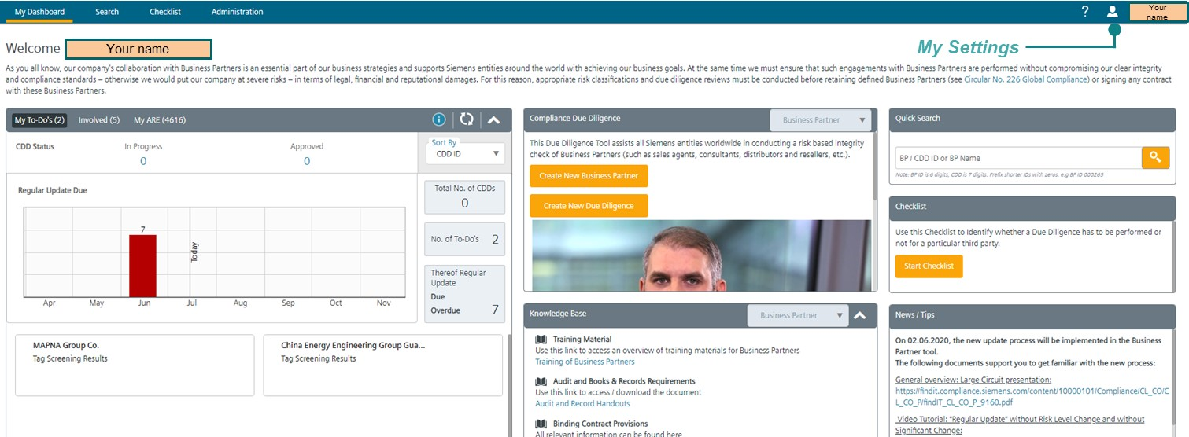

From ***My Dashboard*** (personalized Dashboard per User) you can access all the functions, e.g. open To Do's, create of Business Partners and CDDs, quick search, checklist to prove if a CDD is required as well as additional material. There are links to relevant materials, e.g. internal regulations, supporting documents, "how to" video tutorials and information on how to get help.

### C.1.4. My Settings

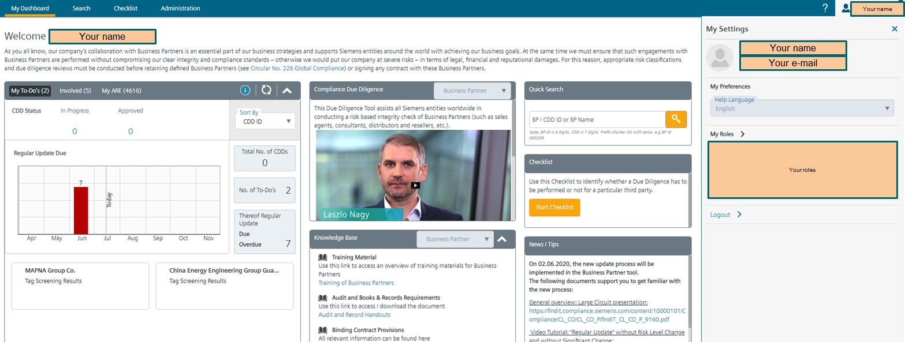

By clicking on **your** name in the top right corner you will find the roles you currently have in the [CDD-Tool](https://compliance-tools.siemens.com/due-diligence/), e.g. ARE viewer, CO Reviewer, etc. and the AREs the roles are applicable for.

### C.1.5. My Dashboard

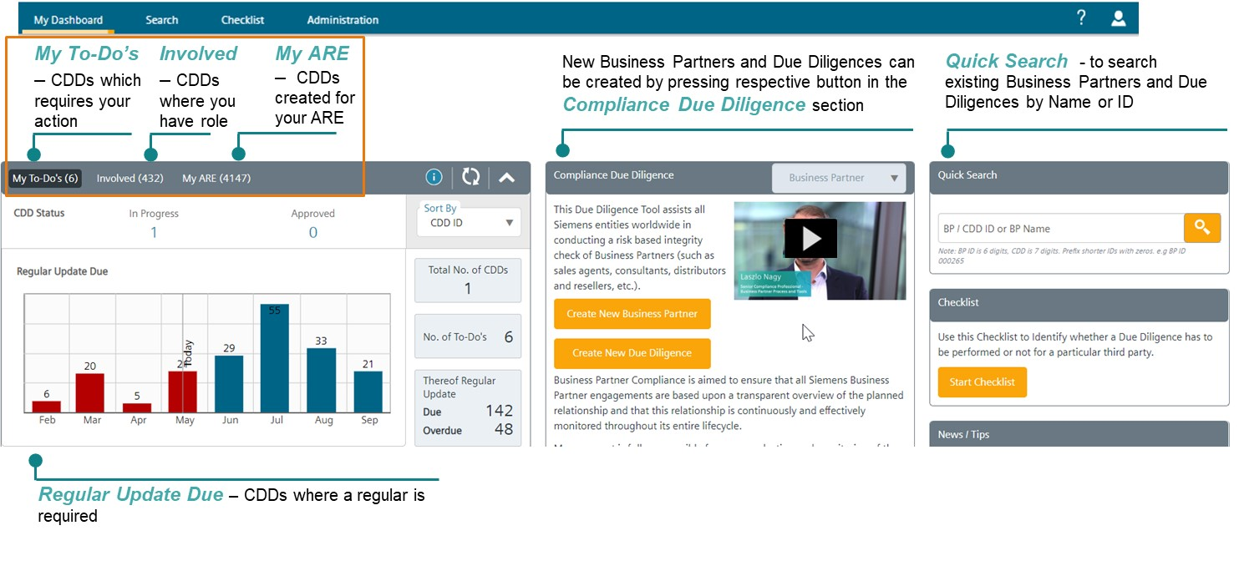

In “My Dashboard” on the top left the following information is available:

* “My To-Do`s”: gives a quick overview of all CDDs requiring your attention.
* "Involved": gives an overview of CDDs you have a role in
* "My AREs": you can see all CDDs created for **Your** AREs.

The "update symbol" allows you to update the status box. 

The "info symbol " will open a box on the right with additional information. 

A graph “Regular Update Due” shows CDDs where a regular update is required. Below the graph, your “To Do’s” are displayed as CDD cards.

### C.1.6. Searching for existing Business Partners or CDDs

The first step is to search for a matching Business Partner entry to avoid double entries. There are different ways to search for existing Business Partners and/or CDDs, either using the Navigation Menu or the functionalities in My Dashboard:

* **Quick Search -** to find Business Partner/ CDD by Name or Identification Number (ID) (available in *„****My Dashboard“*** or ***„Search“*** section of the Navigation Menu)
* **Map Search -** to find Business Partners which are located in a particular country
* **Advanced Search** - to search by various criteria, e.g. risk level, Business Partner type, CDD status etc.

If the Business Partner cannot be found, a **new Business Partner** must be created.

**Quick search**

You can enter either an Identification Number (ID) for a CDD or Business Partner or enter the Business Partner name. The [CDD-Tool](https://compliance-tools.siemens.com/due-diligence/) will automatically display options after entering three digits.

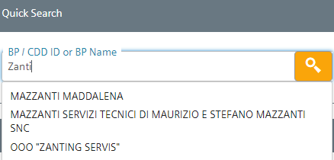

Please note: BP ID is 6 digits, CDD is 7 digits. Prefix shorter IDs with zeros. e.g. BP ID 000265

**Map search**

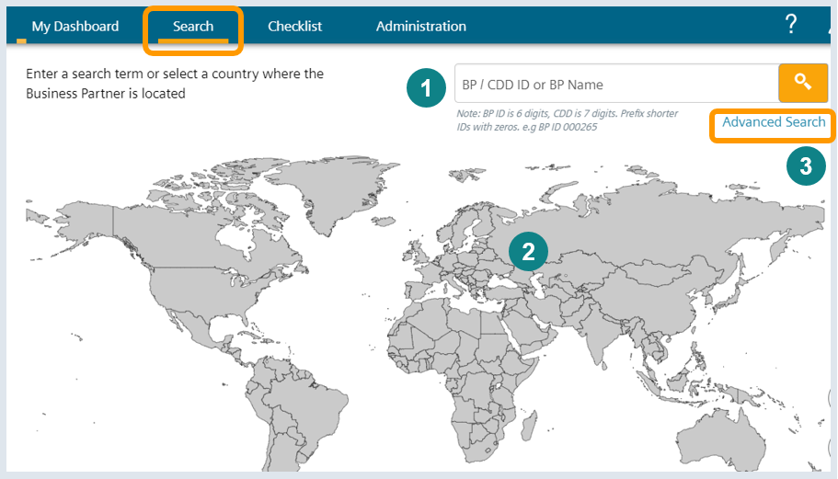

In this section you can either use (1) a BP ID / BP name or (2) select the country where the Business Partner is located using the map.

**Advanced Search**

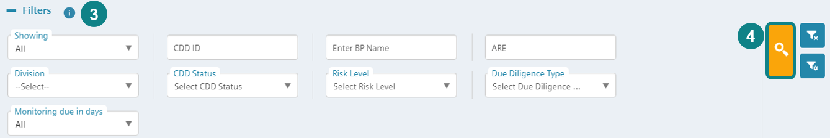

To perform an Advanced Search (3) click *“Advanced search”* andenter the search criteria (e.g. CDD ID, Business Partner name, ARE number, Company units (e.g. BUs, former Divisions, OpCos, CDD Status, Risk Level, etc.) and (4) start by clicking the search button.

Per default the shown search criteria are displayed. Additional filters (Regular Update Due etc.) can be selected by clicking  (configure filters). The settings are saved per user.

## C.2. Business Partner CDD Process



### C.2.1. Business Partner Checklist - Determining if a CDD is required

A "[Business Partner Checklist](https://compliance-tools.siemens.com/due-diligence/#/ui/checklist)" in the [CDD-Tool](https://compliance-tools.siemens.com/due-diligence/) can help determining whether a partner is in scope.

The Checklist can be accessed via My Dashboard or the **Business Partner Checklist section**.

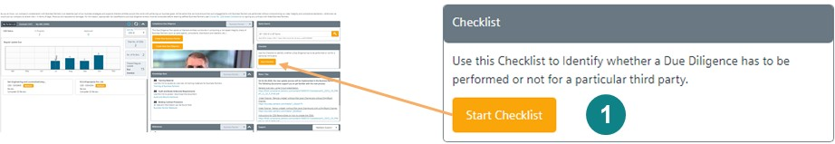

1. Start Checklist  
     
   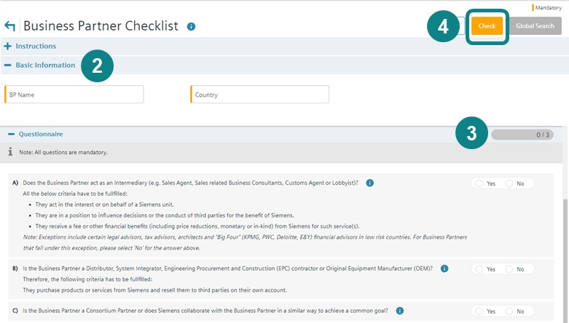
2. Enter Business Partner Name **and** Business Partner Country
3. Answer all questions
4. Click the “Check”

The questions are based on the relevant types of Business Partners (e.g. intermediaries, resellers, consortium partners). For matters of simplification, there is no differentiation between Sales related Intermediaries and Non-sales related Intermediaries, since a CDD is mandatory for both. Further details on the definitions and types can be found in chapter A.1.

* Depending on the answers, sub-questions will automatically pop-up if necessary.
* All questions must be answered with “yes” or “no"
* The “  ” symbol provides more detailed explanations to the questions.

After the Check (4), the [CDD-Tool](https://compliance-tools.siemens.com/due-diligence/) determines whether a CDD is necessary. A report of the results can be printed out. If a CDD is necessary, click the Global Search button in the top right corner (next to the Check button), which will redirect you to the search page where you can creation of a new Business Partner entry.

This [video](https://myid.siemens.com/idp/SSO.saml2?SAMLRequest=fVLBbgIhFPyVDffdRYwaiGtiNU1NbDWu7aGXBtlnJVlgy2Nt%2Ffuy2iZ68cDlMTNvZmCM0tSNmLbhYDfw1QKG5MfUFsX5oiCtt8JJ1CisNIAiKFFOn5eCZVQ03gWnXE2uKPcZEhF80M6SZDEvyAfsK7VnXO7iAT4aSMaAVopyUJzt%2BmxIh2xYjeiAk%2BQNPEZmQaJQpCO2sLAYpA1xRBlNKU8Z31Iuen0x6L2TZB7TaCvDmXUIoUGR5%2Bakqww1GLCYKWdyXTV5Wa6yzj0jyfTf4sxZbA34EvxRK3jdLK9FjroCd6PTRl4uY5Fgg1YyAEnWfwU9aFtp%2B3m%2Fm90FhOJpu12n61W5JZNxZ0qcs%2FrJneXj%2FBo4vjzqS1yxmK9drdUpeXTeyHDfQTfRVbo%2FQ0XT9Y0hpoml1LX7nnmIqQoSfAskn1x23v6dyS8%3D&RelayState=https%3A%2F%2Fmyvideo.siemens.com%2Fembed%2Fsecure%2Fiframe%2FentryId%2F1_jxvscz55%2FuiConfId%2F35060351) provides assistance on how to check if a Business Partner is in scope.

### C.2.2. Business Partner Key Data – How to create a Business Partner

##### C.2.2.1. Creating a new Business Partner

First search for the Business Partner in the [CDD-Tool](https://compliance-tools.siemens.com/due-diligence/), to ensure that it has not already been created.

One or more CDDs can be registered for Business Partner (please see detail for the **re-use** of an existing CDD in C.4.).

The creation of a Business Partner can be initiated directly from the Business Partner Checklist or via My Dashboard”.

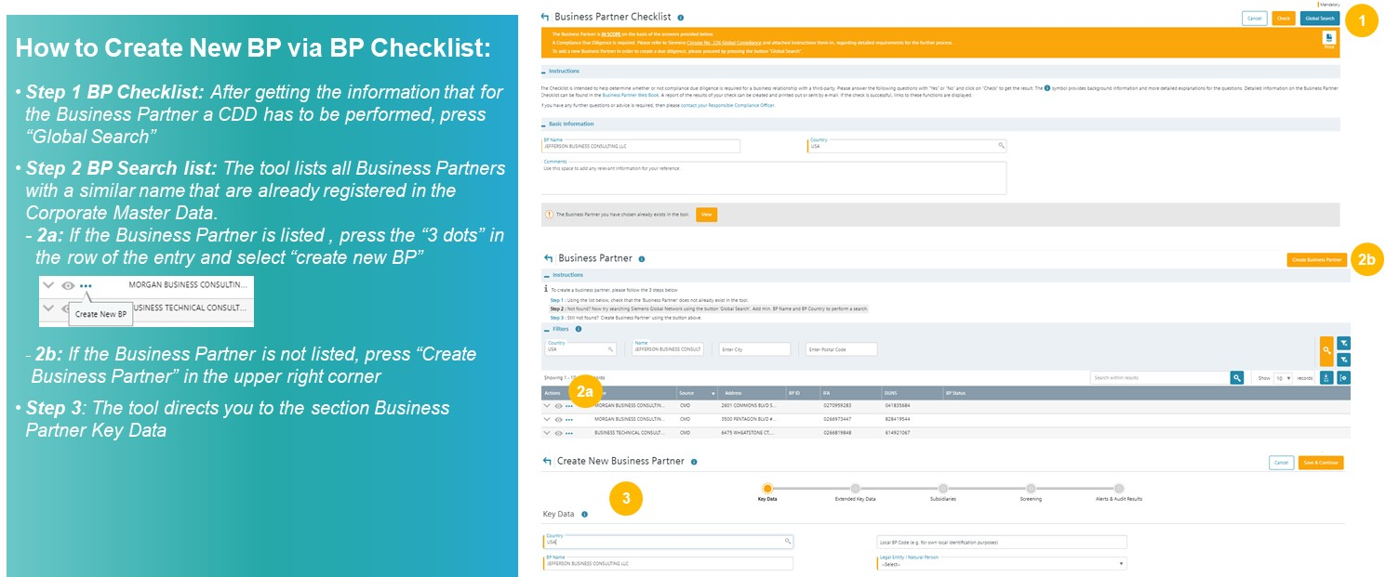

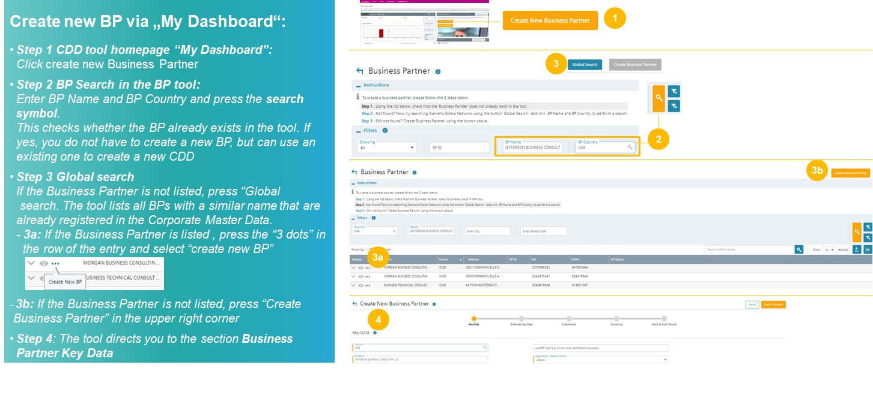

This [video](https://myid.siemens.com/idp/SSO.saml2?SAMLRequest=fVLLboMwEPwV5DuPWiUhFiCliapGShsUaA%2B9VA4sjSWwqdekzd%2FXkFZKLhy9npmdGTtG3jYdW%2FbmKPfw1QMa56dtJLLxIiG9lkxxFMgkbwGZKVm%2BfN4y6gWs08qoUjXkijLN4IigjVCSOJt1Qj74XTSjlM%2FCmsNdNA8AIKzD%2BX1dBYtZHUY15Qdqz1FFnDfQaJkJsUKWjtjDRqLh0thRQAM3WLg0LIKQhSGj9J04a5tGSG5G1tGYDpnvt2dReSigBYleqVpfVJ2f5ztvcE%2BJs%2Fy3uFIS%2BxZ0DvokSnjdb69FTqICdaPTW57PbZEgjSi5AeJkfwU9CFkJ%2BTndzeECQvZUFJmb7fKCpPFgio1ZdTqxPPavgfHlUV%2Fsis06U40oz86j0i030w6GiajceoSybugbjU1jS2ka9b3SYFMlxOgeiJ9edt7%2BnfQX&RelayState=%2Fmedia%2F1_0o4wucxd) provides additional assistance on how to create a new Business Partner.

##### C.2.2.2. Business Partner Key Data

The Key Data page is the first page when creating a Business Partner. The progress bar shows the different chapters where information about the Business Partner can be registered. The orange circle shows where in the process you currently are.

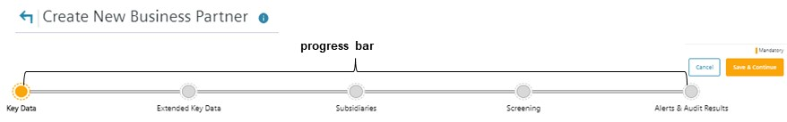

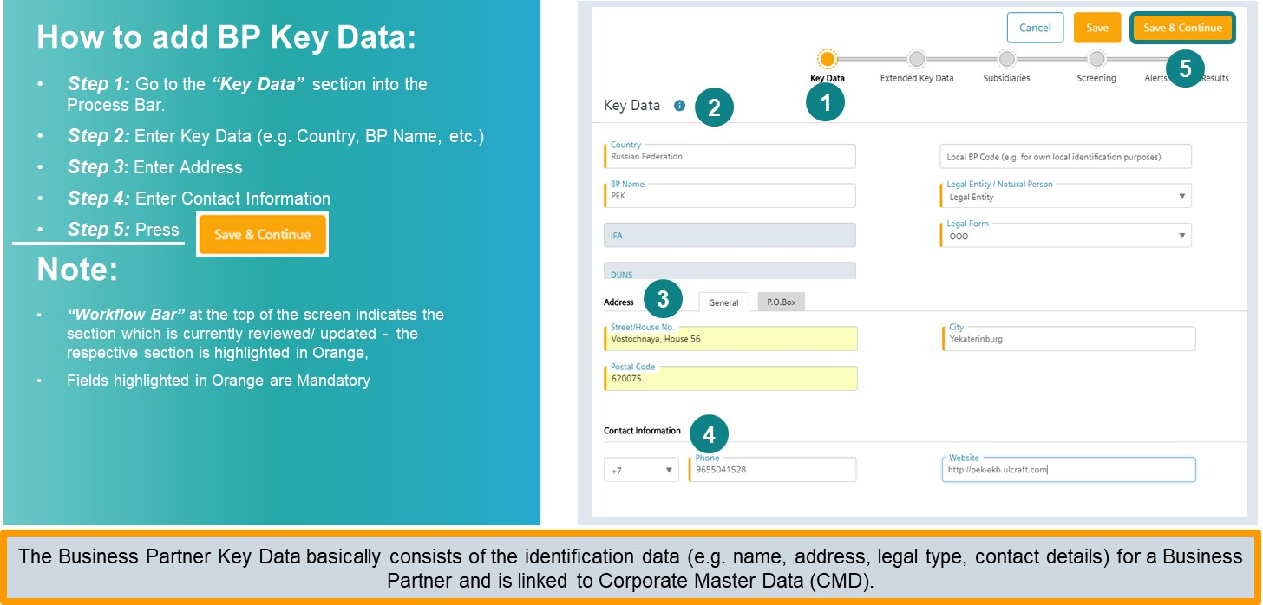

In the Key Data enter address and contact information of the Business Partner. All mandatory fields are marked with an orange bar.

Legal entity/natural person: If the Business Partner is a company, select “legal entity” and chose the legal form. If the Business Partner is an individual, select “natural person”

##### C.2.2.3. Extended Key Data

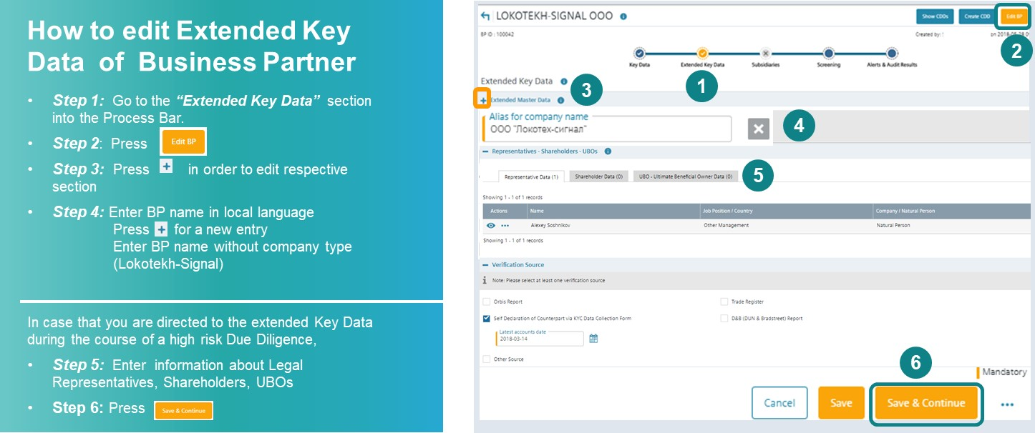

In the extended key data section, register alias names of a Business Partner (step 1-step 4). An alias name can be a for example a pseudonym of the Business Partner but also the name in local characters. Alias names are also automatically checked against SETIS (Internet and World Compliance database and DAMEX-SPS, i.e. Sanctioned Party Screening) during the CDD.

**Example**: If you have registered a company with the Business Partner name “Lokotekh-Signal OOO” in Russia, you should register the Alias “LOKOTEKH-SIGNAL” (without OOO) plus this name in **local characters**.

This increases the accuracy of SETIS searches.

**Registration of legal representatives, shareholders, ultimate beneficial owners (UBO's) (only for high risk CDDs)**

For high risk CDDs, additional Business Partner key data related information to Legal Representatives, Shareholders and Ultimate Beneficial Owners (UBOs) is required. The risk level is determined by the CDD Risk Assessment at a later stage. The [CDD-Tool](https://compliance-tools.siemens.com/due-diligence/) directs you from the high risk CDD Questionnaire directly to this section.

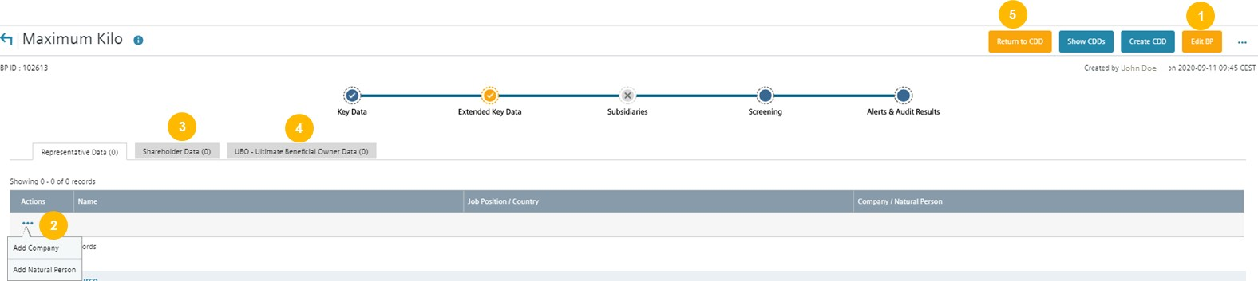

* **Step 1:** Press “Edit” to add relevant information in the chapter “Representatives, Shareholders and UBOs”.
* **Step 2:** Press the three dots to enter the name (Surname and Name) and position of the requested person or the company name. Press “Save” to save the entered information.
* **Step 3:** Register shareholder with >= 25% shares
* **Step 4:** Register the Ultimate Beneficial Owner (UBO)
* **Step 5:** After pressing save return to the CDD Questionnaire of the high risk CDD and complete the questionnaire

Further explanations on Key Persons and Key / Acting Employees Legal Representatives, Shareholders, UBOs can be found in the chapter on [Definitions and Abbreviations](https://webbooks.siemens.com/public/LC/chen/index.htm?n=General-Introduction,2.-Definitions-and-Abbreviations) of the General Introduction of the Compliance Handbook.

This [video](https://myid.siemens.com/idp/SSO.saml2?SAMLRequest=fVJPT8IwFP8qS%2B9js4MhzViCECMJysLQgxdT24c02drZ16F%2Be7uhCVx2fX2%2Fv68Z8rpq2KJ1R72DzxbQBd91pZH1D3PSWs0MR4VM8xqQOcHKxeOG0VHMGmucEaYiF5BhBEcE65TRJFiv5uRNCpGk9JBOU5Hw6WEC8UTEkkqZCJ5SyuWYzmYpTJNbEryARY%2BcE0%2Fk4YgtrDU6rp0fxTQO41lIJ%2FubhI1TNhm%2FkmDl0yjNXY86Otcgi6L6R8kRKqhB40iYOlKyicpyO%2BrcUxIs%2Fi0ujca2BluCPSkBz7vNJclJSTBXPK3HRdwXCdopwR2QoPgr6E5pqfTHcDfv5yVkD%2Ft9ERbbck%2FyrDPF%2Bqw2HxDPosvF7HzUJy%2BxXhWmUuInuDe25m7YQTdRMjz0q6zp%2Bkbn0%2FhSqsp8LS34VHPibAskys%2Ba138n%2FwU%3D&RelayState=https%3A%2F%2Fmyvideo.siemens.com%2Fembed%2Fsecure%2Fiframe%2FentryId%2F1_lzahxvmd%2FuiConfId%2F35060351) provides further assistance on how to regarding Extend Key Data.

##### C.2.2.4. Subsidiaries

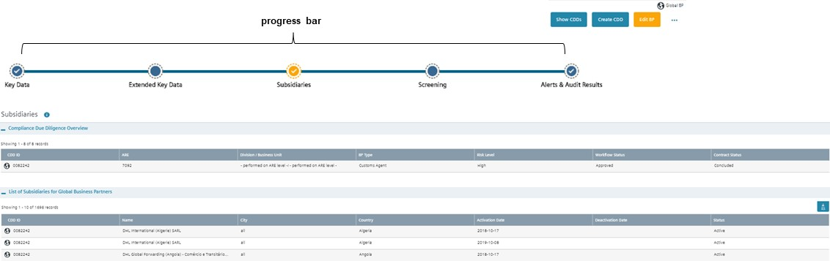

Subsidiary section is relevant only for Global Business Partners. It will be only available after the Business Partner is marked as global in CDD data.

##### C.2.2.5. Screening

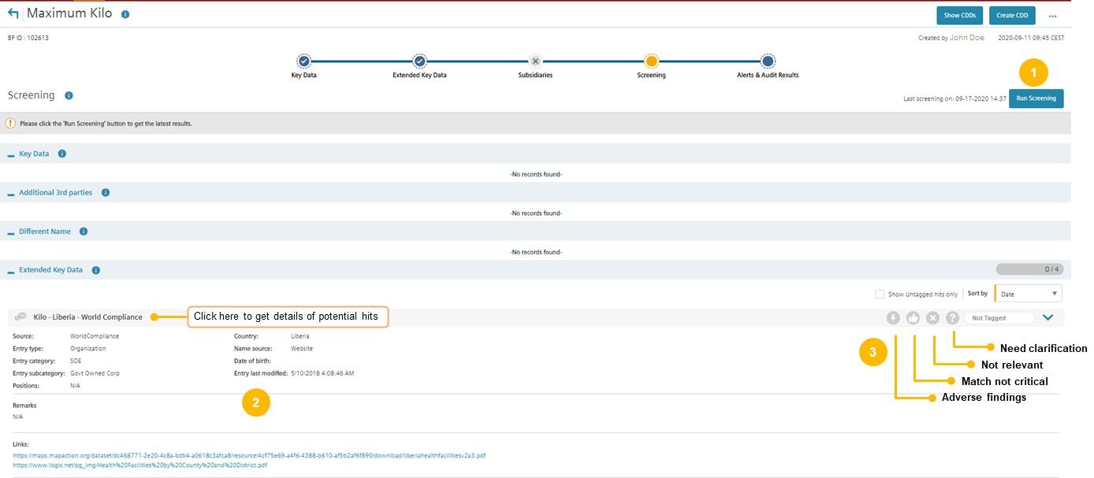

In the "**Screening"** results of screenings against the listings from World Compliance and DAMEX using the tool SETIS are displayed.

This [video](https://myid.siemens.com/idp/SSO.saml2?SAMLRequest=fVLLboMwEPwV5DuPWiUhFiCliapGShsUaA%2B9VA4sjSWwqdekzd%2FXkFZKLhy9npmdGTtG3jYdW%2FbmKPfw1QMa56dtJLLxIiG9lkxxFMgkbwGZKVm%2BfN4y6gWs08qoUjXkijLN4IigjVCSOJt1Qj74XTSjlM%2FCmsNdNA8AIKzD%2BX1dBYtZHUY15Qdqz1FFnDfQaJkJsUKWjtjDRqLh0thRQAM3WLg0LIKQhSGj9J04a5tGSG5G1tGYDpnvt2dReSigBYleqVpfVJ2f5ztvcE%2BJs%2Fy3uFIS%2BxZ0DvokSnjdb69FTqICdaPTW57PbZEgjSi5AeJkfwU9CFkJ%2BTndzeECQvZUFJmb7fKCpPFgio1ZdTqxPPavgfHlUV%2Fsis06U40oz86j0i030w6GiajceoSybugbjU1jS2ka9b3SYFMlxOgeiJ9edt7%2BnfQX&RelayState=%2Fmedia%2F1_nxu0lvvp) provides assistance on how to use SETIS for internet checks.

**Note:**

The Screening starts automatically if a new CDD is created or if a Regular Update of a CDD is performed. It is repeated automatically every 6 months.

**To perform a Screening manually**

* ***Step 1:*** Press **“Run Screening”** to get latest results, and
* ***Step 2:*** Review identified hints (if any)
* ***Step 3:*** Tag the hits

Hits identified during a CDD have to be analyzed and tagged by the CDD Responsible. New hits resulting from a screening that is automatically repeated every 6 months have to be analyzed and tagged by a Lead CO Reviewer (Compliance) of CDDs performed for this Business Partner.

Explanations regarding potential hits in DAMEX can be found in the [DAMEX Sanctions Matrix](https://findit.compliance.siemens.com/content/10000101/Compliance/LC_CO/LC_CO_EX_GOV/findIT_LC_CO_EX_GOV_6348.xlsx).

This [video](https://myid.siemens.com/idp/SSO.saml2?SAMLRequest=fVJbb4IwFP4rpO%2Fcg0oDJE6zzMRNImwPe1kqHGYTaFlPcfPfr%2BKW6Auvp%2Be7nibIurany0EfxR6%2BBkBt%2FXStQDo%2BpGRQgkqGHKlgHSDVFS2Wz1saOB7tldSyki25gUwjGCIozaUg1madko9q4R%2B8hs0iCIMmnMOsqasFgB%2FGdex5fhwBa8KZX%2FsRsd5AoUGmxBAZOOIAG4GaCW1GXuDZXmwHUen7NJxTb%2F5OrLVJwwXTI%2BqodY%2FUdbszrx3k0IFAp5Kdy%2BveLYqdc3EfEGv5b3ElBQ4dqALUiVfwut%2Fekpx4DfKOZzA4l5kiQWheMQ3Eyv8KeuCi5uJzupvDdQnpU1nmdr4rSpIlF1N0zKqyCfHEvV1Mrkd9MRKbdS5bXp2tR6k6pqcdXCa8tptxlfaXvlGbNKaUtpXfKwUmVUq0GoC42VXz%2Fu9kvw%3D%3D&RelayState=%2Fmedia%2F1_d7uqgbhz) provides assistance on handling of new Integrity Search Results.

##### C.2.2.6. Alerts & Audit Results

The Alerts and Audit Results section can be only edited by a Compliance Officer, for standard users this section is read only.

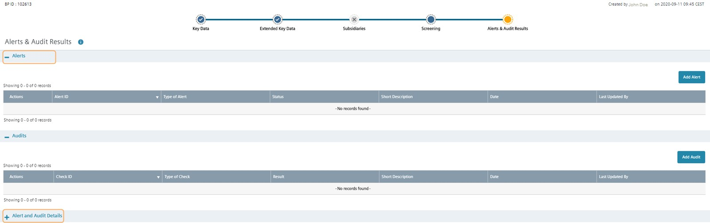

**Alerts**

In this section a Business Partner can be e.g. flagged as “under observation” or centrally disapproved by a Compliance Officer see also C.5.1.3. Centrally Disapproval / Business Partner under observation.



* ***Step 1:*** Press “Add Alert”

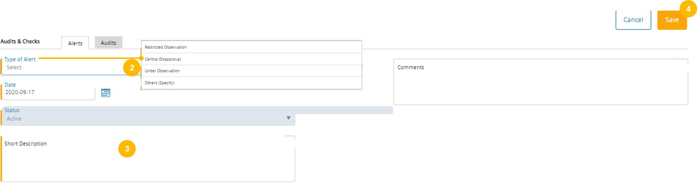

* ***Step 2:*** Select the type of the alert
* ***Step 3:*** Enter a short description (text will be included in the e-mail to involved persons)
* ***Step 4:*** Press Save

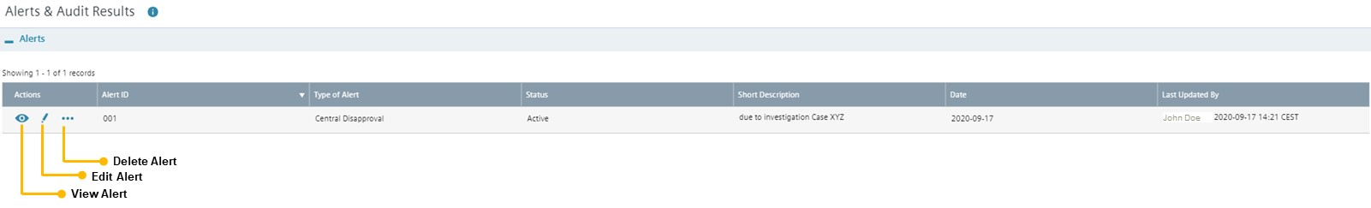

Clicking the symbols, you can view, edit (e.g. deactivate) or delete an alert.

**Audits**

The results of a Business Partner audit performed by CF A or of a Compliance Onsite Check (B.4. Compliance onsite check) can be registered. The process to add an audit is similar to the alerts process.

This [video](https://myid.siemens.com/idp/SSO.saml2?SAMLRequest=fVJPT4MwFP8qpPcBFqbYAMncYlwyHRnowYtp4emaQIt9Zeq3t2yabBeur%2B%2F39zVF3rU9Wwx2r3bwOQBa77trFbLjQ0YGo5jmKJEp3gEyW7Ny8bhh1A9Zb7TVtW7JGWQawRHBWKkV8darjLyJOElEw%2BNIRDymV4kIKadCUCooT66TEBpIwnh%2BIyjxXsCgQ2bEETk44gBrhZYr60YhDWfh7YzOq3DO5hGj0SvxVi6NVNweUXtre2RB0P3IxkcJHSj0a90FsumDstz6o3sns%2Fi3uNQKhw5MCeYga3jebc5JDrIBfcEzOFzAXZGgrKy5BeIVfwXdSdVI9THdjTgtIXuoqmJWbMuK5Oloih2zmnxCPA3OF9PTUZ%2BcxHpV6FbWP969Nh230w7GiWxm78dV1o99o3VpXCltq7%2BWBlyqjFgzAAnyk%2Bbl38l%2FAQ%3D%3D&RelayState=https%3A%2F%2Fmyvideo.siemens.com%2Fembed%2Fsecure%2Fiframe%2FentryId%2F1_d1gxq9w7%2FuiConfId%2F35060351) provides assistance for the Alerts & Audit Results section.

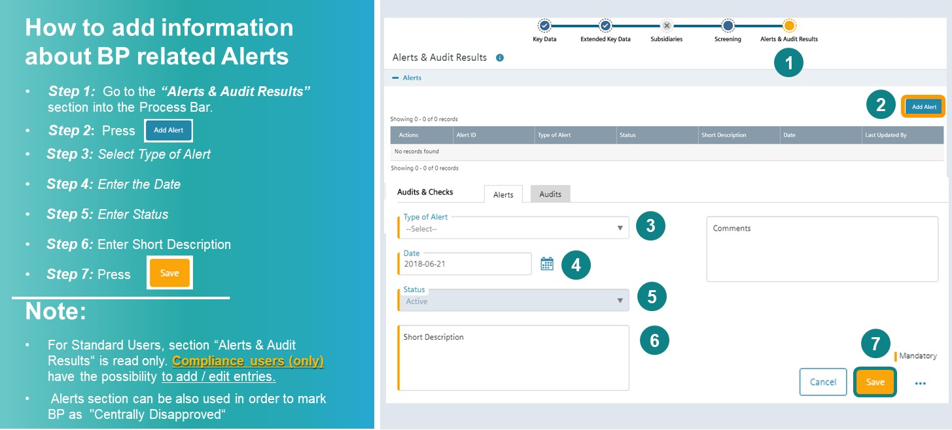

### C.2.3. Due Diligence Key Data – How to create a CDD

##### C.2.3.1. Creating a CDD

One or more CDDs can be registered for the same Business Partner. This [video](https://myid.siemens.com/idp/SSO.saml2?SAMLRequest=fVLLboMwEPwV5DuPWiUhFiCliapGShsUaA%2B9VA4sjSWwqdekzd%2FXkFZKLhy9npmdGTtG3jYdW%2FbmKPfw1QMa56dtJLLxIiG9lkxxFMgkbwGZKVm%2BfN4y6gWs08qoUjXkijLN4IigjVCSOJt1Qj74XTSjlM%2FCmsNdNA8AIKzD%2BX1dBYtZHUY15Qdqz1FFnDfQaJkJsUKWjtjDRqLh0thRQAM3WLg0LIKQhSGj9J04a5tGSG5G1tGYDpnvt2dReSigBYleqVpfVJ2f5ztvcE%2BJs%2Fy3uFIS%2BxZ0DvokSnjdb69FTqICdaPTW57PbZEgjSi5AeJkfwU9CFkJ%2BTndzeECQvZUFJmb7fKCpPFgio1ZdTqxPPavgfHlUV%2Fsis06U40oz86j0i030w6GiajceoSybugbjU1jS2ka9b3SYFMlxOgeiJ9edt7%2BnfQX&RelayState=%2Fmedia%2F1_jqs236zu) provides additional assistance on how to create a new due diligence.

There are two options to create a CDD:

1. Business Partner Key Data are already available and you are creating a first CDD for this BP:

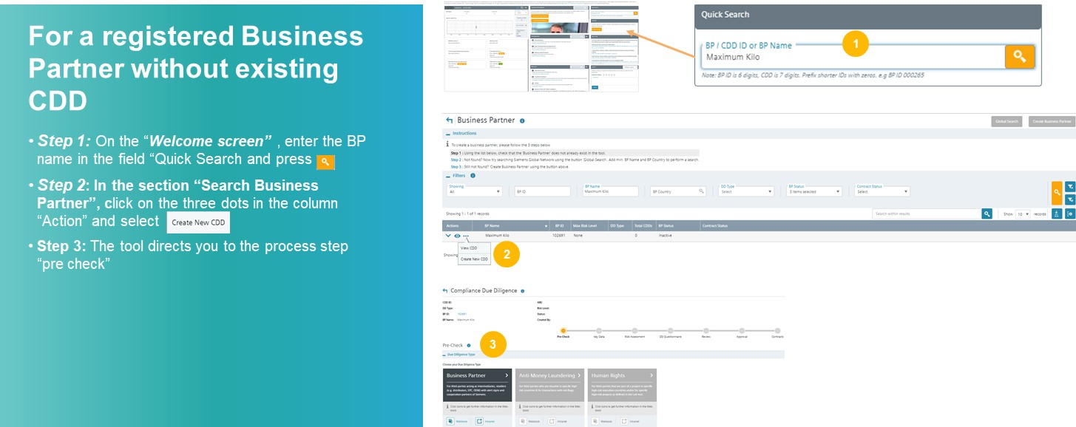

1. Business Partner Key Data are created and other CDD(s) exist(s):

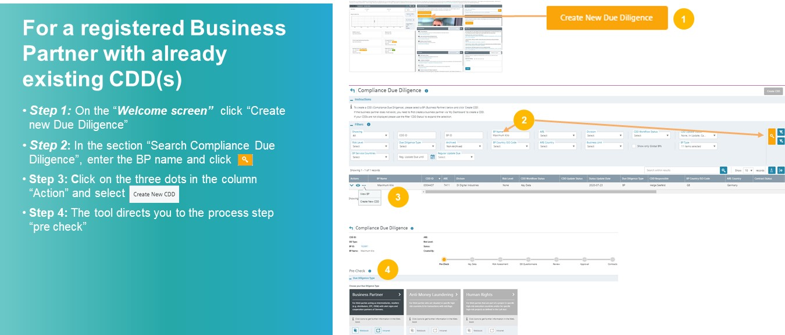

##### C.2.3.2. Pre-Check

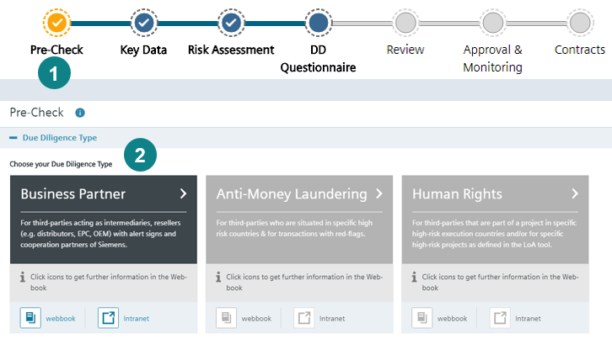

**Once you have started creating a new CDD,** click on Business Partner in the Pre-Check.

##### C.2.3.3. CDD Key Data

In the CDD Key Data key elements of the business relationship must be described.

If CDD Key Data is newly created or a Regular Update is started, an automatic screening of Business Partner name and alias name(s) against SETIS is initiated. The evaluation of potential hits must be performed as part of the risk assessment of the CDD.

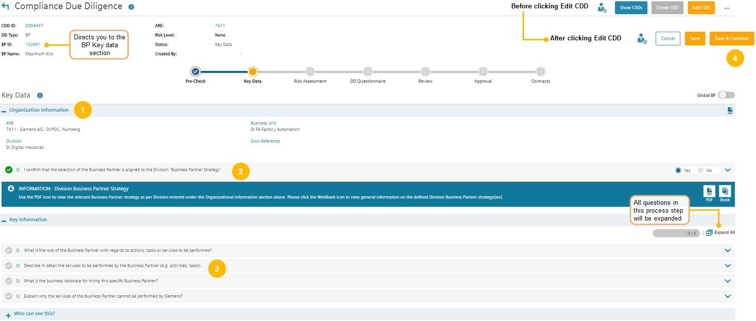

CDD Key Data consists of

1. Organizational Information
2. Key Information
3. Who can see this? (maintenance of CDD roles => see C.5.1.1.)

To edit information, click "Edit CDD".

* ***Step 1:*** Enter details of the Siemens entity engaging the Business Partner (ARE number, Business).
* ***Step 2:*** Depending on the organization data, confirm that the engagement is in line with the Business Partner Strategy (available in the [CDD-Tool](https://compliance-tools.siemens.com/due-diligence/))
* ***Step 3:*** Enter requested details of the business relationship
* ***Step 4:*** Press "Save and Continue"

This [video](https://myid.siemens.com/idp/SSO.saml2?SAMLRequest=fVLLboMwEPwV5DuPWiUhFiCliapGShsUaA%2B9VA4sjSWwqdekzd%2FXkFZKLhy9npmdGTtG3jYdW%2FbmKPfw1QMa56dtJLLxIiG9lkxxFMgkbwGZKVm%2BfN4y6gWs08qoUjXkijLN4IigjVCSOJt1Qj74XTSjlM%2FCmsNdNA8AIKzD%2BX1dBYtZHUY15Qdqz1FFnDfQaJkJsUKWjtjDRqLh0thRQAM3WLg0LIKQhSGj9J04a5tGSG5G1tGYDpnvt2dReSigBYleqVpfVJ2f5ztvcE%2BJs%2Fy3uFIS%2BxZ0DvokSnjdb69FTqICdaPTW57PbZEgjSi5AeJkfwU9CFkJ%2BTndzeECQvZUFJmb7fKCpPFgio1ZdTqxPPavgfHlUV%2Fsis06U40oz86j0i030w6GiajceoSybugbjU1jS2ka9b3SYFMlxOgeiJ9edt7%2BnfQX&RelayState=%2Fmedia%2F1_5fy0qxyl) provides additional assistance on how to complete the CDD Key Data.

**Explanation of some questions asked in the chapter CDD Key Data.**

**Role of the Business Partner**



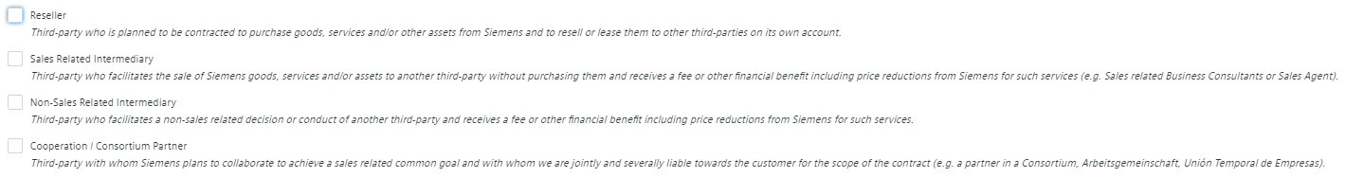

* Detailed information about Business Partner types (=roles) are available in A.1.
* If the Business Partner acts in several roles e.g. as Reseller and Sales Agent, more than one role can be selected.
* Depending on the Business Partner type additional specific questions must be answered during the course of the due diligence.

**Service description Business Partner**  


Ensure that information about the relationship is complete and transparently described in a way that it is understood by an objective independent person. The description should explain:

a) How consistent the scope compared to the Business Partners normal operations is and

b) Whether the Business Partner has sufficient resources and qualifications.

Press “Save and Continue” to finalize the CDD Key Data and move to the Risk Assessment.

[Best practice examples of neutral service descriptions](https://findit.compliance.siemens.com/content/10000101/Compliance/LC_CO/LC_CO_RG_PL/findIT_LC_CO_RG_PL_9576.pdf) (e.g. for Sales Agent, EPC, non-sales related intermediary provide further assistance.

### C.2.4. Risk Assessment

After completing the Key Data, you are forwarded to the Risk Assessment.  
The risk level of the **relationship** (low, medium or high) is determined by the Business Partner type in the Key Data and by risk relevant questions to be answered in the risk assessment.  
In addition, the evaluation of potential SETIS hits influences the risk level of the CDD.

The risk level will determine the subsequent questionnaires, the necessity for a Compliance onsite check, whether the Business Partner must receive a training, approval requirements and mandatory contract provisions.

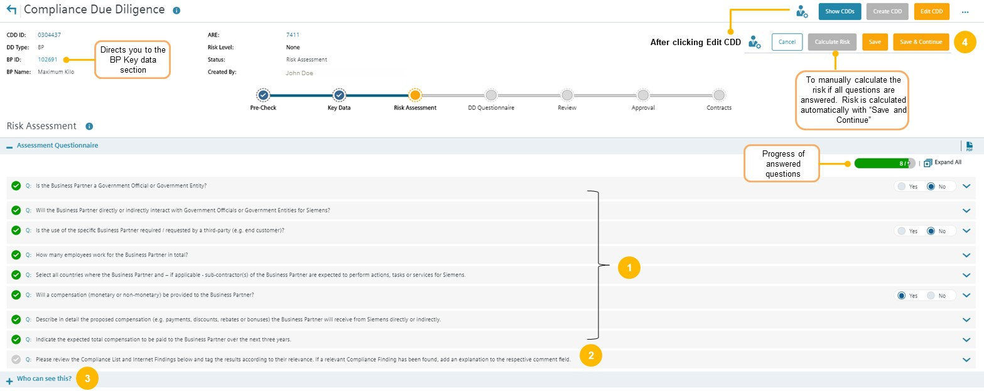

* ***Step 1:*** Answer all questions (except the last one about results of the Internet check)
* ***Step 2:*** Evaluate SETIS / Internet Search see **C.2.4.2.**
* ***Step 3:***Maintain Approver roles see **C.5.1.1**.
* ***Step 4:***Press Save & Continue

This [video](https://myid.siemens.com/idp/SSO.saml2?SAMLRequest=fVJPT8IwFP8qS%2B%2BwUZBBw5YgxEiCsjD04MV07UOabO3s61C%2Fvd3QBC67vr7f39cF8qqs2bJxJ72HzwbQBd9VqZF1DwlprGaGo0KmeQXInGD58mnL6DBitTXOCFOSK0g%2FgiOCdcpoEmzWCXmP4xGlEwnjYiqiCZd0PpOFmApZjOJxAVMRz45HOqXFhASvYNEjE%2BKJPByxgY1Gx7Xzo4hGg2g%2BoHeH0YiN52wcv5Fg7dMozV2HOjlXIwvD6kfJISqoQONQmCpUsg7zfDds3VMSLP8trozGpgKbgz0rAS%2F77TXJWUkwNzyNx4XcFwnaKcEdkCD7K%2Bheaan0R383xWUJ2ePhkA2yXX4g6aI1xbqsNu0RX4TXi4vLUZ%2B9xGadmVKJn%2BDB2Iq7fgftRMnBsVtldds3Op%2FGl1KW5mtlwadKiLMNkDC9aN7%2BnfQX&RelayState=%2Fmedia%2F1_5seveyds) provides additional assistance on how to complete the Risk Assessment.

If the Risk Assessment determines a low risk CDD, confirm that the CDD is complete, includes accurate information and select whether the Business Partner raises Compliance concerns or not. After that you can submit the CDD for Management Approval

In case of a medium or high risk CDD, continue with the DD Questionnaire (C.2.5.)

##### C.2.4.1. Explanation of some questions in the Risk Assessment

**Interaction with government officials**

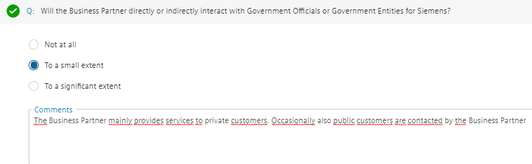

If there is any kind of interaction with governmental officials or entities, detailed information regarding the kind of interaction with Government Officials must be provided in the comment box.

The Business Partner does not interact with government officials or entities to **a significant extent** if the interaction is only on an occasional or random basis (e.g. a business partner occasionally delivers equipment to public schools, but the main customer basis are private enterprises).

You can find the definition of governmental officials [here](https://webbooks.siemens.com/public/LC/chen/index.htm?n=General-Introduction,2.-Definitions-and-Abbreviations).

**Compensation details**

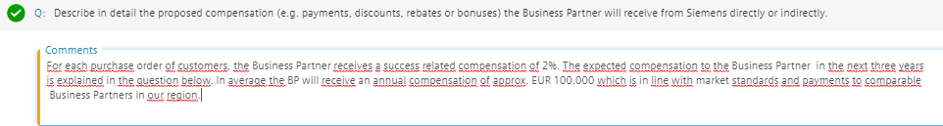

The question must be answered that an independent reader understands, what the Business Partner will receive and whether the compensation is in line with market practice. It must be plausible that the compensation is in a reasonable proportion to the services the Business Partner provides.

##### C.2.4.2. Internet checks and Sanctioned Party/World Compliance checks

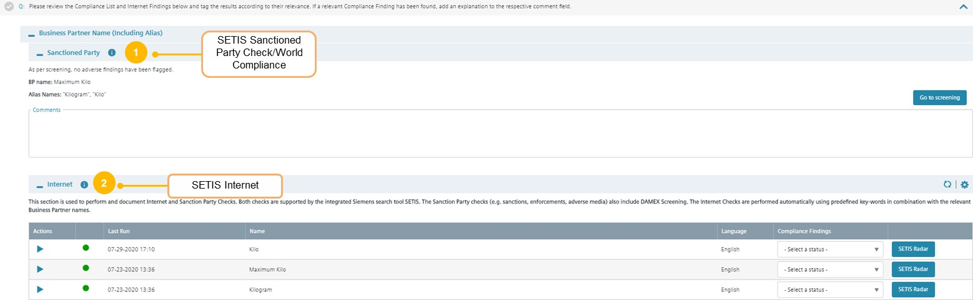

Potential hits of SETIS of Business Partner names and alias names must be evaluated.

##### C.2.4.3. Sanctioned Party/World Compliance

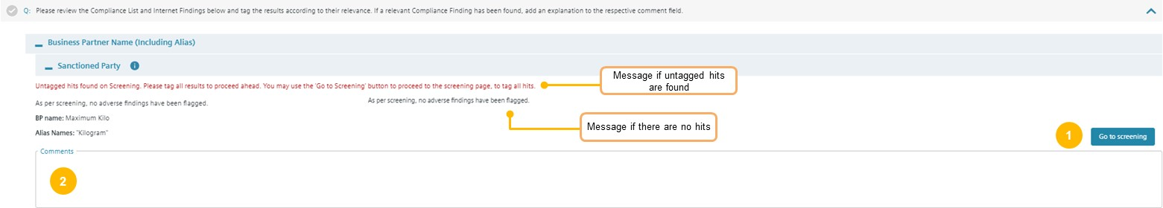

If “As per screening, no adverse findings have been flagged” skip the section and continue with the Internet check.

If hits in the Sanctioned Party lists or the World Compliance Database are found, a message is displayed: “Untagged hits found on Screening. Please tag all results to proceed ahead”. Hits are displayed and have to be tagged in the Business Partner Screening section, see C.2.2.5.

* ***Step 1:*** If untagged hits were found “Go to Screening”, evaluate and tag the hits in the Business Partner Screening
* ***Step 2:*** Comment results of your evaluation in the comment box and continue with section SETIS Internet Check

Explanations regarding potential hits in DAMEX can be found in the [DAMEX Sanctions Matrix](https://findit.compliance.siemens.com/content/10000101/Compliance/LC_CO/LC_CO_EX_GOV/findIT_LC_CO_EX_GOV_6348.xlsx).

##### C.2.4.4. Internet

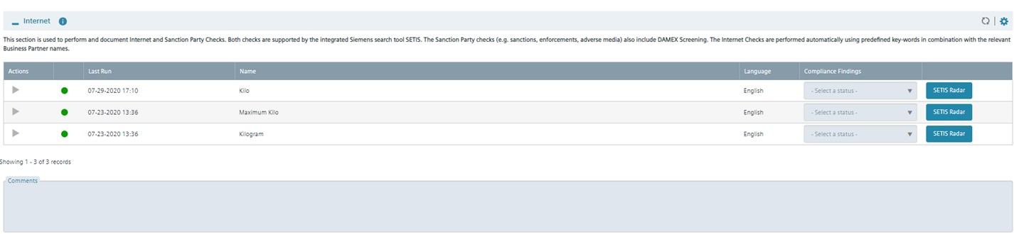

This [video](https://myid.siemens.com/idp/SSO.saml2?SAMLRequest=fVLLboMwEPwV5DuPWiUhFiCliapGShsUaA%2B9VA4sjSWwqdekzd%2FXkFZKLhy9npmdGTtG3jYdW%2FbmKPfw1QMa56dtJLLxIiG9lkxxFMgkbwGZKVm%2BfN4y6gWs08qoUjXkijLN4IigjVCSOJt1Qj74XTSjlM%2FCmsNdNA8AIKzD%2BX1dBYtZHUY15Qdqz1FFnDfQaJkJsUKWjtjDRqLh0thRQAM3WLg0LIKQhSGj9J04a5tGSG5G1tGYDpnvt2dReSigBYleqVpfVJ2f5ztvcE%2BJs%2Fy3uFIS%2BxZ0DvokSnjdb69FTqICdaPTW57PbZEgjSi5AeJkfwU9CFkJ%2BTndzeECQvZUFJmb7fKCpPFgio1ZdTqxPPavgfHlUV%2Fsis06U40oz86j0i030w6GiajceoSybugbjU1jS2ka9b3SYFMlxOgeiJ9edt7%2BnfQX&RelayState=%2Fmedia%2F1_nxu0lvvp) provides additional assistance on how to use SETIS for Internet checks.

In this section potential hits of an automatic internet search (Google or Bing) are displayed.   
The status of the search is marked with a colored bubble:

Green bubble: SETIS-search completed  
Orange bubble: SETIS-search in progress  
Red bubble: Radar has failed

You can only proceed if bubbles are green. If the bubble is orange or red, save the CDD and return after a while to check whether the problem has been solved. In urgent cases send a message to bpc-tool.cit@siemens.com

The searches are automatically performed with Compliance relevant keywords (e.g. corruption, bribery) in English and in the language of the Business Partner country.

You can manually add up to three languages that are supported by SETIS:

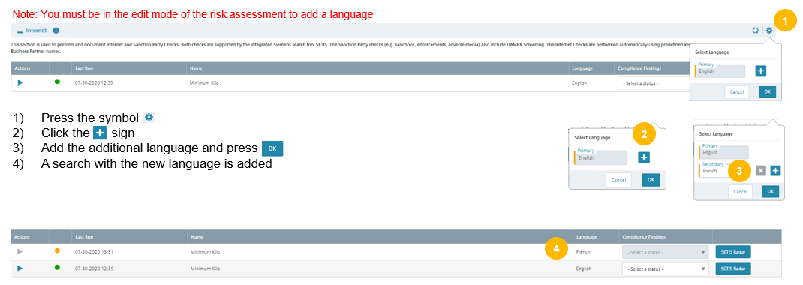

**Evaluation of SETIS internet searches**



After searches are completed press the respective SETIS Radar button to go to SETIS and to view the content of the results.

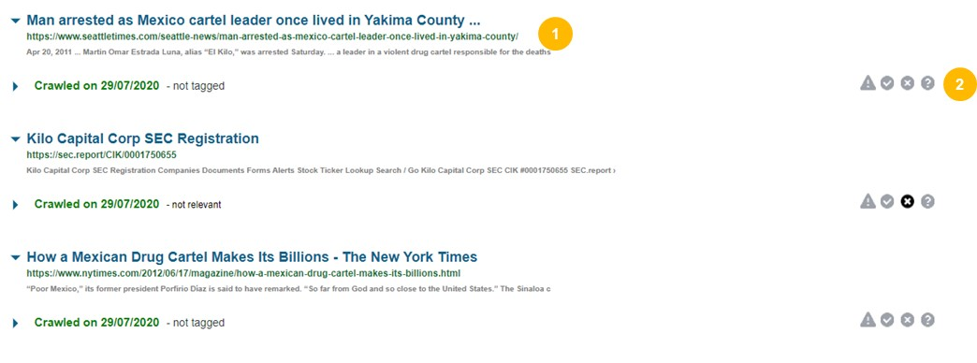

* ***Step 1:*** In SETIS, check all hits. To get more info about a hit, click the respective link
* ***Step 2:*** In SETIS tag all hits with the respective symbols:

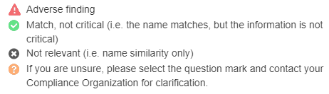

* ***Step 3:*** Go back to Risk Assessment in the [CDD-Tool](https://compliance-tools.siemens.com/due-diligence/)

**Hints for the evaluation of SETIS hits**

The following guidance is a collection of ideas and does not have a binding character:

* Identify false positive hits due to same or similar names or due to different writing or spelling.
* Evaluate **credibility of source** of hit (credibility decreasing):
  + DAMEX
  + Official authority websites
  + World Compliance Database
  + Press or blog articles
* Check **regional, temporal, company, business and individual proximity** of hit:
  + Regional: does the hit concern the countries where the business is planned?
  + Temporal: does the hit cover recent (less than five years) or historical events?
  + Company: does the hit concern the exact legal entity with which business is intended or another entity of a group of companies?
  + Business: does the hit concern the area of business that is relevant for the intended business relationship
  + Individuals: Does the hit concern individuals which are key persons or key employees for the intended business?
* Check **severity of (alleged) infringement**:
  + Does the hit concern allegations or proven convictions?
  + Does the hit concern a serious crime or a misdemeanor (*“Ordnungswidrigkeit” – e.g. minor wrongdoing*)?
  + Does the hit concern the management, a larger number of employees or does it have an isolated character (systematic or one-time failure)?
* Evaluate **remediation measures of business partner:**
  + Did the business partner take appropriate measures after the infringement mentioned in the hit?

**Note: If you get a hit in a language you do not understand, contact a colleague who understands it or your Compliance Officer.**

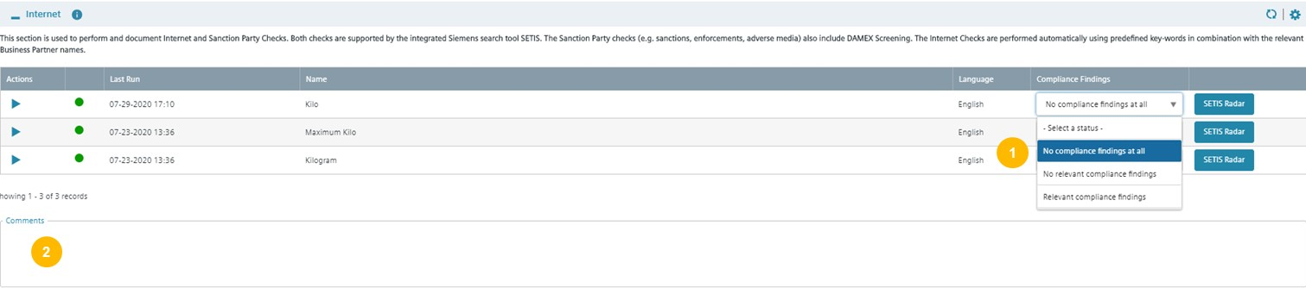

* ***Step 1:*** For each search select whether there are “no Compliance findings at all”, “no relevant Compliance findings” or “relevant Compliance findings”
* ***Step 2:*** Write a short summary of the results of your evaluation in the comment box

If a language is not supported by SETIS, you get a hint:



In this exceptional case perform a manual internet search as per the guidance below in the language of the country the Business Partner is located. If you are not familiar with the language, please contact a colleague who understands oryour Compliance Officer.

**Manual internet search**

Publicly and locally available search engines should be used:

* Search for name as well as close variations. Searches should seek to identify press release / press information that may call into question the compliance of the Business Partner.
* If you encounter a large number of hits when searching for a particular name refine your search by using a combination of terms such as “bribe” and “corrupt” (e.g. “[Name of Business Partner]” + “corrupt”, “[Name of Business Partner]” + “bribe”).
* If available, review the top 20 hits. Be curious and check whether public information is available that might cause you to suspect the Business Partners reputation or integrity. If you get findings obviously solved by the Business Partner (remember the Siemens case), discuss with your Compliance Officer.
* Depending on the result, use the respective answer in question RA 14 (no compliance findings at all; no relevant compliance findings; relevant compliance findings).
* Upload a screenshot or PDF document of the search in the CDD Key Data of the [CDD-Tool](https://compliance-tools.siemens.com/due-diligence/) (supporting documents).
* Document the results of your search in the comment field for Internet searches in the Risk Assessment.

### C.2.5. DD Questionnaire

For medium and high risk CDDs, the CDD Responsible is asked to provide more information. To get a complete and neutral picture, the CDD questionnaires include internal information obtained from the Business Partner as well as external information from independent sources. For high risk CDDs, for example shareholders, Ultimate Beneficial Owner (UBO) and other key persons have to be checked and the Business Partner has to be trained (e.g. via web-based training).

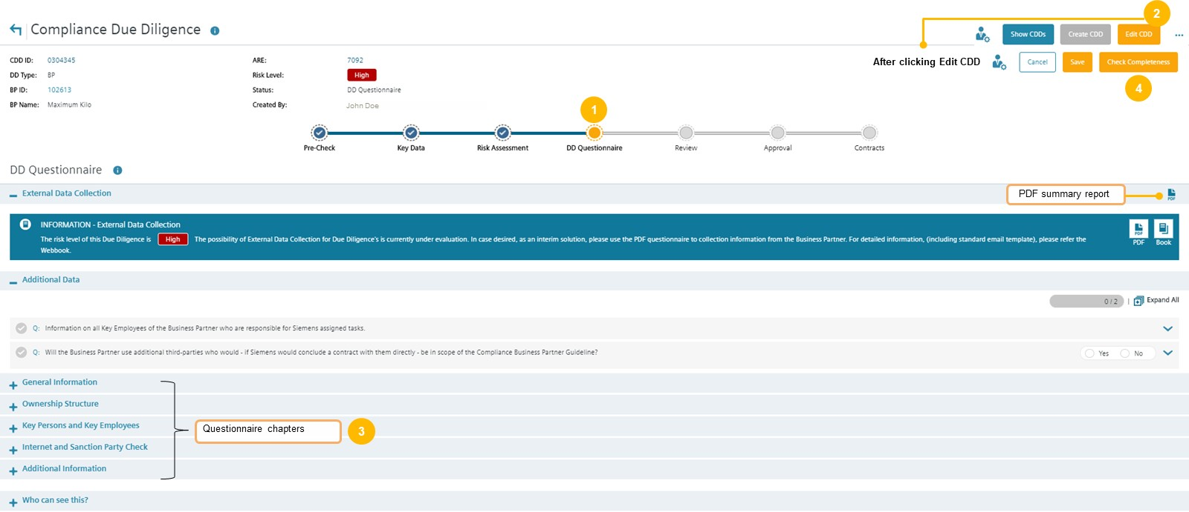

**How to complete the DD Questionnaire:**

* ***Step 1:*** Go to the ***“DD Questionnaire***”
* ***Step 2:*** Press Edit
* ***Step 3:*** Answer all questions
* ***Step 4: Submit CDD for Compliance Review by*** pressing “Check Completeness”

This [video](https://myid.siemens.com/idp/SSO.saml2?SAMLRequest=fVJPT8IwFP8qS%2B%2BwrjCBhi1BiJEEhbDpwYsp7UOabO3s61C%2FvWVoAheur%2B%2F393WKoq4aPmv9wWzhswX00XddGeTdQ0ZaZ7gVqJEbUQNyL3kxe1px1qe8cdZbaStyAbmNEIjgvLaGRMtFRt6ZGggxYWrM0lSlAkaTwU7QCRvskoTK4d1oLweM7pMhI9ErOAzIjASiAEdsYWnQC%2BPDiDLao5MeS0ua8jThdPxGokVIo43wHergfYM8jusfrfqooQaDfWnrWKsmLop1%2F%2BQ%2ByMz%2BLc6twbYGV4A7agkv29UlyVErsFc8bcDFIhQJxmspPJBo81fQvTZKm4%2Fb3ezOS8gfy3LT26yLkuTTkyneZXX5DfFpfLk4PR%2F1OUgsFxtbafkTPVhXC3%2FbwWmiVW%2FfrfLm1Df6kCaUUlX2a%2B4gpMqIdy2QOD9rXv%2Bd%2FBc%3D&RelayState=%2Fmedia%2F1_8tzn98h9) provides further assistance on how to complete a due diligence.

**Explanation of some questions in the DD Questionnaire**

**External Data Collection**

The Siemens unit may also ask the Business Partner to directly provide answers to a major part of the due diligence questions. A blue box will appear, which contain a link to the External Data Collection questionnaire to collect information from the Business Partner directly via PDF document.

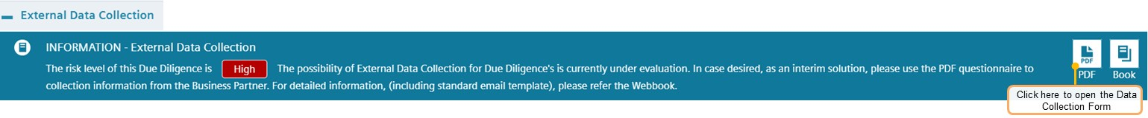

**Information of Key employees of the Business Partner (only high risk CDD)**

Key employee(s) of the Business Partner who will carry out work for Siemens and who will have direct contact with Siemens personnel (other than mere support activities, like assistants)

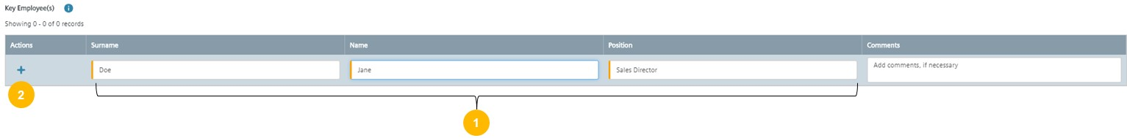

* ***Step 1:*** Enter Surname, Name and Position of the Key Employee
* ***Step 2:*** Press “+” to save the entry (and to add further key employees if applicable)

**Additional third parties used by the Business Partner (subcontractors)**

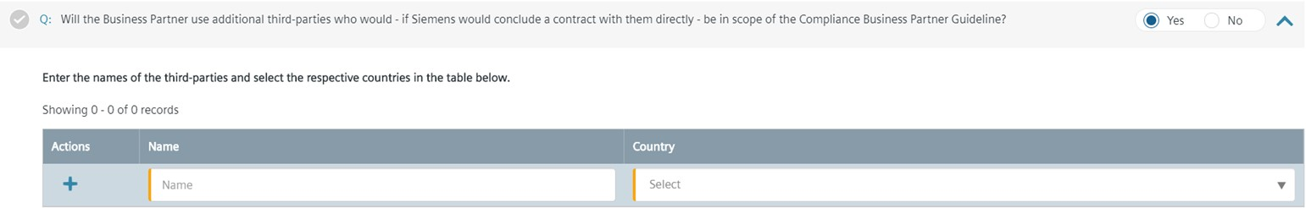

Please refer to chapter A.3. Subcontractors of Business Partners

**Information Letter / Consent Form**

To ensure that the background screening for a medium or high risk CDD on the integrity of the Business Partner is in line with the data privacy regulations at least an Information Letter needs to be sent to the Business Partner.

In some countries, data privacy regulations might require an explicit consent of the Business Partner and or the respective individuals.

The [CDD-Tool](https://compliance-tools.siemens.com/due-diligence/) contains a list of all countries requiring a Consent Form and will show the respective advice based on the country of the Business Partner or the Siemens entity.

For more information, please refer to chapter C.5.2.3.

**Audit rights and Books & Records**

Information about Siemens Audit and Books & Records requirements must be sent to Business Partners with medium or high risk CDDs. The Business Partners must understand the scope of such audits and the expectations of transparent Books & Records.

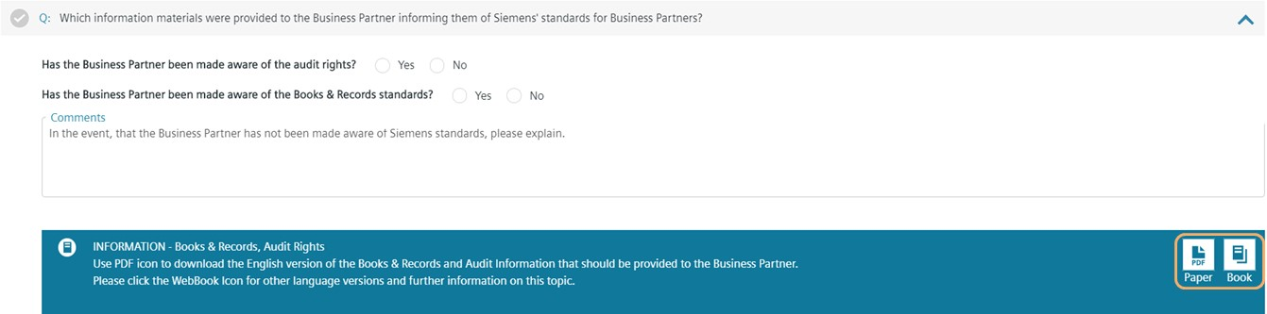

For more information, please refer to chapter C.5.2.2.

**Training of Business Partners**

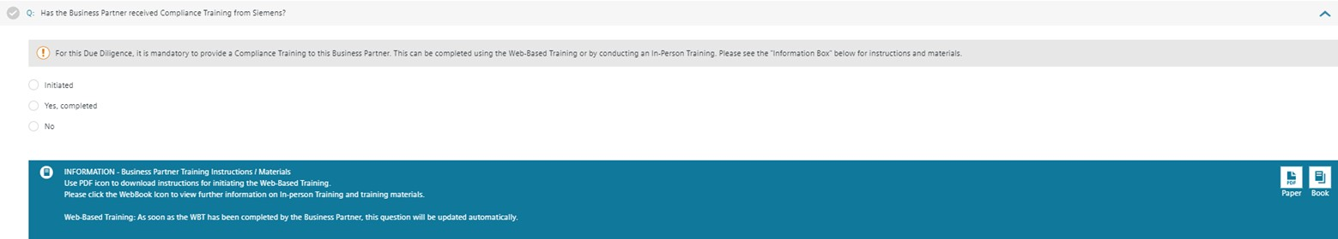

Business Partner training is mandatory for all high risk CDDs and has to be documented in the [CDD-Tool](https://compliance-tools.siemens.com/due-diligence/).

For more information, please refer to chapter A.5.

**Business licenses / authorization**

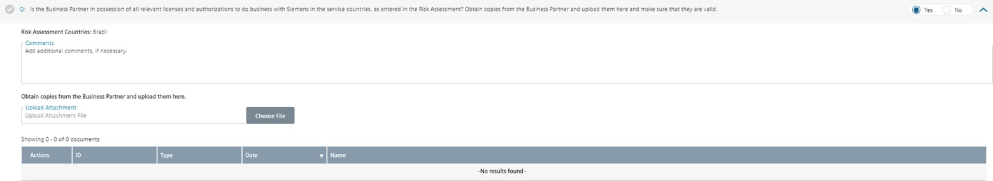

Business licenses are permits issued by government agencies that allow individuals or companies to conduct business within the government's geographical jurisdiction. A single jurisdiction often requires multiple licenses that are issued by multiple government departments and agencies. Business licenses vary between countries, states, and local municipalities. There are often many licenses, registrations and certifications required to conduct a business in a single location.

Typically, a company's business activity and physical location (address) determines which licenses are required to operate lawfully. Other determining factors may include the number of employees and the form of business ownership, such as sole proprietor or corporation.

Also, in many jurisdictions a business must notify the responsible authority and register in official registers to perform business. If the business is entered in the trade or commercial registry, this entry also determines the correct and full company name. Often, also the address and legal representatives as well as additional date are shown in the commercial register.

A list of company registers can also be found on [Wikipedia](https://en.wikipedia.org/wiki/List_of_company_registers).

**Independent background report (e.g. Dun & Bradstreet report, Creditreform, Sinotrust, Spark)**

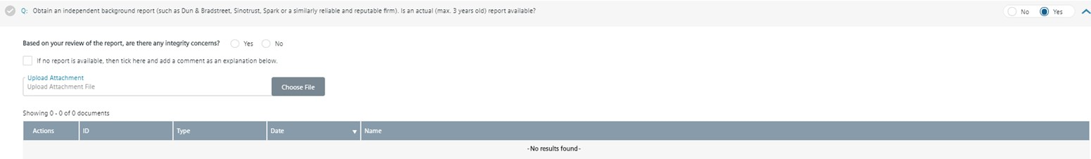

An independent background report should contain information relevant to check the information provided by the Business Partner regarding:

* Integrity of Business Partner
* Business Partners ties (personal or business) to government or a government official
* The names of all directors, officers, managing partners, owners, beneficial owners, majority shareholder, key employees
* Civil or criminal judgements against the business partner.

If there are any differences between the information in the report and the information provided by business partner, point this out to the Business Partner, obtain the business partners explanation and provide details.

Credit Reports such as Dun & Bradstreet and Creditreform can be ordered via Siemens Global Information Sphere: <https://sgi.siemens.com/home?f=credit&a=Resultlist!sm>

However, it is recommended that you contact your Compliance Officer to get information about local sources for such background report.

**Extended Key Data (Legal Representatives, Shareholders and Ultimate Beneficial Owners)**

For high risk CDDs, additional Business Partners key data related information to legal representatives, shareholders and Ultimate Beneficial Owners (UBOs) is required.

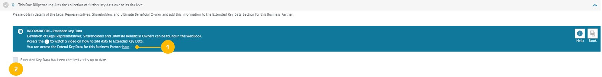

* **Step 1:** Click to access the Extended Key Data for this Business Partner. The tool automatically redirects you to the Business Partners Extended Key Data page.
* **Step 2:** After the Extended Key Data is completed tick the box.

You can find more information how to enter Extended Key Data here

**Internet and Sanction Party Check**

This [video](https://myid.siemens.com/idp/SSO.saml2?SAMLRequest=fVLLboMwEPwV5DuPWiUhFiCliapGShsUaA%2B9VA4sjSWwqdekzd%2FXkFZKLhy9npmdGTtG3jYdW%2FbmKPfw1QMa56dtJLLxIiG9lkxxFMgkbwGZKVm%2BfN4y6gWs08qoUjXkijLN4IigjVCSOJt1Qj74XTSjlM%2FCmsNdNA8AIKzD%2BX1dBYtZHUY15Qdqz1FFnDfQaJkJsUKWjtjDRqLh0thRQAM3WLg0LIKQhSGj9J04a5tGSG5G1tGYDpnvt2dReSigBYleqVpfVJ2f5ztvcE%2BJs%2Fy3uFIS%2BxZ0DvokSnjdb69FTqICdaPTW57PbZEgjSi5AeJkfwU9CFkJ%2BTndzeECQvZUFJmb7fKCpPFgio1ZdTqxPPavgfHlUV%2Fsis06U40oz86j0i030w6GiajceoSybugbjU1jS2ka9b3SYFMlxOgeiJ9edt7%2BnfQX&RelayState=%2Fmedia%2F1_nxu0lvvp) provides additional assistance on how to use SETIS for Internet checks.

For Business Partner with key persons, representatives, shareholder and UBOs an further internet and sanction party checks need to be evaluated. Check the representative names against the Sanctioned Party List result and Internet search result in SETIS. Review anything that might cause you to suspect the company’s reputation or integrity.

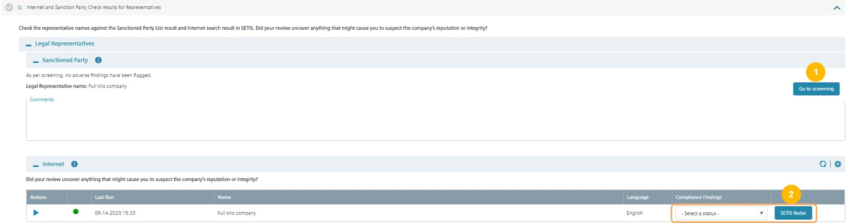

* **Step 1:** In case of adverse findings, press “Go to Screening” to evaluate results from sanction parties list. The [CDD-Tool](https://compliance-tools.siemens.com/due-diligence/) redirects you to the Business Partners Screening page (C.2.2.5. Screening) to tag potential hits. Afterwards return to the DD Questionnaire to finalize the CDD question.
* **Step 2:** Review internet results from SETIS. Press “SETIS Radar” Button to show relevant results from Intranet. The [CDD-Tool](https://compliance-tools.siemens.com/due-diligence/) redirects you in an second window to the SETIS Internet Results page to tag relevant Internet hits. Afterwards select the overall rating of the Compliance findings.

If key employees, shareholder and ultimate beneficial owner subcontractor exist, further checks need to be reviewed in these chapter.

### C.2.6. Review & Approval

An approval decision for a CDD must be documented in the [CDD-Tool](https://compliance-tools.siemens.com/due-diligence/). Contracts for high risk CDDs require an additional approval (outside of the [CDD-Tool](https://compliance-tools.siemens.com/due-diligence/)).

Where integrity concerns exist, the Siemens unit must take appropriate steps – in cooperation with the relevant General Counsel and Compliance Officer – to mitigate the risk of corruption.

Approval requirements depend on the CDD risk level. Approval steps are **automatically set** in the [CDD-Tool](https://compliance-tools.siemens.com/due-diligence/).

**Low risk CDD**

* **Management approval of CDD and contract:** Management function of the respective Siemens unit according to the signature mandate of this unit.

**Medium risk CDD**

* **Compliance review of CDD:** Compliance Reviewer as defined in roles management tool (SCROM)
* **Management approval of CDD and contract:** Management function of the respective Siemens unit according to the signature mandate of this unit or specific OpCo / Business Unit.

**High risk CDD**

* **Compliance review of CDD:** Compliance Reviewer as defined in roles management tool (SCROM)
* **Compliance approval of CDD:** All high risk CDDs are to be approved by the responsible CMC Member. Further information can be found [here](https://findit.compliance.siemens.com/content/10000101/Compliance/LC_CO/LC_CO_RG_PL/findIT_LC_CO_RG_PL_9045.pdf).
* **Management approval of CDD**: Management function of the respective Siemens unit according to the signature mandate of this unit or specific OpCo / Business Unit regulations (see Business Partner strategy of corresponding unit).
* **Management approval of contract:** Relevant CEO / Head of a Business Company[28], Regional Company or Corporate Function.

For the avoidance of doubt, further approvals for the contracts or alignment with dedicated departments within Siemens may be required to finalize a contract with the Business Partner. For example, Strategy ST TO is responsible for the preparation and conclusion of contracts between sales agents / distributors and Siemens AG allocating representation rights / sales rights to third parties to ensure that sales rights granted to the Business Partner do not overlap with those granted to other sales agents. Nevertheless, the Siemens unit concerned must make sure that the agency agreement contains the relevant compliance model clauses (see [SC 140 “Regional sales activities - Representation rights and sales rights](https://regulations-admin.siemens.com/content/SC/140/en)” for details).

##### C.2.6.1. Compliance Review

For medium and high risk CDDs, the responsible Compliance Reviewer (Compliance Officer) must perform a Compliance Review and submit the CDD. The [CDD-Tool](https://compliance-tools.siemens.com/due-diligence/) determines the responsible Compliance Reviewer automatically based on the ARE. 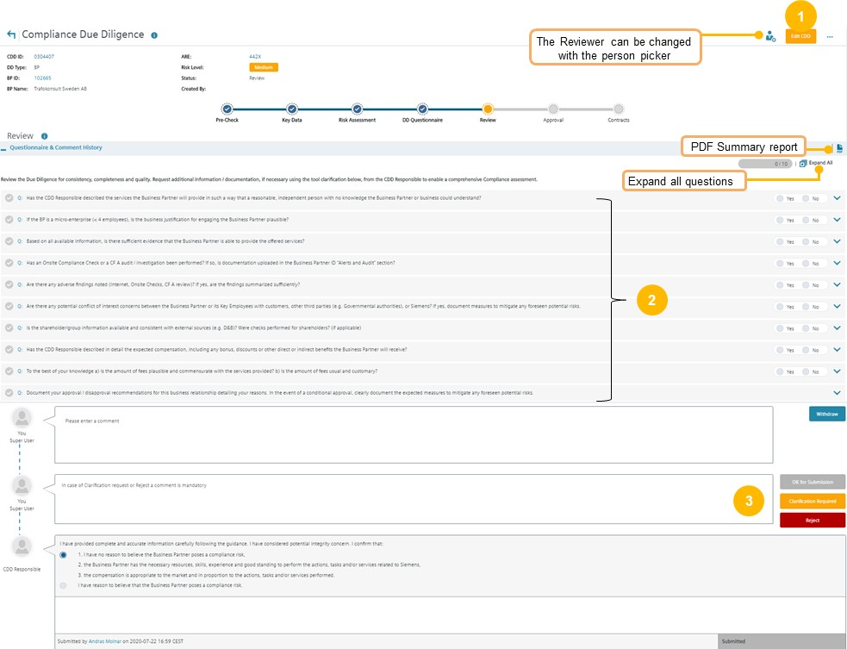

* **Step 1:** Press “Edit CDD”
* **Step 2:** Answer all questions. Click on the blue arrow to expand the sections
* **Step 3:** Based on your review either submit for the next approval step(s) (OK for submission) or submit the CDD back to the CDD Responsible (Reject)

If based on a review, the CDD shall be disapproved, you must submit the CDD to the next approver to do the disapproval in the approval section.

**Note:**In the EDIT mode, you cannot switch to other process steps like DD Questionnaire. If you want to review the CDD information (Key Data, Risk Assessment or DD Questionnaire) just press “Cancel” to leave the EDIT mode in the Review section.

This [CO Review guidance](https://findit.compliance.siemens.com/content/10000101/Compliance/LC_CO/LC_CO_DF/findIT_LC_CO_DF_9224.pdf) is aimed for the CO Reviewer and useful for CO Approvers and other Compliance colleagues to understand the main aspects of the CO Review and analysis of all the information in a CDD.

##### C.2.6.2. Compliance Approval

All high risk CDDs must be approved by the responsible CMC Member. Further information can be found [here](https://findit.compliance.siemens.com/content/10000101/Compliance/LC_CO/LC_CO_RG_PL/findIT_LC_CO_RG_PL_9045.pdf).

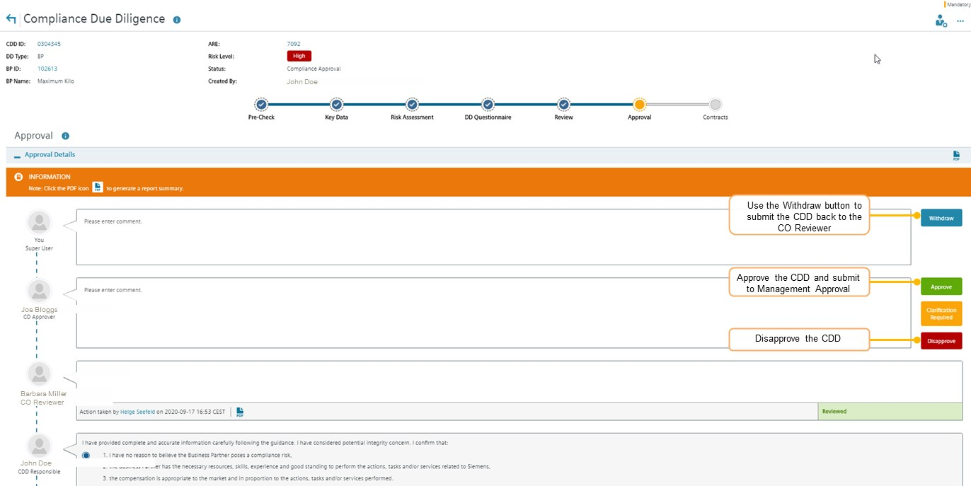

**Step 1:** Go to **“Approval”** section

**Step 2:** Select one of the decision options

**Note:** With the clarification request button, you can communicate with persons involved In the CDD in a chat function. The clarification request button has no influence on the workflow status - it remains in “Compliance Approval”. To submit the CDD back to the CO Reviewer to adapt the CO Review, use the Withdraw button.

##### C.2.6.3. Management Approval

Once the CDD is submitted for approval the respective **Management Approver** receives a notification for an approval decision.

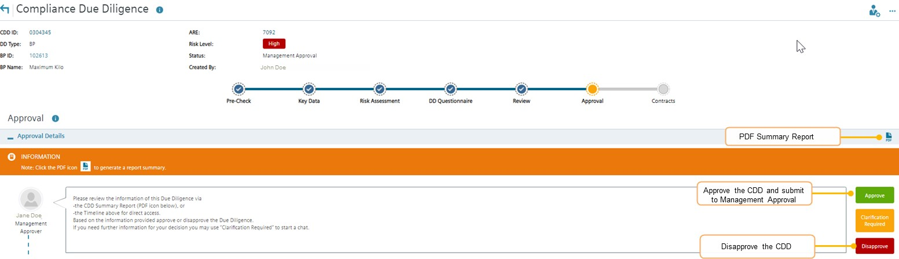

**Step 1:** Go to **“Approval”** section

**Step 2:** Select one of the decision options

For definition and change of Management Approvers please refer to C.5.1.1.

##### C.2.6.4. Withdrawal of Approval or Disapproval

The approval of a CDD can be withdrawn by Management or Compliance if compliance concerns have been identified and the approval decision must be changed.

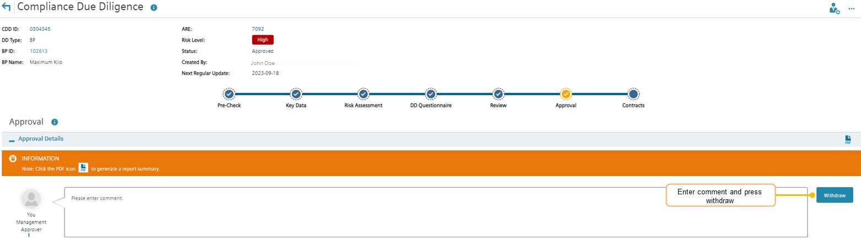

***Step 1:*** *Go to* ***“Approval”*** *section****Step 2:*** *Press “Withdraw”*

**Note:** After Withdrawal, the workflow status changes to “In Update – Key Data”.

### C.2.7. Contracts

The status of contracts with Business Partners must be registered in the [CDD Too](https://compliance-tools.siemens.com/due-diligence/)l. The details must be updated in case of subsequent alterations, amendments, or extensions.

For details regarding mandatory contract provisions and other issues regarding the contractual relationship see chapter A.6.

After approval of the CDD, the “contracts” section becomes available. The status must be entered and regularly updated.

**How to register contract information**

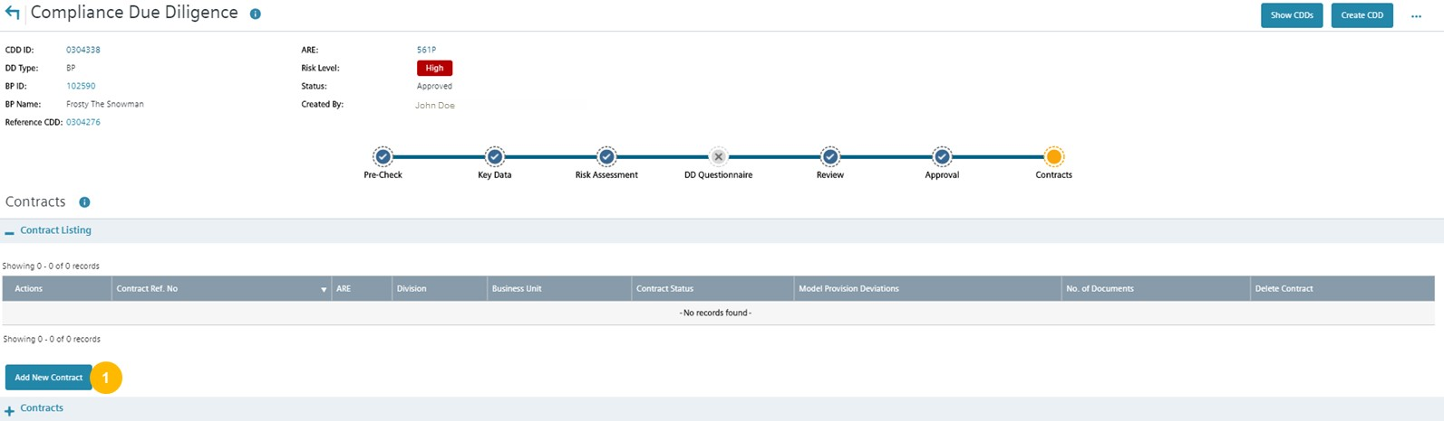

**Step 1:** Go to **“Contracts”** and press “Add New Contract”

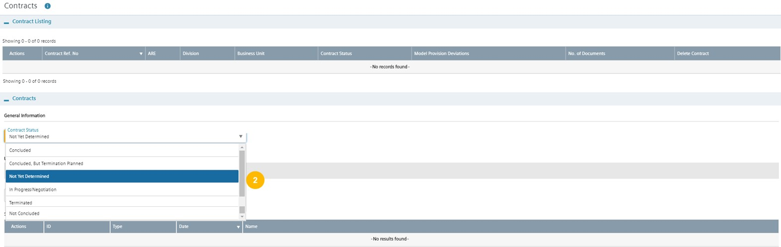

**Step 2:** Select the contract status (e.g. concluded)

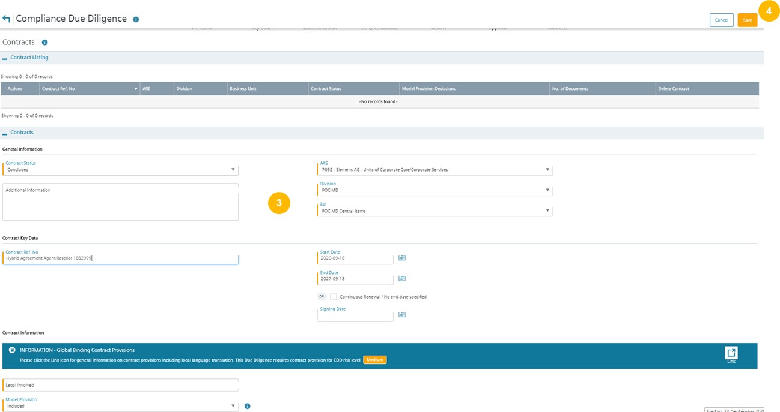

**Step 3:** Add information about the contract (fields in orange are mandatory)

**Step 4:** Press “Save”

## C.3. Update of CDDs

**Overview of Update Process (Regular and Ad hoc)**

The Update Process in combination with the existing Business Partner portfolio reviews of CDDs in Compliance Review Boards, the automatic SETIS screening of a Business Partner every 6 months and regular discussions in Management meetings support the ongoing monitoring of Business Partner relationships.

**Regular Updates:**

A Regular (mandatory) update of a CDD is due every three years from the last approval date. Only a limited number of questions must be re-answered. However, the CDD Responsible must check the CDD and must ensure that the **content of the complete CDD is up to date and reflects the current relationship** with the Business Partner.  
The following information must be newly answered:

* Low risk: updated integrity search;
* Medium risk: as low risk plus a new version of the independent background report (Dun & Bradstreet) to be obtained and reviewed;
* High risk: as for low/medium plus update of organizational setup (Extended Key Data and group structure) and integrity checks (SETIS/internet and Involvement of Key Persons in litigations).

The CDD Responsible gets an email notification to start an Update of a CDD and the approval process is streamlined depending on the significance of any changes as follows:

* No significant changes: only sign-off by the CDD Responsible is required, with the Management Approver and CO Reviewer informed of the changes made via email. They may still raise questions and request further information if deemed necessary.
* Significant changes: a re-approval by the Management and a repeat of the review by CO Reviewer responsible. An involvement of further stakeholders like CO Approver or CMC may be necessary. Only an increase of the risk level to high risk requires a documented Compliance approval.

The [CDD-Tool](https://compliance-tools.siemens.com/due-diligence/) automatically determines the relevant approval process.

**Change of Regular Update Date:**

Compliance Officers can change the due date for a Regular Update. In order not to run the risk that the information in the CDD is not kept up to date, the date should be chosen sensibly. The new due date must not be in the past and max. 1 year later than the current due date.

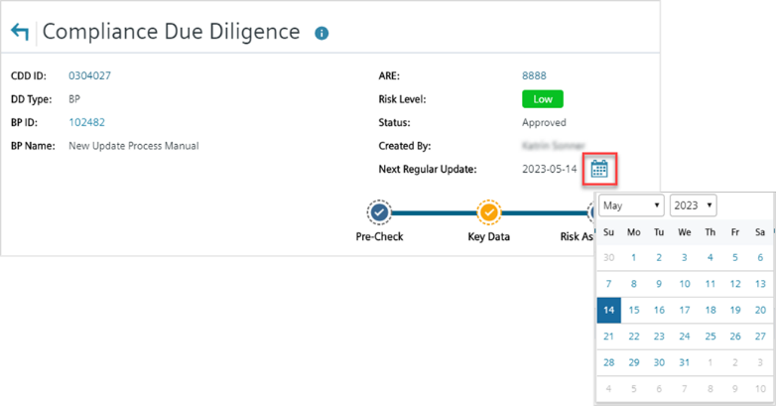

**Ad hoc Updates:**

Between the three-year Regular Updates, the CDD Responsible is still obliged to keep the CDD up to date by starting an Ad Hoc Update. Any Update that constitutes a significant change will result in a reapproval as under the Regular Update.

To further limit risk, every six months the Business Partner name and Aliases will be automatically screened via SETIS against our integrity database. In case of new hits Compliance Reviewers will be informed via email, asked to evaluate the hits and to initiate further actions if deemed necessary.

The Regular and Ad hoc Update process is illustrated on the following picture:

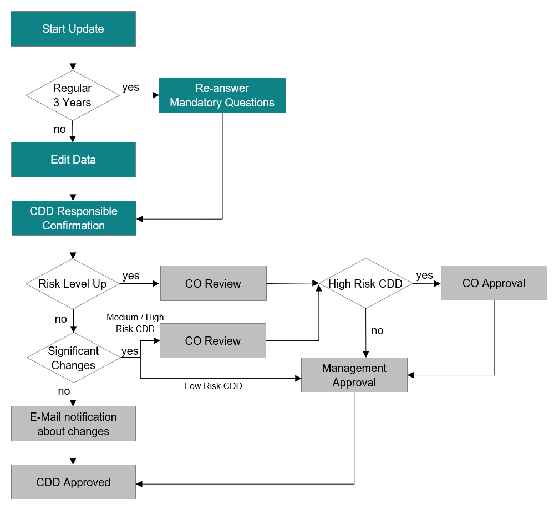

**Regular Update and Ad Hoc Update**

The process of Regular and Ad hoc Updates is basically the same, but the Regular Update Process will reset answers to essential questions. These must be answered again by the CDD Responsible.

**Regular Update**

The request to update a CDD is made in 2 ways. One is by receiving an e-mail notification and the other is via “My Dashboard” in the [CDD-Tool](https://compliance-tools.siemens.com/due-diligence/) itself.

**Ad Hoc Update**

**Hint**

Once the Update Process has started, it can no longer be stopped and must be run through to the end. If no changes are made, the Update Process is completed without a management approval.

Before you start the update, please check in the Person Picker if the correct Management Approver has been selected.

If the Approver needs to be changed, the new responsible persons can be added in the WCST (“Who can see this?”) section and then selected in the Person Picker.

The following cases are considered below:

* Case a: **Update without re-approval** (No increase of Risk Level and no Significant Changes)
  + Example: Low Risk CDD
* Case b: **Update with re-approval** (No increase of Risk Level and Significant Changes)
  + Example: Medium Risk CDD

1. **Update without re-approval** (No increase of Risk Level and no Significant Changes)

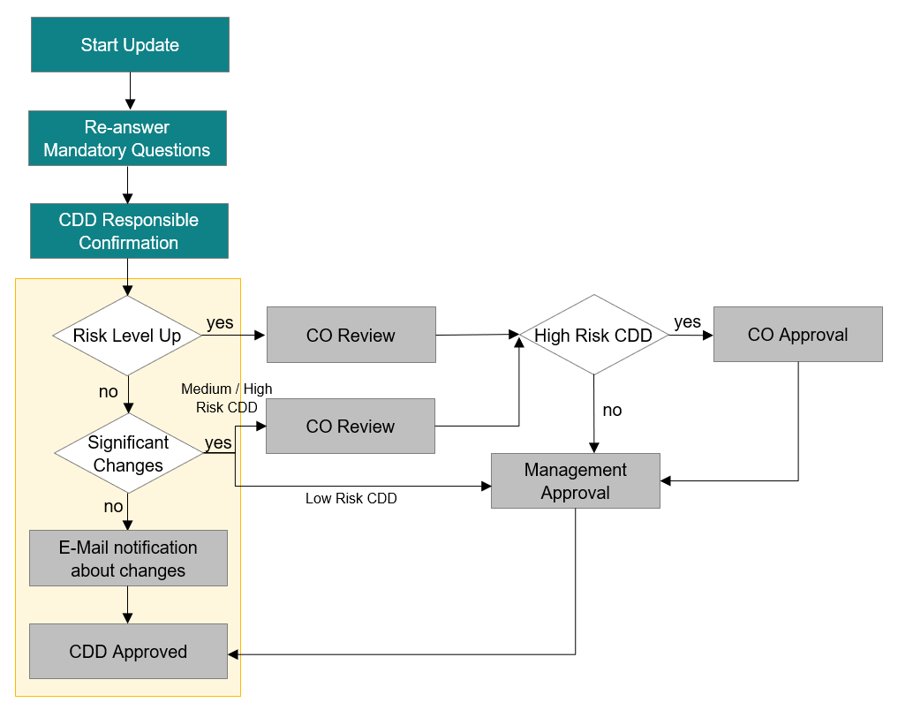

1. **Start Update – CDD Responsible**

My Dashboard: CDD Responsible starts update in “My Dashboard”

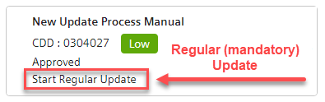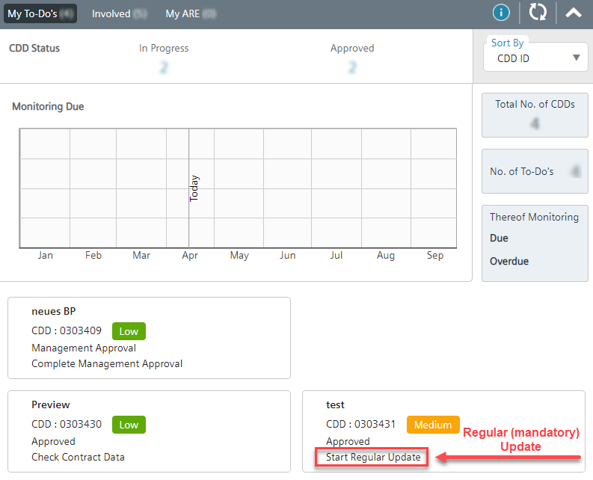

Open CDD and ***Start Update*** process:



1. **Key Data – CDD Responsible**

The Status of the CDD will change into ***in Update – Key Data***.

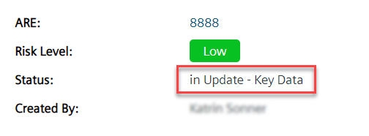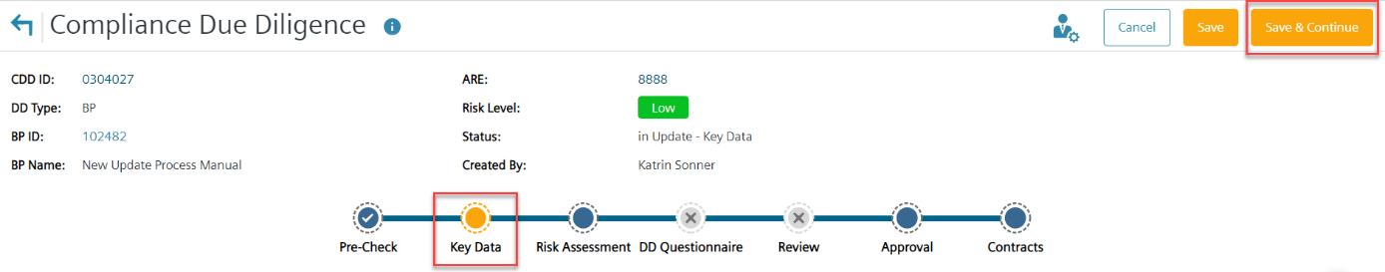

In this example, no changes in the **Key Data** section are required. Press ***Save & Continue***.

1. **Risk Assessment – CDD Responsible**

Tag the search results for SETIS, go back to [CDD-Tool](https://compliance-tools.siemens.com/due-diligence/) ***and Select a status*** in the Compliance Findings in the **Risk Assessment** section. In this example, the status is the same as before the update: **No relevant Compliance findings**.

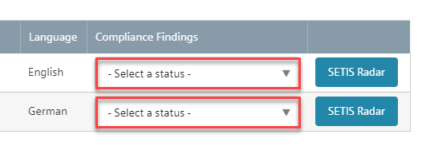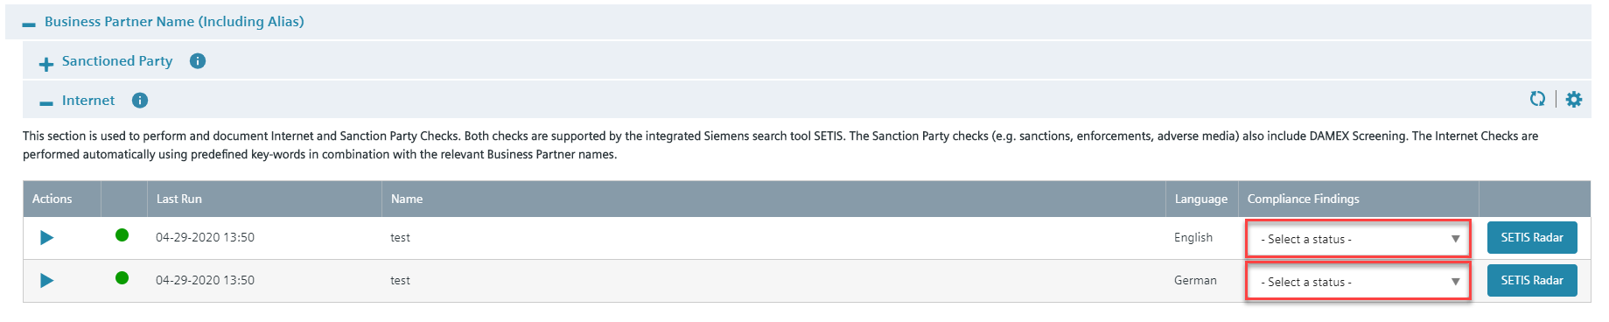

… and press ***Save & Continue***.

With the confirmation that the guidance has been followed, information is provided and integrity concerns are considered, the Update can be completed. Press “***Complete Update”***.

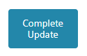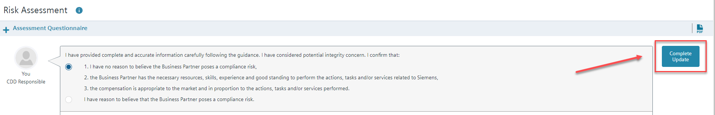

An E-Mail notification will be sent to the selected Management Approver and the selected CO Reviewer (Medium / High Risk CDDs).

Update is now completed.

1. **Update with re-approval** (No increase of Risk Level and Significant Changes)

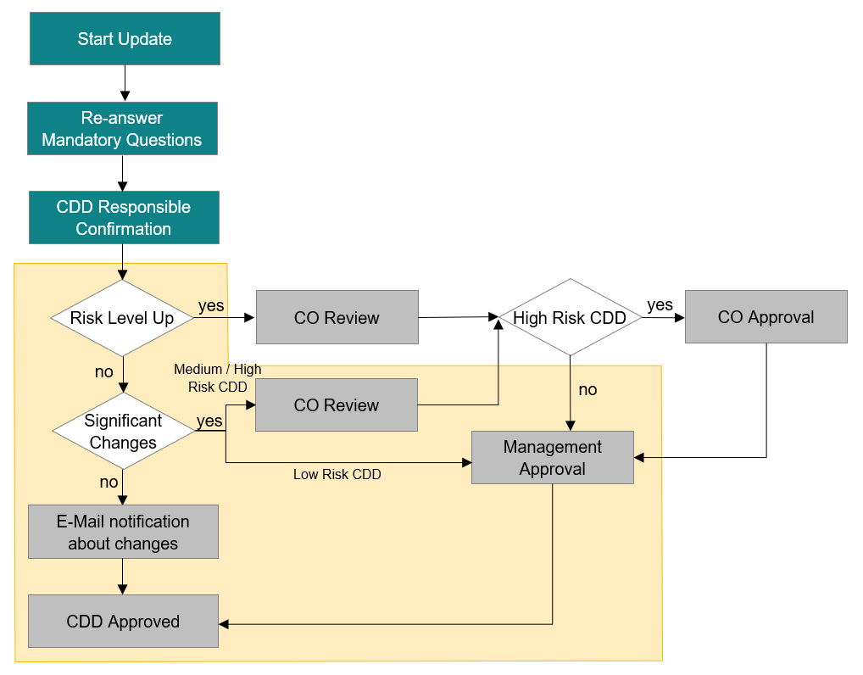

**Low Risk CDDs** with significant changes need to be approved by the Management.

**Medium Risk CDDs** with significant changes need to be reviewed by Compliance and then approved by the Management.

**High Risk CDDs** with significant changes need additionally a Compliance Approval after the Compliance Review and before the Management Approval.

1. **Start Regular Update – CDD Responsible**

My Dashboard: CDD Responsible starts update in “My Dashboard”



Open CDD and ***Start Update*** process:



1. **Key Data – CDD Responsible**

The Status of the CDD will change into ***in Update – Key Data***.

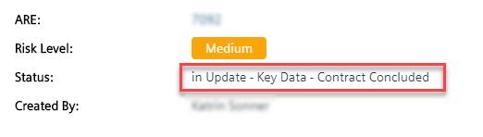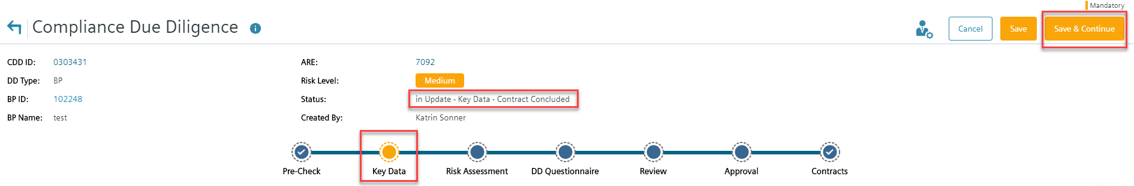

If there is no need to update the **Key Data** section, press ***Save & Continue***.

1. **Risk Assessment and SETIS Screening – CDD Responsible**

The [CDD-Tool](https://compliance-tools.siemens.com/due-diligence/) switches to **Risk Assessment** …

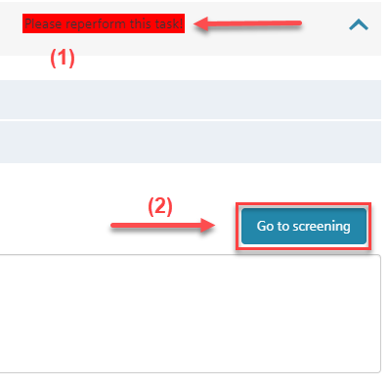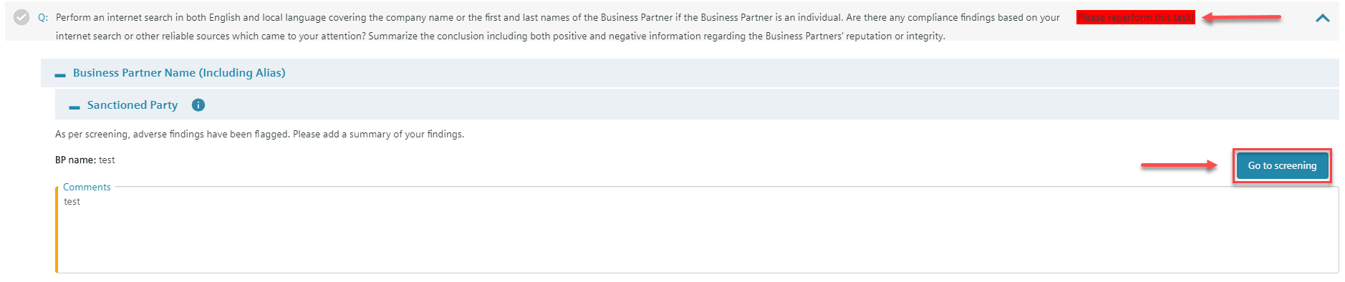

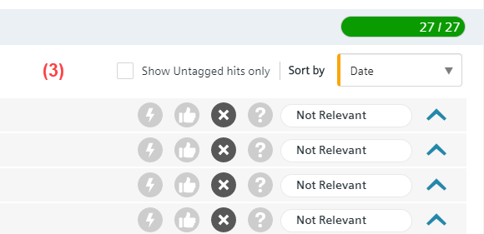

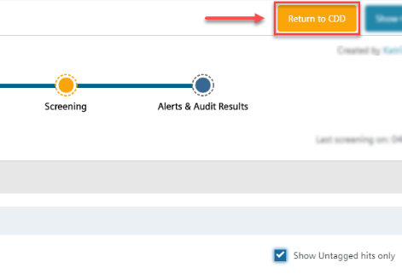… and ask you to perform mandatory tasks (1), to do a SETIS screening (2) and tag all search results (3) according to their relevance.

After finishing the screening in SETIS, press ***Return to CDD***.

***Select a status*** in the Compliance Findings in the **Risk Assessment** …



… and press ***Save & Continue***.

1. **DD Questionnaire – CDD Responsible**

The CDD jumps to **DD Questionnaire** and asks to reperform the mandatory tasks.

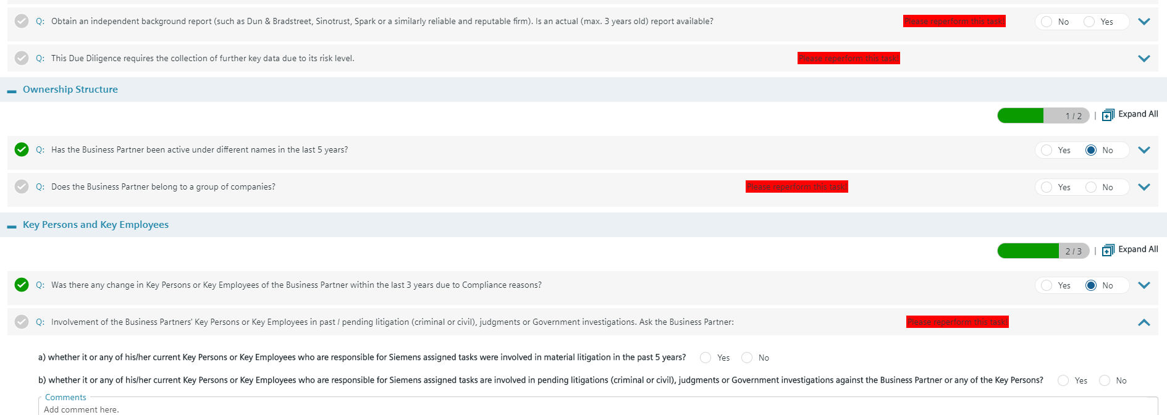

Press ***Check Completeness*** to ensure that all questions are answered.

1. **Submit for Review – CDD Responsible**

If the completeness check was successful, the CDD must send to the CO Reviewer with ***Submit for Review***.

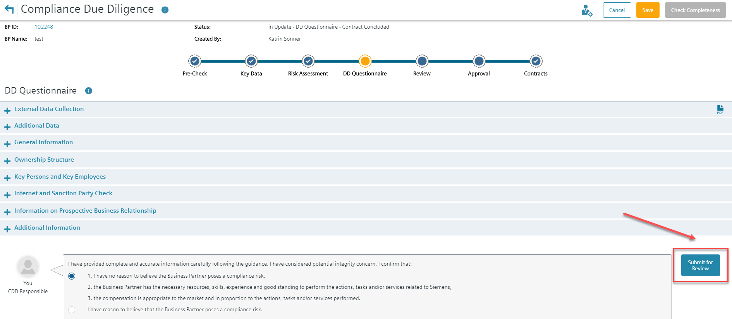

1. **Complete Compliance Review – CO Reviewer**

My Dashboard: CO Reviewer starts review in “My Dashboard”

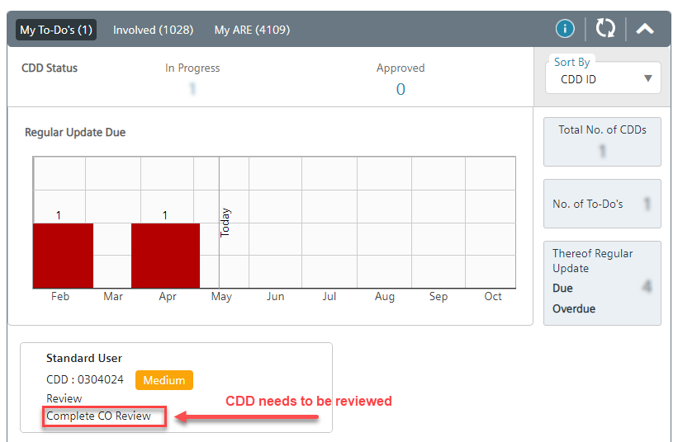

Open CDD and ***Edit CDD*** to start review:

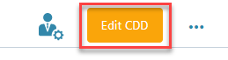

Answer the questions and press ***Save & Continue***.

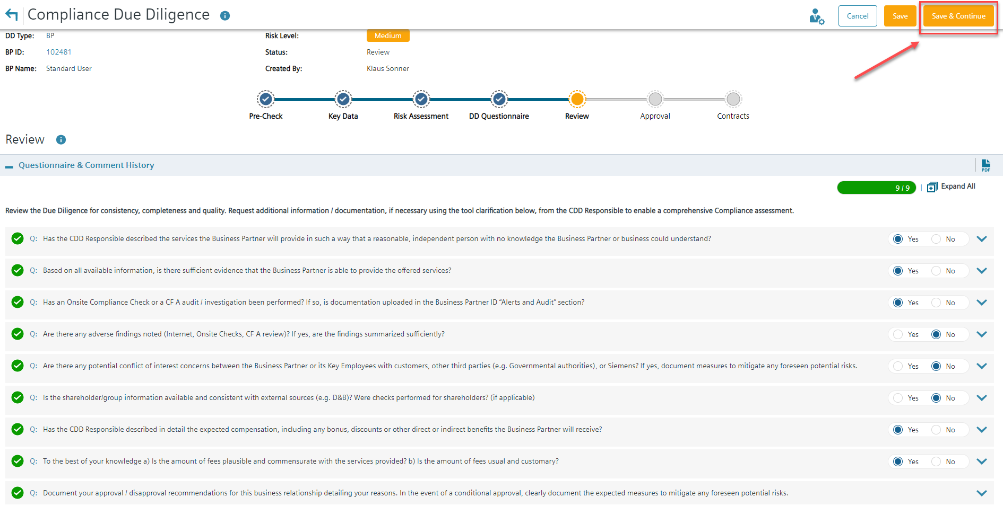

To complete the review, press ***OK for Submission***.

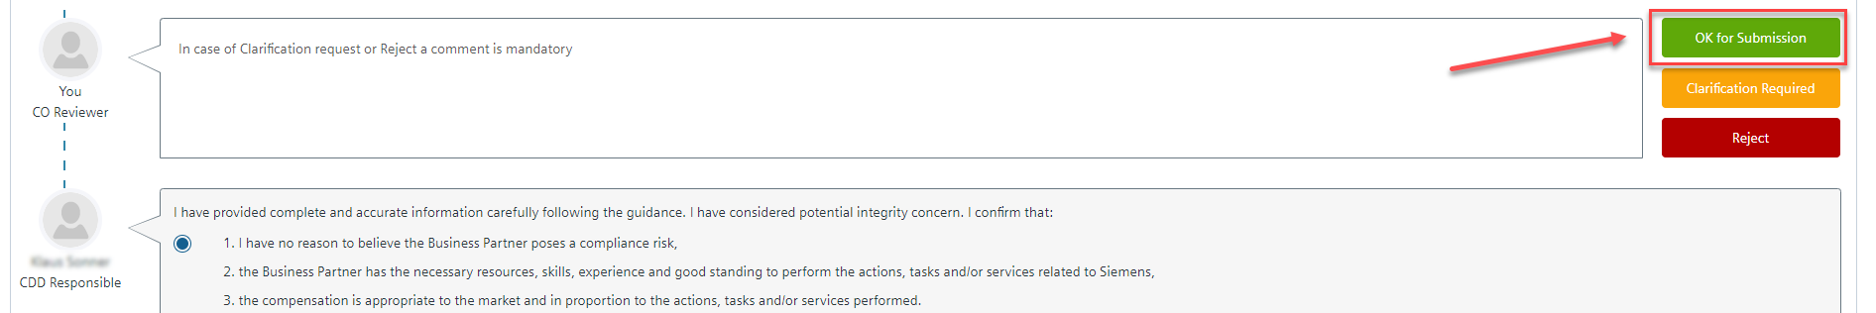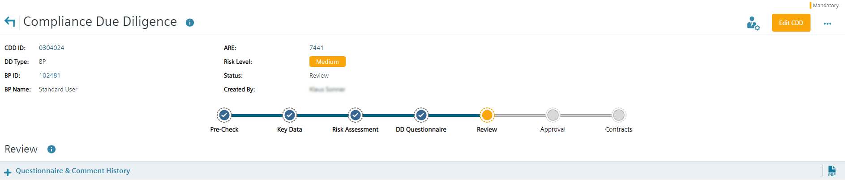



1. **Complete Approval – Management Approver**

My Dashboard: Management Approver starts approval in “My Dashboard”

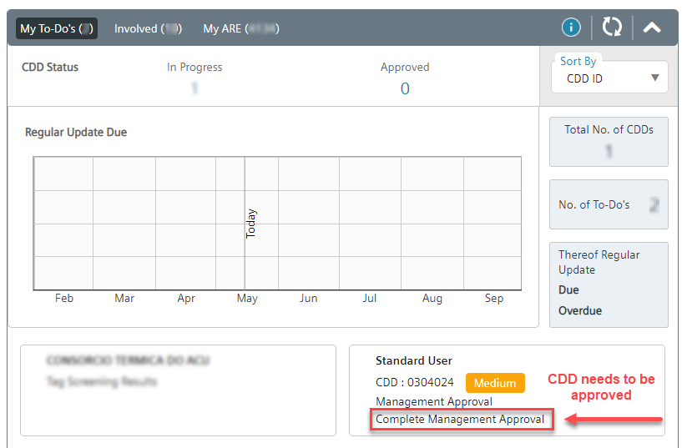



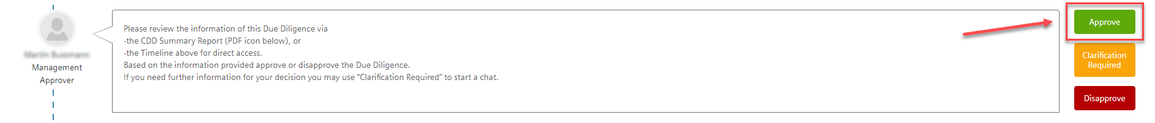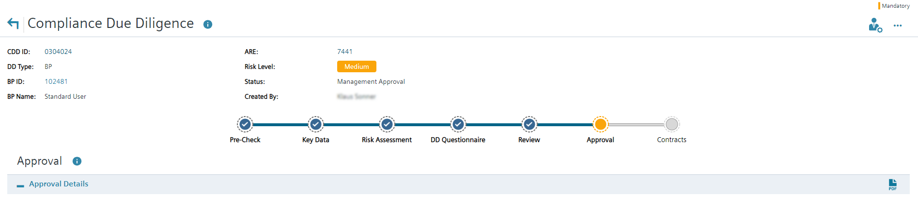

Update is completed.

**Further information and guidance material is available:**

* [Video Tutorial: "Handling of new Integrity Search Results - Instructions for Compliance Reviewer"](https://myvideo.siemens.com/media/1_d7uqgbhz)
* [Video Tutorial: "Regular Update" without Risk Level Change and without Significant Changes](https://myvideo.siemens.com/media/1_v0uszm7h)
* [Video Tutorial: "Adhoc Update" without Risk Level Change and with a Significant Change](https://myvideo.siemens.com/media/1_82s9bain)
* [Questions & Answers - New Update Process](https://findit.compliance.siemens.com/content/10000101/Compliance/CL_CO/CL_CO_P/findIT_CL_CO_P_9172.pdf)
* [Instructions for CDD Responsibles on how to update the CDDs](https://findit.compliance.siemens.com/content/10000101/Compliance/CL_CO/CL_CO_P/findIT_CL_CO_P_9096.pdf)
* [Instructions for Management Approver on how to complete the Management approval](https://findit.compliance.siemens.com/content/10000101/Compliance/CL_CO/CL_CO_P/findIT_CL_CO_P_9116.pdf)
* [Video: How to monitor regular updates in the CDD Tool and in the BP Dashboard (06:18 min)](https://web.microsoftstream.com/video/72cf02f6-ec81-48c3-9723-7386dd9b48b0?list=studio)

## C.4. Reuse of existing CDDs (reference CDD)

If a Business Partner is retained more than once, an approved and valid CDD may already exist. If this CDD was performed by the same Siemens unit (ARE) and covers all aspects of the new engagement e.g. Business Partner type, scope of work, country, proposed remuneration and payment terms, this CDD can be used and no additional CDD is required. However, the new contract must be maintained in the contract section of this CDD.

If the CDD was performed by a different ARE a new CDD must be performed even if all aspects of the business relationship are identical. Further, if the Business Partner is retained for a different scope of work, or if other circumstances of the CDD which may influence the approval decision are different from those which have already been approved in the existing CDD, a new CDD is necessary.

The results of an existing CDD (parent) can be reused in certain cases to avoid double work using the Reference function for medium and high risk CDDs.

For Global Business Partners refer to chapter A.4.3..

**How to create a Reference**

* ***Step 1: Start*** new CDD and complete the Risk Assessment.
* ***Step 2:*** If Reference is possible (Key Data and Risk Assessment of both CDDs are generally the same), select relevant CDD at the end of ***“Risk Assessment”*** and provide a comment.
* ***Step 3***: Press “Request Reference”

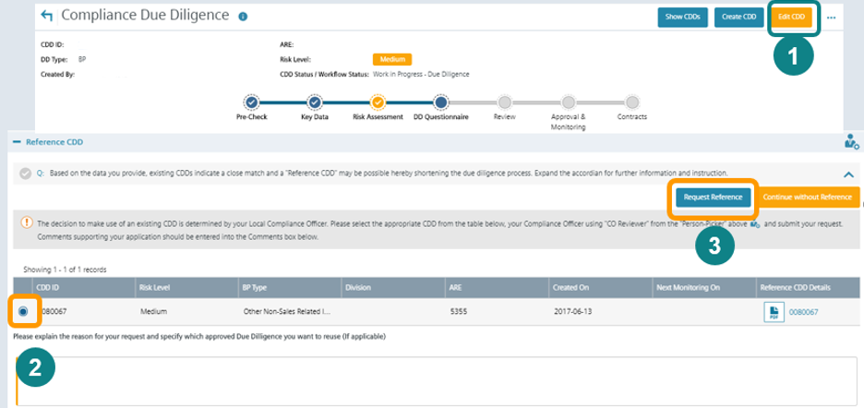

The request for Reference must be confirmed by Compliance and approved by Management

**How to confirm a Reference by Compliance**

* ***Step 1:*** Go to **“Review”** section
* ***Step 2***: Press “OK for Manager Approval”

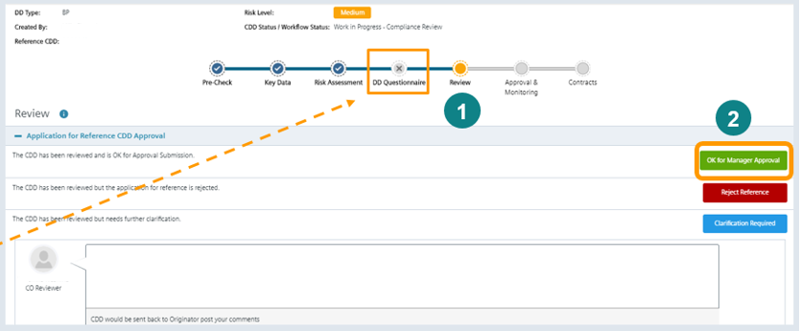

**Note:**

* “DD Questionnaire” is not applicable for References.
* After confirmation by Compliance the Management Approver is informed via email to “Approve” the Reference CDD. (Ensure that *Management Approver* is maintained in “Who can see this?”)
* Approval of a Reference does not mean that no separate contract is required to be signed / registered. Every Siemens unit must ensure that a valid contract with the Business Partner is existing and contract details are maintained in the CDDs “Contracts” section.
* If the parent CDD becomes invalid, the existing Reference CDD must be changed to a standard CDD via the Update process. (Compliance Officers may use the Business Partner Dashboard to figure out References with invalid parent CDDs.)

## C.5. Supporting functions and documents

### C.5.1. Supporting functions

##### C.5.1.1. How to manage CDD roles

**Note**: CDD roles can be managed in the View mode of a CDD. There is no need to edit the CDD or to start an update of a CDD to change roles.

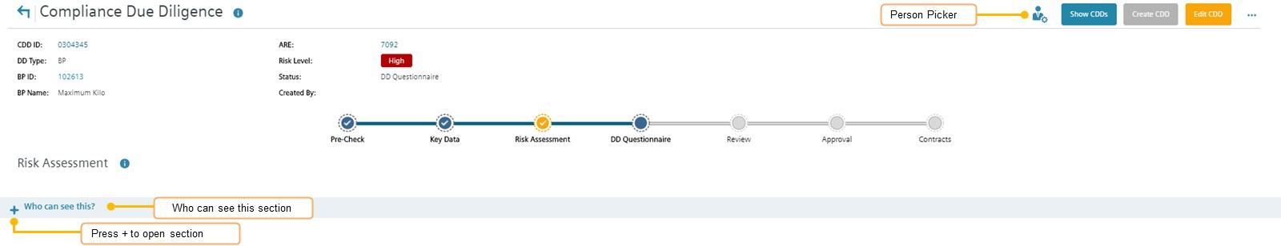

In the “**Who can see this?**” section roles for CDD Responsible, Management Approver and CDD Viewer can be added or deleted. Management Approvers **should be added manually in all cases**.

Compliance Officer roles (CO Reviewer, CO Approver) are maintained in the Compliance role Management system SCROM and cannot be manually added in this section.

With the **“person picker”** in the right upper corner **–** the lead roles for the CDD (Lead CDD Responsible, Lead Management Approver, Lead CO Reviewer, Lead CO Approver) can be defined/changed. You can define for example two or more CDD Responsibles for a CDD in the “Who can see this?” section (who can edit a CDD and receive relevant e-mail notifications). But only the CDD Responsible in the “person picker” is the Lead CDD Responsible who can, for example, submit a CDD for Management Approval or for CO Review.

**How to enter Roles in the “Who can see this?” section**

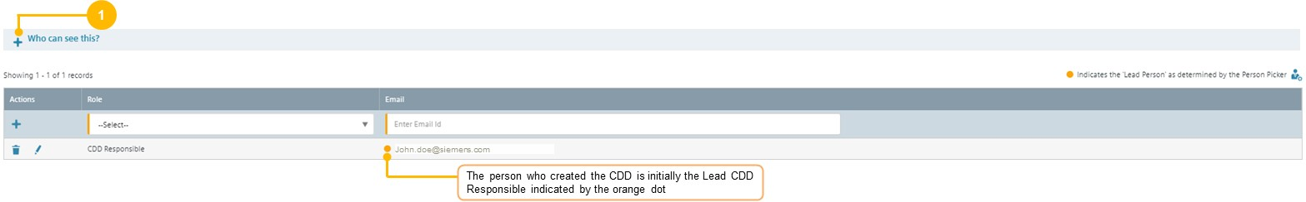

***Step 1:*** Press "+" at “**Who can see this**” at the very bottom.

***Step 2:*** Select the role that you want to add 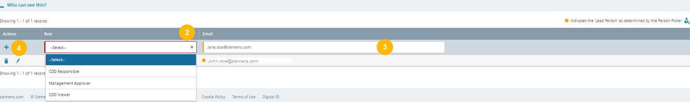 (CDD Responsible, Management Approver, CDD Viewer).

***Step 3:*** Enter the e-mail address of the person you want to add.

***Step 4:*** Press “+” to save.



**How to change Lead Roles with the Person picker**

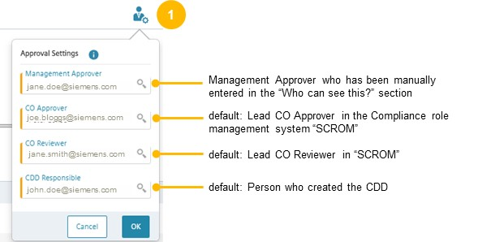

***Step 1:*** Click on the “person picker” button next to the “Show CDDs” button in the upper right corner.

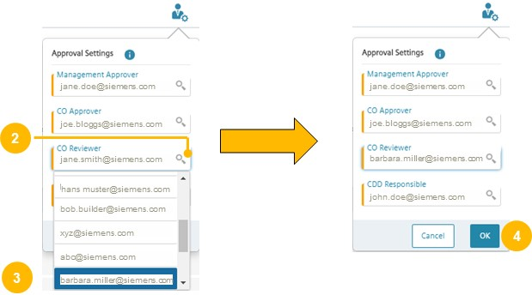

***Step 2:*** Select the lead role that you want to change (e.g. CO Reviewer) and click the magnifying glass.

***Step 3:*** Select the person that should get the new lead role.

**Step 4:** Confirm with OK

**Scenario:**

A CDD Responsible (john.doe@siemens.com) should be replaced by another person (james.young@siemens.com)

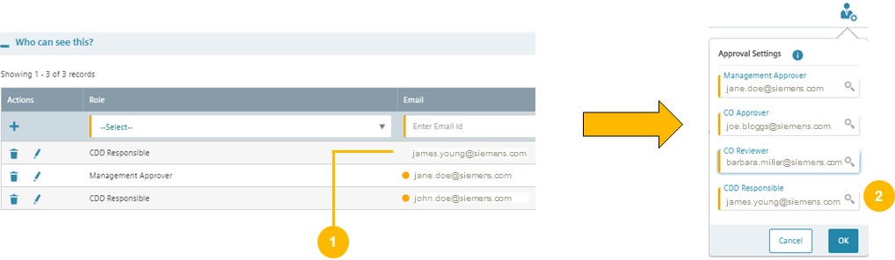

***Step 1:*** Add the new CDD responsible (james.young@siemens.com) in the “Who can see this?” section

***Step 2:*** Change the lead CDD responsible with the person picker from john.doe@siemens.com to james.young@siemens.com)

*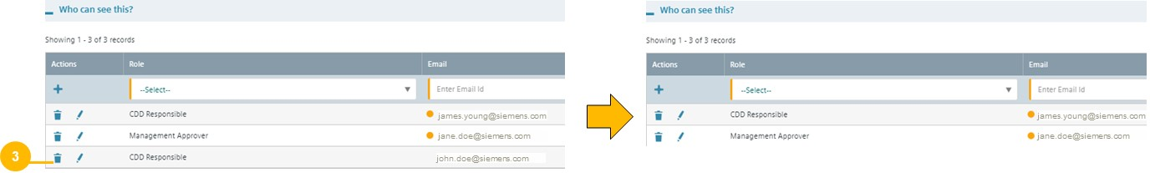****Step 3:*** Delete the old CDD responsible john.doe@siemens.com with the paper bin.

##### C.5.1.2. Closing/Cancellation/Reactivation of CDDs

A CDD in work in progress (e.g. in status “key data”, “risk assessment”, or in an approval stage) can be **cancelled** by a CDD Responsible or a Compliance Officer.

An approved or disapproved CDD can be **closed** by a Compliance Officer only. A CDD should be closed if the CDD is no longer needed (not even as a parent CDD for a Reference CDD). If the contract status of a CDD is “not concluded” or “terminated” for one year, the CDD will be automatically closed (in accordance with the data deletion concept).

Closing and cancellation are done with the same process steps.

**How to cancel a CDD**

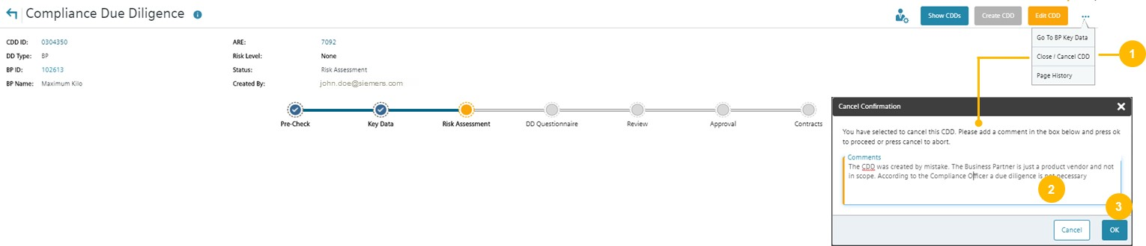

***Step 1:*** In the view mode of a CDD (not in the edit mode) press the three dots to open the menu bar. Press “Close / Cancel CDD”

***Step 2:*** In the pop-up window, enter a comprehensive comment why the CDD should be cancelled.

***Step 3***: Press OK

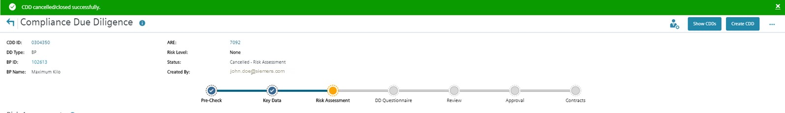

Note: A cancelled CDD gets a cancellation flag and the status “cancelled” but is not immediately physically deleted (according to data deletion concept).

**How to reactivate a CDD**

A cancelled or closed CDD can be reactivated by a Compliance Officer

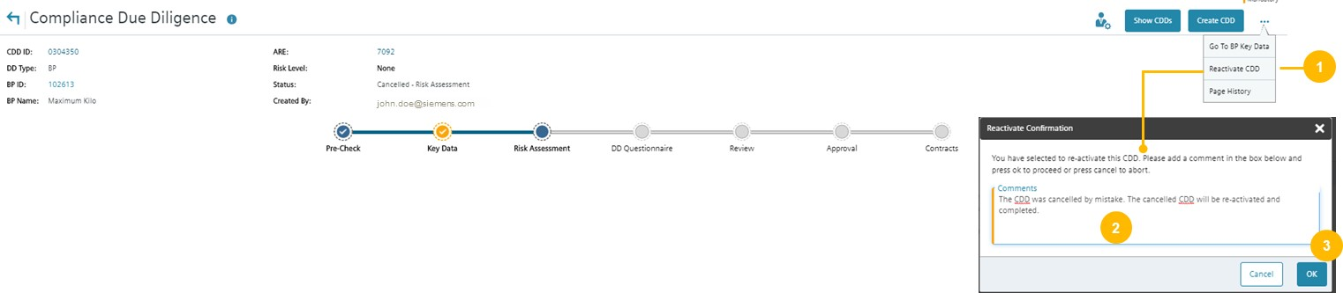

***Step 1:*** In the view mode of a CDD (not in the edit mode) press the three dots to open the menu bar. Press “Reactivate CDD”.

***Step 2:*** In the pop-up window, enter a comprehensive comment why the CDD should be reactivated.

***Step 3***: Press OK.

##### C.5.1.3. Centrally Disapproval / Business Partner under observation

Compliance Officer can flag a Business Partner as “under observation” or as "centrally disapproved" In the Alerts & Audits Result section.

A Centrally Disapproval should be performed e.g. in case of a negative result of a CF A audit or an internal investigation (if it is aligned with the investigation team). If a Business Partner is centrally disapproved no further CDD can be performed.

A Business Partner should be flagged as under observation e.g. in case of negative information that requires further monitoring.

If a Business Partner is flagged as under observation or as centrally disapproved, all persons involved in CDDs for the Business Partner get an e-mail notification.

To flag a Business Partner as "centrally disapproved" or as "under observation", please refer to C.2.2.6.

### C.5.2. Supporting documents

##### C.5.2.1. External Data Collection

The documents can be sent to the Business Partner for the collection of Information needed for the DD questionnaire:

[Medium risk due diligence](https://findit.compliance.siemens.com/content/10000101/Compliance/LC_CO/LC_CO_STR_RM/findIT_LC_CO_STR_RM_7208.pdf)

[High risk due diligence](https://findit.compliance.siemens.com/content/10000101/Compliance/LC_CO/LC_CO_STR_RM/findIT_LC_CO_STR_RM_7207.pdf)

##### C.5.2.2. Audit and Books & Records Requirements

Information about Siemens Audit and Books & Records requirements must be sent to medium and high-risk Business Partners. The Business Partner must understand the scope of such audits and the expectations of transparent Books & Records.

Based on the binding contract provisions for medium and high risk due diligences (A.6.), Siemens has the right to perform audits in the event that

* there is a reason to believe that there is a breach of Compliance provisions by the Business Partner or
* internal assessments indicate a potential corruption risk for Siemens.

The “On-site Audits Purpose and Approach” should be provided to the Business Partner.

|  |  |  |
| --- | --- | --- |
| [**English**](https://findit.compliance.siemens.com/content/10000101/Compliance/LC_CO/LC_CO_STR_RM/findIT_LC_CO_STR_RM_7205.pdf) | [**Chinese**](https://findit.compliance.siemens.com/content/10000101/Compliance/LC_CO/LC_CO_STR_RM/findIT_LC_CO_STR_RM_5971.pdf) | [**French**](https://findit.compliance.siemens.com/content/10000101/Compliance/LC_CO/LC_CO_STR_RM/findIT_LC_CO_STR_RM_5240.pdf) |
| [**Canadian French**](https://findit.compliance.siemens.com/content/10000101/Compliance/LC_CO/LC_CO_STR_RM/findIT_LC_CO_STR_RM_5523.pdf) | [**German**](https://findit.compliance.siemens.com/content/10000101/Compliance/LC_CO/LC_CO_STR_RM/findIT_LC_CO_STR_RM_5869.pdf) | [**Italian**](https://findit.compliance.siemens.com/content/10000101/Compliance/LC_CO/LC_CO_STR_RM/findIT_LC_CO_STR_RM_5439.pdf) |
| [**Portuguese**](https://findit.compliance.siemens.com/content/10000101/Compliance/LC_CO/LC_CO_STR_RM/findIT_LC_CO_STR_RM_5622.pdf) | [**Brazilian Portuguese**](https://findit.compliance.siemens.com/content/10000101/Compliance/LC_CO/LC_CO_STR_RM/findIT_LC_CO_STR_RM_5621.pdf) | [**Spanish**](https://findit.compliance.siemens.com/content/10000101/Compliance/LC_CO/LC_CO_STR_RM/findIT_LC_CO_STR_RM_5383.pdf) |
| [**Russian**](https://findit.compliance.siemens.com/content/10000101/Compliance/LC_CO/LC_CO_STR_RM/findIT_LC_CO_STR_RM_5873.pdf) |  |  |

Siemens requires an appropriate documentation from its Business Partners for the compliant use of the funds received from Siemens. A misuse can have consequences up to a termination of the contract.

“Siemens’ Books and Records Requirements” should be provided to the BP.

|  |  |  |
| --- | --- | --- |
| [**English**](https://findit.compliance.siemens.com/content/10000101/Compliance/LC_CO/LC_CO_STR_RM/findIT_LC_CO_STR_RM_7205.pdf) | [**Chinese**](https://findit.compliance.siemens.com/content/10000101/Compliance/LC_CO/LC_CO_STR_RM/findIT_LC_CO_STR_RM_6804.pdf) | [**Portuguese**](https://findit.compliance.siemens.com/content/10000101/Compliance/LC_CO/LC_CO_STR_RM/findIT_LC_CO_STR_RM_6193.pdf) |
| [**Brazilian Portuguese**](https://findit.compliance.siemens.com/content/10000101/Compliance/LC_CO/LC_CO_STR_RM/findIT_LC_CO_STR_RM_6192.pdf) | [**Russian**](https://findit.compliance.siemens.com/content/10000101/Compliance/LC_CO/LC_CO_STR_RM/findIT_LC_CO_STR_RM_6195.PDF) | [**Spanish**](https://findit.compliance.siemens.com/content/10000101/Compliance/LC_CO/LC_CO_STR_RM/findIT_LC_CO_STR_RM_6120.pdf) |
| [**French**](https://findit.compliance.siemens.com/content/10000102/Compliance/SouthWest%20Europe%20Cluster/RCo_Belgium/findIT_RCo_Belgium_2691.pdf) |  |  |

A combined version of the flyer in English can be found [here](https://findit.compliance.siemens.com/content/10000101/Compliance/LC_CO/LC_CO_STR_RM/findIT_LC_CO_STR_RM_7205.pdf).

##### C.5.2.3. Information Letter / Consent Form

To ensure that the background screening for a medium or high risk CDD on the integrity of the Business Partner is in line with the data privacy regulations at least the following Information Letter/E-Mail ([English](https://findit.compliance.siemens.com/content/10000101/Compliance/LC_CO/LC_CO_STR_RM/findIT_LC_CO_STR_RM_7200.docx) and local adoptions: [Italian](https://findit.compliance.siemens.com/content/10000101/Compliance/LC_CO/LC_CO_STR_RM/findIT_LC_CO_STR_RM_7482.docx) and [Chinese](https://findit.compliance.siemens.com/content/10000101/Compliance/LC_CO/LC_CO_STR_RM/findIT_LC_CO_STR_RM_7483.DOCX)) with a reference to the Siemens “Business Partner Privacy Notice” (available [here](https://new.siemens.com/global/en/general/privacy-notice.html)) needs to be send to the Business Partner.

In some countries, data privacy regulations might require an explicit consent of the Business Partner and or the respective individuals. A draft of such Consent Form for local adoption can be found here in [English](https://findit.compliance.siemens.com/content/10000101/Compliance/LC_CO/LC_CO_STR_RM/findIT_LC_CO_STR_RM_7199.docx). The [CDD-Tool](https://compliance-tools.siemens.com/due-diligence/) contains a list of all countries requiring a Consent Form[29] and will show the respective advice based on the country of the Business Partner or the Siemens entity.

##### C.5.2.4. Compliance Country Rating

Compliance Country Ratings Transparency International publishes the [Corruption Perception Index (TI/CPI)](https://eur01.safelinks.protection.outlook.com/?url=https%3A%2F%2Fwww.transparency.org%2Fresearch%2Fcpi%2Foverview&data=02%7C01%7Cchristina.wolfgramm%40siemens.com%7Cbc09d0edce084d353e0b08d865213e25%7C38ae3bcd95794fd4addab42e1495d55a%7C1%7C0%7C637370540727961504&sdata=XWlxmAyOE22n7Chubitt9Cd1voamzPqzkkPLGiC5VsE%3D&reserved=0) regularly. Based on these ratings and a risk evaluation by LC CO, the Compliance Country Ratings (low/medium/high) are determined and shown in this [country list with risk ratings](https://findit.compliance.siemens.com/content/10000101/Compliance/LC_CO/LC_CO_STR_RM/findIT_LC_CO_STR_RM_8266.pdf).

The threshold values are:

High-risk countries are countries with a rating ≤ 42

Medium-risk countries are countries with a rating ≥ 43 and ≤ 66

Low-risk countries are countries with a rating ≥ 67

##### C.5.2.5. Legend of icons / symbols

Different symbols that you will find in the [CDD-Tool](https://compliance-tools.siemens.com/due-diligence/).

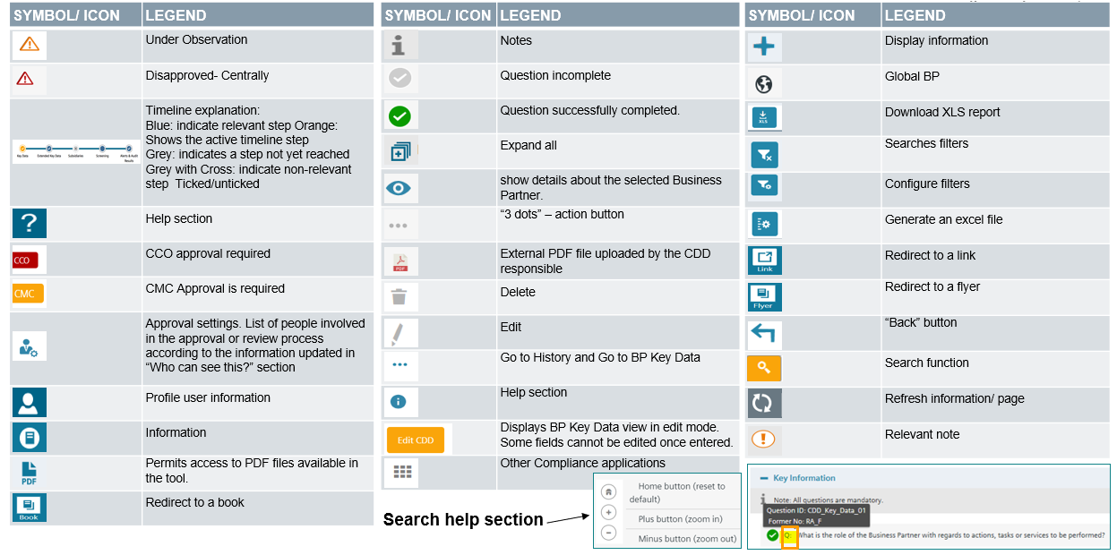

### C.5.3. [CDD-Tool](https://compliance-tools.siemens.com/due-diligence/) Support

If you have technical questions with the [CDD-Tool](https://compliance-tools.siemens.com/due-diligence/) please contact [bpc-tool.cit@siemens.com](mailto:bpc-tool.cit@siemens.com)

A web based training is available in the [financeTraining Desk.](https://financetraining.siemens.com/lms/?StoryID=741&fcourseid=666&tile=1&websiteLang=en)

## C.6. Data Retention Concept

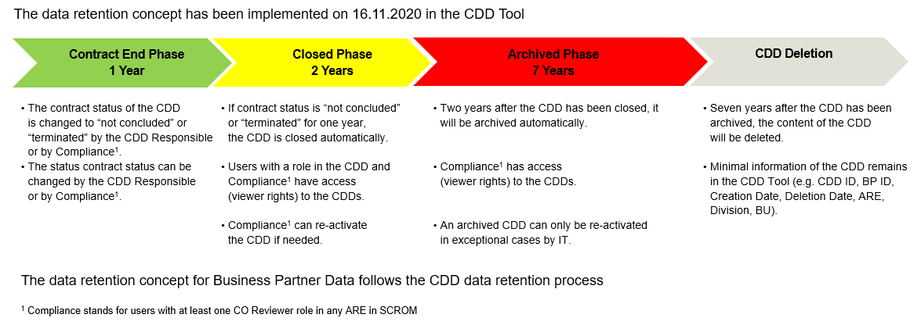

The data retention process starts with the closing of a CDD. A CDD can be closed manually see C.5.1.2. or a CDD is closed automatically if the status of all contracts of a CDD have been actively set as “not concluded” or “terminated” see C.2.7. and this has not been changed for one year.  
A closed CDD can be re-activated by a Compliance Officer (role CO Reviewer or CO Approver as per SCROM) see C.5.1.2.

If a CDD is in CDD Update Status “Closed” for a time period of two years, the status of the CDD changes automatically from “Closed” to “Closed Archived”. Only Compliance Officers and Superusers have still access to archived CDDs with viewer rights.

Seven years after the CDD has been archived, the content of the CDD will be deleted. Only minimal information remains in the CDD tool (e.g. CDD ID, BP ID, ARE Division, BU, creation and deletion date).

1. A Business Partner is in a position to **“facilitate”** decisions or the conduct of third parties to the benefit of Siemens when it may, actually or potentially, influence their conduct or decisions itself or through a third party. It is not relevant whether actually any improper influence is undertaken or intended. In contrast, if a Business Partner has no contact to any other party than Siemens or merely advises Siemens in its own decisions, generally he lacks the ability to influence decisions of a third party and is therefore out of scope of the Circular No. 226.
2. “**Siemens goods and services**” covers the entire Siemens portfolio, both physical and digital as well as financial.
3. **“Assets”** such as real estate or those being part of a Merger & Acquisition (M&A) transaction are also considered to be “Siemens goods”. Insofar, real estate brokers or M&A advisors are also considered Sales related Intermediaries. But please note: If Siemens is for example interested e.g. to rent a new storage place, the real estate is not a Siemens asset. The real estate broker is then to be classified as non-sales related intermediary (for details please refer to [Overview with examples](https://findit.compliance.siemens.com/content/10000101/Compliance/LC_CO/LC_CO_DF/findIT_LC_CO_DF_9246.pdf) and A.1.2.)
4. If the Siemens goods, services and/or assets would be **purchased** by the Business Partner and then sold to another third party, the Business Partner does qualify as “Reseller”. In some cases Business Partners might also fulfill both criteria (e.g. in case of combined agency / distributorship agreements).
5. A **"financial benefit"** is every financial advantage, monetary or non-monetary. Examples for financial benefits are payments, transfers of tangible assets, granting of future business opportunities to the partner, a waiver of rights or titles by Siemens, price reductions, distribution rights, software licenses or simply any other valuable thing provided. “**Receiving**” from Siemens is not limited to a direct grant of the benefit by Siemens but covers also any indirect grant under the responsibility of Siemens, e.g. via third parties.
6. A business partner provides a "**service**" in the interest of Siemens when he is assigned by Siemens to influence decisions or the behavior of third parties in favor of Siemens. He does not act in the interest or on behalf of a Siemens entity if he pursues his own interests by influencing decisions or the behavior of third parties in his favor outside his work area and unmotivated by any advantages he may receive from Siemens.

   Examples: If a customer facilitates the purchase of Siemens products to be converted into components by its supplier, he is not acting in the interest of Siemens but in his own interest, even if he receives minor advantages from Siemens in return. The same applies to partners who (1) sell their own product and must additionally purchase Siemens by-products or services from Siemens or (2) sell their own product (e.g. a MindSphere App) for which the partner's customers must additionally purchase Siemens products or services (e.g. MindSphere operating system). The "supplementary" character of a Siemens product must be examined on a case-by-case basis; however, the Partner shall act in the interest of Siemens in any case if the purchase price of the Siemens product or the Siemens service is higher than 20% of the purchase price of the Partner's main product or service.
7. A Business Partner is able to **“facilitate”** decisions or the conduct of third parties to the benefit of Siemens when it may, actually or potentially, influence their conduct or decisions itself or through a third party. It is not relevant whether actually any improper influence is undertaken or intended. However, if a Business Partner has no contact to any other party than Siemens or merely advises Siemens in its own decisions, generally he lacks the ability to influence decisions and is therefore out of scope of the Circular No. 226.
8. Other “**non-sales related decision or conduct**” would be e.g. the issuance or award of an acceptance, permission, a registration or liquidation, a confirmation or recognition, a technical certification.
9. “**To the benefit of Siemens**”: In general, those decisions or conducts are covered, where the realistic danger of corruption, facilitation payments or other illegal conduct e.g. towards a third party exists, of which Siemens could benefit. However, an external engineer who is responsible for controlling the construction works of external contractors for a Siemens power plant would not be in scope. In that constellation, the engineer might technically have the possibility facilitate a “non-sales related decision or conduct” of such contractors. On the other hand, it is an unlikely scenario, that an engineer bribes a construction company - that is a contractor of Siemens - for the benefit of Siemens. However, if the same engineer has contact to authorities in relation to permits etc. needed for the final operation of the power plant, the situation is different as Siemens might benefit from it.
10. A **"financial benefit"** is every financial advantage, monetary or non-monetary. Examples for financial benefits are payments, transfers of tangible assets, granting of future business opportunities to the partner, a waiver of rights or titles by Siemens, price reductions, distribution rights, software licenses or simply any other valuable thing provided. **“Receiving from Siemens”** is not limited to a direct grant of the benefit by Siemens but covers also any indirect grant under the responsibility of Siemens, e.g. via third parties.
11. A Business Partner is performing a **“service”**, if he acts in the interest or on behalf of a Siemens unit. This is the case when he is tasked by Siemens to influence decisions or the conduct of third parties for the benefit of Siemens. Insofar, a Business Partner is not acting in the interest or on behalf of a Siemens unit if he pursues his own interests by influencing decisions or the conduct of third parties to his benefit outside of his scope of work and unmotivated by any benefits he might receive from Siemens.
12. **“Dual distribution”** describes the situation of being a manufacturer on the one hand and a competitor to our own distributor vis-à-vis (end) customers on the other hand.
13. A **“specific Reseller”** is a Reseller (e.g. an EPC, Distributor) individually identified by the third party and explicitly required by it to become the direct contractual customer of Siemens instead of the end customer. Please be aware, that a company, which belongs to the same group of companies as the end customer is not considered to be a Reseller.
14. **“Required”** means any demand or request either in written or verbal form to use a specific Reseller. A Reseller is not deemed to be “required” by a third party if it is requested in the framework of a public or private tender, in a transparent manner in the tender documents and this requirement applies equally to all bidders.
15. A **“third party”** is any company or individual outside Siemens.
16. **“Unusual”**: In general, it is not uncommon that Siemens supports Resellers to promote Siemens' products. Insofar, only “unusual” financial benefits should get into our focus. See chapter A.3.2.3.2.2. for details.
17. “**Financial benefits”** include any actual or promised payments of any sum of money as well as other benefits with a monetary value. Examples are “rebates”, “discounts”, “bonuses”, “special prices”, easily achieved penalties for project deadlines or guarantees or warranted characteristics as well as reimbursement of marketing, advertising or warehousing expenses, acceptance of unjustified claims or unjustified change orders.
18. **“Business term”** means every clause, condition or other stipulation, either in written or verbal form, which defines a part of the business relationship, e.g. contract provisions, general terms and conditions or any other mutual agreement via email, telephone or in meetings.
19. **“Placed”** means that our contractual Reseller establishes a further business relationship between himself and an additional third party to conduct his business with the end-customer.
20. **“Without plausible cause”** means a non-comprehensible involvement of the further third party. This is e.g. the case when the further third party does not create any added (or only minor) value for the envisaged business case.
21. **“Source”** could be any source of information, e.g. news, internet including social media or personal contacts. **“Reliable”** means that the source is competent in the field of interest, without any biases or conflicts of interest. Examples are established journals, reputable magazines, authors with credits and affiliation, governmental information.
22. Collaboration in the framework of a research and development (R&D) cooperation/consortium is not sales related.
23. A CEO may also delegate the approval-role in alignment with the respective Compliance Officer to a member of the CEO`s Top or Senior Management.
24. In the case that essential topics will be negotiated and signed later than the (main) contract (e.g. a commission rate) the highest management has to be involved upfront also.
25. The purpose is to identify the relevant people within the Business Partner organization who are or will be managing Siemens business and who could be more exposed to inappropriate behavior due to their function and interactions with government officials or other relevant third parties.
26. For example, consider the difference in performing a Compliance Check on individual sales agent compared with a company with 200 employees, 10 of which might be involved in Siemens related business activities. The duration and format of the meeting would obviously differ.
27. The Appendix 1 template can be located in the *Preparation Tool* Excel file and on the *Appendix 1: Detailed Report* Word file. The template is the same, so feel free to use whichever format (Excel or Word) you feel more comfortable with for the Appendix.
28. A CEO may also delegate the approval-role in alignment with the respective Compliance Officer to a member of the CEO`s Top or Senior Management.
29. Currently, according to our information the following countries require a Consent Form: Argentina, Belarus, Colombia, France, India, Indonesia , Kazakhstan, Mauritius, Peru, Portugal, Russia, Slovakia, Turkey and Uruguay.